Capacitor Charge: Stored energy: 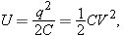 Name:___________
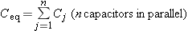 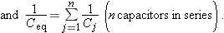______________________________________________________________________________
B. In the Figure below, V = 9.0 V, C₁ = 2.5 μF, C₂ = 7.3 μF, C₃ = 3.0 μF, C₄ = 2.7 μF, C₅ = 6.0 μF, and C₆ = 1.5 μF.
1. What is the equivalent capacitance?
2. What is the charge on the equivalent capacitance?
3. What is the charge on C₄?
4. What is the energy stored on C₄?
