PHYS 212 Sample Test Question
Faraday’s law of induction is given by:
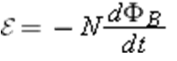
1. Describe the meaning of the each term in the above equation including the minus sign.

2. P7: In Fig. 30-36, the magnetic flux through the loop increases according to the relation Φ_{B} = 6.0t² + 7.0t, where Φ_{B} is in milliwebers and t is in seconds. (a) What is the magnitude of the emf induced in the loop when t = 2.0 s? (b) Is the direction of the current through R to the right or left?
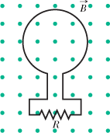

3. P82: A uniform magnetic field is perpendicular to the plane of a circular wire loop of radius r. The magnitude of the field varies with time according to B = B₀e^{-t/t}, where B₀ and τ are constants. Find an expression for the emf in the loop as a function of time.

