PHYS 212 Current and current density Name:__________________________
1. Define electric current, express its unit, and identify it as a vector or scalar.

2. Define current density, express its unit, and identify it as a vector or scalar.

3. The figure shows a portion of a circuit. What is the current i in the lower right-hand wire?
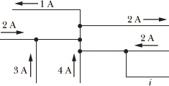
4. The magnitude J of the current density in a certain wire with a circular cross section of radius R = 4.0 mm is given by J = (3 × 10⁸)r², with J in amperes per square meter and radial distance r in meters. What is the current through the wire?
