PHYS 212 In-Class Problem Solving Name:____________________
1. Define electric potential, V using electric potential energy, U.
2. Express electric potential, V at a distance r from a point charge, q.

P17. In Fig. 24-33, what is the net electric potential at point P due to the four particles if V = 0 at infinity, q = 5.00 fC, and d = 4.00 cm? (f=femto=10⁻¹⁵)
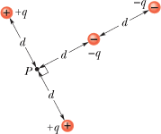
P85: In Fig. 24-62, we move a particle of charge +2e in from infinity to the x axis. How much work do we do? Distance D is 4.00 m.
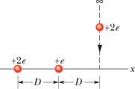

P88. Two charges q = +2.0 μC are fixed a distance d = 2.0 cm apart (Fig. 24-64). (a) With V = 0 at infinity, what is the electric potential at point C? (b) You bring a third charge q = +2.0 μC from infinity to C. How much work must you do? (c) What is the potential energy U of the three-charge configuration when the third charge is in place?
