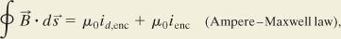

•15
Prove that the displacement current in a parallel-plate capacitor of capacitance C can be written as i_{d} = C(dV/dt), where V is the potential difference between the plates.

•13
At what rate must the potential difference between the plates of a parallel-plate capacitor with a 2.0 μF capacitance be changed to produce a displacement current of 1.5 A?

67
In Fig. 32-41, a parallel-plate capacitor is being discharged by a current i = 5.0 A. The plates are square with edge length L = 8.0 mm. (a) What is the rate at which the electric field between the plates is changing? (b) What is the value of 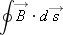around the dashed path, where H = 2.0 mm and W = 3.0 mm?
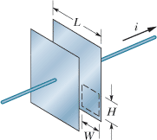
••24 | The magnitude of the electric field between the two circular parallel plates in Fig. 32-32 is E = (4.0 × 10⁵) - (6.0 × 10⁴t), with E in volts per meter and t in seconds. At t = 0, is upward. The plate area is 4.0 × 10⁻² m². For t ≥ 0, what are the (a) magnitude and (b) direction (up or down) of the displacement current between the plates and (c) is the direction of the induced magnetic field clockwise or counterclockwise in the figure?  Figure 32-32 Problem 24.

