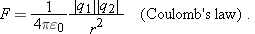

•3. | A particle of charge is 12.0 cm distant from a second particle of charge . Calculate the magnitude of the electrostatic force between the particles.

54. | In Fig. 21-42, two tiny conducting balls of identical mass m and identical charge q hang from non conducting threads of length L. Assume that is so small that can be replaced by its approximate equal, . (a) Show that  gives the equilibrium separation x of the balls. (b) If , and , what is ?
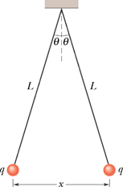

••9. | In Fig. 21-23, the particles have charges and , and distance . What are the (a) x and (b) y components of the net electrostatic force on particle 3?
