http://edugen.wiley.com/edugen/courses/crs1650/art/math/halliday8019c29/math069.gif

1. Using Ampere’s law, show that the magnitude of the magnetic field (B) due to a long straight wire, carrying a current I, at a distance r, is given by: (μ0= 4πx10-7 T.m/A)

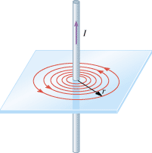

2. Describe few properties of the above magnetic field.

3. Two long straight wires, carrying currents 9.00A and 5.00A are separated by a distance of 0.120 m, lie as shown below. Determine the net magnetic field (magnitude and direction) from both currents at point B?

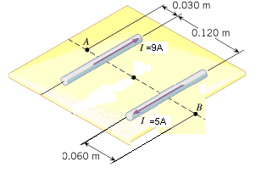

|  |  |  |  |  |  |  |  |  |  |  |
| --- | --- | --- | --- | --- | --- | --- | --- | --- | --- | --- |
| 4. **••21** | |  | | --- | |  |   http://edugen.wiley.com/edugen/courses/crs4957/common/art/go.gif Figure [29-48](http://edugen.wiley.com/edugen/courses/crs4957/halliday9118/halliday9088c29/halliday9118/halliday9088c29/halliday9088c29xlinks.xform?id=halliday9088c29-fig-0048) shows two very long straight wires (in cross section) that each carry a current of 4.00 A directly out of the page. Distance *d*1 = 6.00 m and distance *d*2 = 4.00 m. What is the magnitude of the net magnetic field at point *P*, which lies on a perpendicular bisector to the wires?   |  |  |  |  |  |  |  |  | | --- | --- | --- | --- | --- | --- | --- | --- | |  | |  | | --- | | http://edugen.wiley.com/edugen/courses/crs4957/common/art/pixel.gif | | |  |  |  |  | | --- | --- | --- | --- | | |  | | --- | | http://edugen.wiley.com/edugen/courses/crs4957/common/art/pixel.gif | |  | |  | | |   http://edugen.wiley.com/edugen/courses/crs4957/halliday9118/halliday9088c29/image_n/nt0051-y.gif | |