PHYS 212 Alternating Current (ac) Voltage Name:_________________
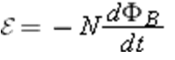
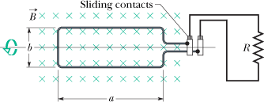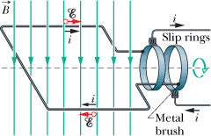
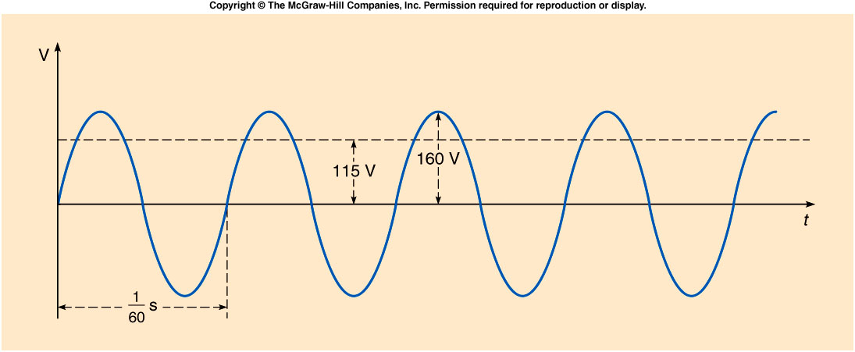
••11 | A rectangular coil of N turns and of length a and width b is rotated at frequency f in a uniform magnetic field , as indicated in Fig. 30-38. The coil is connected to co-rotating cylinders, against which metal brushes slide to make contact.  (a) Show that the emf induced in the coil is given (as a function of time t) by  (30-0)  This is the principle of the commercial alternating-current generator.  (b) What value of Nab gives an emf with ₀ = 160 V when the loop is rotated at 60.0 rev/s in a uniform magnetic field of 0.500 T?

