PHYS 201L VECTORS Name:___________________________
Partners:____________________________________ Day________Time________
Addition of Vectors  Draw the vectors including the Resultant, F_{R} and Equilibrant, F_{E}. |  |  |  |  | Resultant Vector |  | Force Table Check
 |  |  |  |  | From website | Analytical method
50 g @ 0⁰  and  100 g @ 90⁰ | 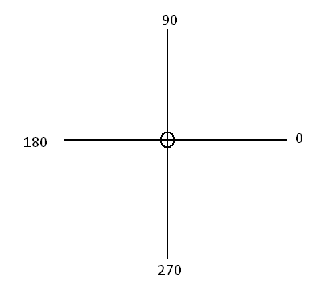 |  |  |  | F_{R}=  θ_{R}= | F_{R}=  θ_{R}=  θ_{E}= | ________
50 g @ 20⁰  and  250 g @ 120⁰ |  |  |  |  | F_{R}=  θ_{R}= | F_{R}=  θ_{R}=  θ_{E}= | ________
50 g @ 20⁰  250 g @ 120⁰  300 g @ 300⁰ |  |  |  |  | F_{R}=  θ_{R}= | F_{R}=  θ_{R}=  θ_{E}= | ________
100 g @ 30⁰  150 g @ 140⁰  125 g @ 200⁰  200 g @ 300⁰ |  |  |  |  | F_{R}=  θ_{R}= | F_{R}=  θ_{R}=  θ_{E}= | _________
A = 160 g,  B = 100 g  C = 120 g,  D = 260 g |  |  |  | 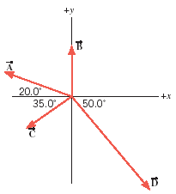 | F_{R}=  θ_{R}= | F_{R}=  θ_{R}=  θ_{E}= | _________
Resolution  300 g @ 30⁰ |  |  |  |  | XXXXX | F_{x}=  F_{y}= | _________
Exercise: Use the graphical method to find the magnitude (F_{R}) & direction (θ_{R}) of the resultant for the case of addition of four vectors. Here you need to draw a vector diagram, using a protractor and ruler, following the tail-to-tip method, to scale. Show the direction of the vectors and identify F_{R} & θ_{R} in the drawing. Use 20 g = 1 cm.
 | A = 160 g = cm  B = 100 g = cm  C = 120 g = cm  D = 260 g = cm | F_{R} = _________cm  F_{R} = _________ g  θ_{R} = _____________

................................................................................................................................................
................................................................................................................................................
................................................................................................................................................
............................................................................................................................................................................................................................................................................................0⁰................................................................................................................................................
................................................................................................................................................
................................................................................................................................................
............................................................................................................................................................................................................................................................................................0⁰................................................................................................................................................
................................................................................................................................................
................................................................................................................................................
............................................................................................................................................................................................................................................................................................0⁰................................................................................................................................................
................................................................................................................................................
................................................................................................................................................
............................................................................................................................................................................................................................................................................................0⁰................................................................................................................................................
................................................................................................................................................
................................................................................................................................................
............................................................................................................................................................................................................................................................................................0⁰................................................................................................................................................
................................................................................................................................................
................................................................................................................................................
............................................................................................................................................................................................................................................................................................0⁰................................................................................................................................................
................................................................................................................................................
................................................................................................................................................
............................................................................................................................................................................................................................................................................................0⁰................................................................................................................................................
................................................................................................................................................
................................................................................................................................................
............................................................................................................................................................................................................................................................................................0⁰................................................................................................................................................
................................................................................................................................................
................................................................................................................................................
………………………………………………………………………………………………

