Remote Lab VECTORS Name:___________________Course______
Purpose: To determine the resultant of two or more vectors analytically and to verify the results using a website and graphical method.
Theory: Analytical method
Let's say two forces F₁ (making an angle θ₁, counterclockwise from the +X-axis) and F ₂ (making an angle θ₂, counterclockwise from the +X-axis) are acting on an object.
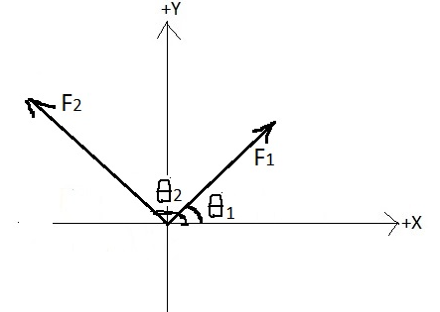
To find the resultant (net) force, F_{R} we need to find the X and Y components of the two forces, as shown below:
Force | X component | Y component
F₁ | F₁ Cos θ₁ | F₁ Sin θ₁
F₂ | F₂ Cos θ₂ | F₂ Sin θ₂
$$F_{R}=F_{1}+F_{2}$$ | F_{x} = F₁ Cos θ₁+ F₂ Cosθ₂ | F_{y} = F₁ Sin θ₁ + F₂ Sin θ₂
Magnitude of the resultant (F_{R}) is given by; F_{R}² = F_{x}² + F_{y}²
Direction of the resultant, θ_{R}, measured from the +X axis counterclockwise, depends on the signs of Fx and Fy, as shown in the data table below.
Case | Vector Diagram | θ_{R} | F_{R}
Fx > 0  and  Fy >0 |  | $$θ_{R}=\tan^{-1}\frac{F_{y}}{F_{x}}$$ | $$F_{R}=\sqrt{{F_{x}}^{2}+{F_{y}}^{2}}$$
Fx < 0  and  Fy > 0 |  | $$A=\tan^{-1}\frac{F_{y}}{\left|F_{x}\right|}$$  $$θ_{R}=180-A$$ | $$F_{R}=\sqrt{{F_{x}}^{2}+{F_{y}}^{2}}$$
Fx < 0  and  Fy < 0 |  | $$B=\tan^{-1}\left|\frac{F_{y}}{F_{x}}\right|$$  $$θ_{R}=180+B$$ | $$F_{R}=\sqrt{{F_{x}}^{2}+{F_{y}}^{2}}$$
Fx > 0  and  Fy < 0 |  | $$C=\tan^{-1}\frac{\left|F_{y}\right|}{F_{x}}$$  $$θ_{R}=360-C$$ | $$F_{R}=\sqrt{{F_{x}}^{2}+{F_{y}}^{2}}$$
Procedure
A) From the website: http://www.1728.org/vectors.htm
Open the above website, enter the vectors, and obtain the magnitude, F_{R} and direction, θ_{R} of the resultant. Enter your data in the data table.
B) Analytical Method
Using the analytical method (component method) find the magnitude, F_{R} and direction, θ_{R} of the resultant. Complete the data table and attach your worksheets.
C) Do the graphical method exercise on page 5.
D) Write a conclusion and submit your report within a week.

Data Table
Addition of Vectors |  | Resultant Vector
http://www.1728.org/vectors.htm |  | From website | Analytical method
2.0 N @ 0⁰  2.0 N @ 90⁰ |  | F_{R}=  θ_{R}= | F_{R}=  θ_{R}=
2.0 N @ 0⁰  and  3.0 N @ 90⁰ |  | F_{R}=  θ_{R}= | F_{R}=  θ_{R}=
1.5 N @ 20⁰  and  2.5 N @ 120⁰ |  | F_{R}=  θ_{R}= | F_{R}=  θ_{R}=
1.5 N @ 20⁰  2.5 N @ 120⁰  3.0 N @ 300⁰ |  | F_{R}=  θ_{R}= | F_{R}=  θ_{R}=
1.0 N @ 30⁰  1.5 N @ 140⁰  2.0 N @ 200⁰  3.0 N @ 300⁰ |  | F_{R}=  θ_{R}= | F_{R}=  θ_{R}=
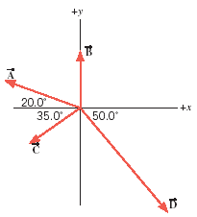 | A = 1.6 N, B = 1.0 N  C = 1.2 N, D = 2.6 N | F_{R}=  θ_{R}= | F_{R}=  θ_{R}=
Exercise
Use the graphical method (clicking this hyperlink will open up a video) to find the magnitude (F_{R}) & direction (θ_{R}) of the resultant for the case of addition of four vectors. Here you need to draw a vector diagram, using a protractor and ruler, following the tail-to-tip method, to scale. Show the direction of the vectors and identify F_{R} & θ_{R} in the drawing.
 | A = 1.6 N  B = 1.0 N  C = 1.2 N  D = 2.6 N | F_{R} = ____________  θ_{R} = _____________
............................................................................................................................................0⁰................................................................................................................................................
................................................................................................................................................
................................................................................................................................................
............................................................................................................................................................................................................................................................................................0⁰................................................................................................................................................
................................................................................................................................................
................................................................................................................................................
............................................................................................................................................................................................................................................................................................0⁰................................................................................................................................................
................................................................................................................................................
................................................................................................................................................
............................................................................................................................................................................................................................................................................................0⁰................................................................................................................................................
................................................................................................................................................
................................................................................................................................................
............................................................................................................................................................................................................................................................................................0⁰................................................................................................................................................
................................................................................................................................................
................................................................................................................................................
............................................................................................................................................................................................................................................................................................0⁰................................................................................................................................................
................................................................................................................................................
................................................................................................................................................

