Data Collection with a PC-I Name:______________________________
Partner(s):________________________________________________Day/Time:______
A. Introduction:
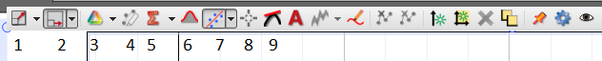
Menu | Description
1
4
6
7
8
9
B1. DATA for MOTION: Smallest distance the motion sensor can detect = _________
 | Using x vs. t Graph | Using v vs. t Graph | Using a vs. t Graph | % Difference
Describe  the  Graph |  |  |  | XXXXXX  XXXXXX  XXXXXX  XXXXXX
Initial/resting position |  | XXXXXX  XXXXXX  XXXXXX | XXXXXX  XXXXXX  XXXXXX | XXXXXX  XXXXXX  XXXXXX
Final position |  | XXXXXX  XXXXXX  XXXXXX | XXXXXX  XXXXXX  XXXXXX | XXXXXX  XXXXXX  XXXXXX
Distance Travelled |  |  | XXXXXX  XXXXXX  XXXXXX
Initial Velocity |  |  | XXXXXX  XXXXXX | XXXXXX  XXXXXX
Final Velocity |  |  | XXXXXX  XXXXXX  XXXXXX
Acceleration | XXXXXX  XXXXXX |  |  | XXXXXXXXX  XXXXXXXXX
B2. Motion Investigations:

C. Coefficient of Kinetic Friction:
$f_{k}=μ_{k}F_{N}$
The block will be pushed with a force sensor by overcoming and balancing the frictional force, as shown below. Draw a free-body diagram for the block, below.
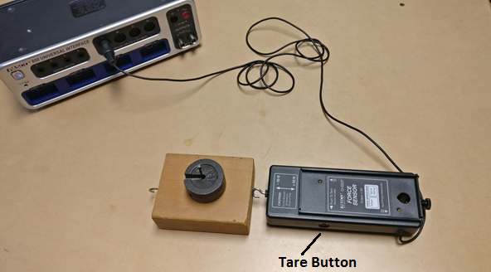
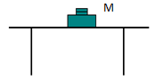
DATA TABLE I Mass of the wooden block, M_{b} = ---------
Mass on Top  M_{t} (g) | M = M_{b} + M_{t} | Normal Force  F_{N} (N) | Frictional Force  f_{k} (N) | µ_{k}
0
100
200
300
400
500
600
700
Also, plot a graph and determine the value of µ_{k}. Attach a copy of your graph to the report. List the value of µ_{k} from the graph, here_____________ and in the conclusion.

