Hooke's Law and Simple Harmonic Motion Name:__________________________
Partner(s):__________________ Course:______________ Time:____________
- Hooke’s Law
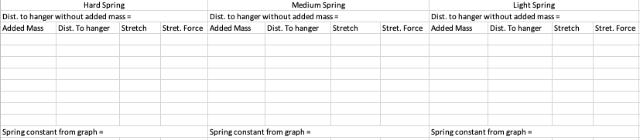
- Purpose: Investigate a simple harmonic motion.
DATA (Use SI units):
Oscillating Mass = m = ___________Spring Constant (from Part A) = k = ____________
I) From the Position VS. Time graph obtain the following:
a. Equilibrium Position = ______________________
b. Amplitude of the Oscillation = __________________________
c. Period of the Oscillation = _______________________________
d. Calculate the period (using spring constant and oscillating mass) = _______________
II) Click Position, choose velocity, and from the Velocity VS. Time graph obtain the following:
a. Maximum Velocity =___________________________
b. Period of the Oscillation = ___________________________
c. Calculate the period (using amplitude and maximum velocity) = ____________________
III) Click Velocity, choose acceleration, and from the Acceleration VS. Time graph obtain the following:
a. Maximum Acceleration =___________________________
b. Period of the Oscillation = ___________________________
c. Calculate the Maximum force = ______________________
d. Calculate the period (using amplitude and maximum acceleration) = ____________________

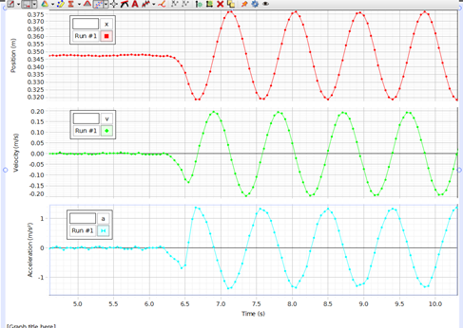
Circle the answers for following questions, by looking at the oscillating mass and using your display:
1. During the oscillation when the mass is at the equilibrium position, what is the,
- Velocity: maximum OR zero b. Acceleration: maximum OR zero
2. During the oscillation when the velocity of the mass is zero, what is the,
- Position: equilibrium OR crest/trough b. Acceleration: maximum OR zero
3. During the oscillation when the acceleration of the mass is zero, what is the,
- Position: equilibrium OR crest/trough b. Velocity: maximum OR zero

