Pre-Lab for Energy Name:____________________________
- DEMO: http://www.youtube.com/watch?v=mhIOylZMg6Q&feature=related
The wrecker ball didn't hit the chin of the professor, even though it broke the glass. Explain why?

- Refer your textbook and answer the following questions:
- Define kinetic energy (KE) using words and express it using an equation.

- Define gravitational potential energy (PE) using words and express it using an equation.

- What is mechanical energy (ME)?

- State the principle of conservation of mechanical energy?

- State the SI unit for energy and state whether energy a scalar or vector?

- A pendulum bob (height H₁) is raised to a height H₂ and released.
1. Show the heights and speed at the bottom of the swing in the diagram.
2. Calculate the speed of the bob at the bottom of the swing.
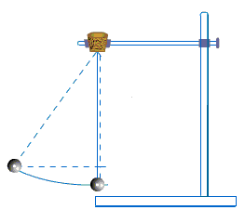
H₁=__________________
H₂ =__________________
Speed, Calculated =___________________
Speed, Measured = ____________________
% Difference = __________________
Course:_________________ Name:__________________________________
Partner(s): ______________________________________________________
Purpose: To investigate the motion of a cart down an inclined air-track and quantify its energy & acceleration.
Apparatus: Air-track, cart, electronic balance, metal can (to incline the air-track), photogate sensor w/cable, meter stick, transparent measuring tape with weight, lab stand, vernier-caliper, Pasco 850-interface, and PC.
Theory: Potential Energy = Kinetic Energy =
Mechanical Energy = ME = PE + KE.
UNITS:
 | Time | Mass | Force | Distance | Velocity | Acceleration | Energy
cgs | s | g | dyne | cm | cm/s | cm/s² | erg
SI | s | kg | newton, N | m | m/s | m/s² | joule, J
cgs- centimeter, gram, second; SI-International System;
PROCEDURE:
1. Incline the air-track using a metal can.
2. Measure the mass (M) of the cart and the Flag-Width of the card on the cart.
3. Pick a position close to the top of the track, 155 cm or 1.55 m, and measure the Height from the table-top.
4. Repeat the height measurements for other positions: 1.45,1.35,1.25……0.25.
5. Keep the cart at the far-end of the track, and record the starting position. (Use the middle of the Flag-Width as the reference)
6. Set up the photo-gate head at the first position, 1.55 m, so that the card will flag the photogate as it moves across the head.
7. Connect the photogate cable to Digital Channel 1, of the PASCO 850 interface, which is turned on, and open PASCO Capstone software from the desktop.
8. Click Hardware Setup under Tools on the left, click on the interface input where the sensor is connected, and select Photogate.
9. Click Timer Setup under Tools, click Next (with Pre-Configured Timer), click Next (with Photogate Ch1), click the drop-down-menu for Select a Timer, and select One Photogate (Single Flag). Click Next (with Speed checked), enter the Flag-Width, click Next, and click Finish. Click Timer Setup again to close it.
10. Double-Click Digits under Displays, click Select Measurement, and select speed.
11. Click Record and turn on the air in the air-track.
12. Stop the Data collection after the cart passes through the photogate-head and enter the velocity data.
13. Repeat the velocity measurements for other timer positions and complete the data table and data analysis.
DATA (Use SI units)
Mass of the cart = M = _______ Flag-Width of the card on the cart = __________
(This will be entered during Timer Set up with Capstone)
Starting position = _________ Initial velocity = 0 Accel. due to gravity = g = 9.8 m/s²
Timer Position (m) | Height, h (m) | Velocity, v (m/s)
1.55
1.45
1.35
1.25
1.15
1.05
0.95
0.85
0.75
0.65
0.55
0.45
0.35
0.25
Angle of Incline Collect the data necessary and calculate the angle of incline.
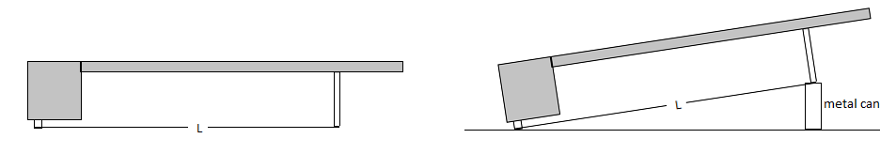
DATA ANALYSIS
Enter the above data in a spread sheet program and create four more columns for Displacement, PE, KE, and ME, and calculate them to 3 significant figures.
Plot PE, KE, and ME VERSUS Displacement; in a single graph.
Plot another graph, and obtain the acceleration from the graph. Also, obtain the acceleration using the angle of incline and acceleration due to gravity.
Write a conclusion.

