PHYS 201 LAB Measurement of density
Name:_____________________________Date:_______________Time:____________
Partner(s):______________________________________________________________
A. Introduction of measuring devices
1) Vernier caliper
Read the following Vernier readings:
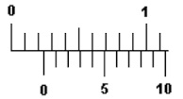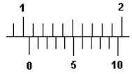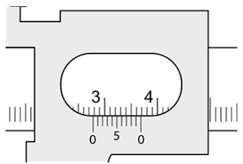
_____________________ _________________ _____________________

2) Micrometer
Read the following micrometer readings:
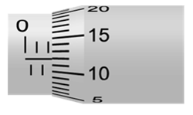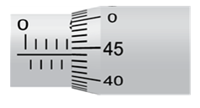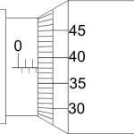
_______________________ _____________________ ___________________

B: Rectangular Solids
 | Mass | Length | Width | Height
Al | - | - | - | -
Cu | - | - | - | -
Fe | - | - | - | -
Brass | - | - | - | -
Sheet metal | - | - | - | -
Acrylic block | - | - | - | -
For Al, calculate the %uncertainty in density:

C. Cylinders
Cylinder |  | Mass | Height, h | Diameter, d
Al
Steel
Cu
Brass
Fe
Wood
Acrylic
Cu wire
Penny | Year:
Use this penny composition website to calculate an accepted density for your penny. Show your work below:

D. Average Density of H₂O _______________and CuSO₄ _______________from graph.

