PHYS 211 PHYS 211 F 2013 Study Guide for Test #3   Chapters 10,11, & 12

Format will be similar to Tests #1 and #2, consists of regular questions, derivations and problems.

A. You should know the following:

1. Solving motion [linear & rotational] problems using kinematics equations.
2. Finding velocity [v(t)] and acceleration [a(t)] from the position vector, r(t).
3. Application of Newton’s second law for linear and rotational motions.
4. Calculating net torque when multiple forces act on an object.
5. Solving problems using the conservation of energy principles.
6. Calculating rotational inertia including the use of the parallel-axis theorem.
7. Solving problems using the conservation of angular momentum.
8. Determining torque and angular momentum in vector form using the cross product.
9. Conditions for equilibrium and static equilibrium.
10. Drawing Free-body diagrams.

B. You should be able to define the following: angular momentum, rotational inertia, moment-arm, and torque.

C. The equations that follow (if needed) and the equations sheet in the following page will be provided.

|  |  |  |
| --- | --- | --- |
| PHYS 211 Equations Sheet | Translational Motion | Rotational Motion |
|  | LINEAR | ANGULAR |
| Time | *t* | *t* |
| Position | *x* | *θ* |
| Velocity |  |  |
| Acceleration |  |  |
| Kinematic Equations | *v = v0 + at* | *ω = ω0 + αt* |
|  | *v2 = v02 + 2a(x-x0)* | *ω2 = ω02 + 2α(θ- θ0)* |
|  | *x-x0 = v0t + ½ at2* | *θ- θ0= ω0t + ½ αt2* |
|  | *x-x0 = ½(v + v0)t* | *θ- θ0 = ½(ω + ω0)t* |
| Inertia | *m* = mass | *I* = Rotational inertia; |
| Momentum | ***p*** *= mv* | $\vec{l}=\vec{r}×\vec{p}$ |
| $$\vec{P}=M{\vec{V}}_{com}$$ | ***L*** *= Iω* |
| Kinetic Energy | Translational Kinetic Energy = *K = ½ mv2* | Rotational Kinetic Energy =  *K = ½ Iω2* |
| To create | force = *F* | torque = $\vec{τ}=\vec{r}×\vec{F}$ |
| Work |  |  |
| Power |  |  |
| Newton's second law of motion |  |  |
|  |  |  |
|  |

Frictional Forces:  

Gravitational Potential energy = ; g = 9.8 m/s2

Elastic Potential Energy = 

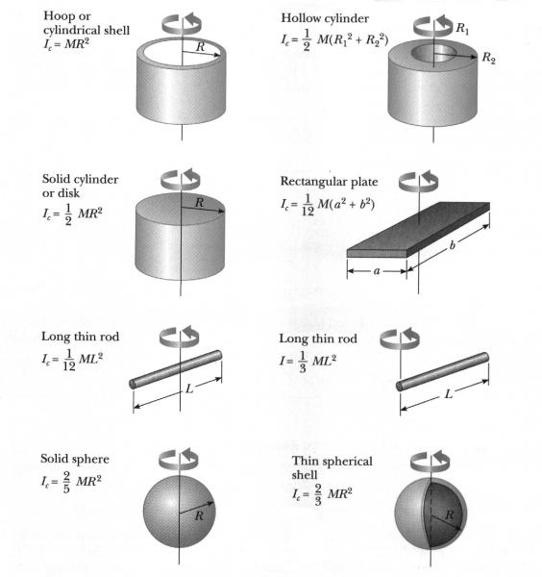

Parallel-axis theorem: 

Vector cross product: $\hat{i}×\hat{j}=\hat{k}$ $\hat{j}×\hat{i}=-\hat{k}$ $\hat{i}×\hat{i}=0$

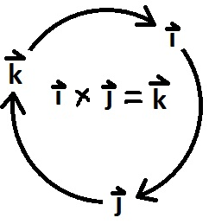

Vector cross product: $\left|\vec{a}×\vec{b}\right|=ab\sin{θ}$; $a=\sqrt{a_{x}^{2}+a_{y}^{2}+a_{z}^{2}}$

where *θ* is the angle between the vectors.   
Vector dot product: $\vec{a}∙\vec{b}=ab\cos{θ;}$ $\hat{i}∙\hat{i}=1$ $\hat{i}∙\hat{j}$ = 0