PHYS 211 F 2013 9:30AM Test #2 Name:______________________________

|  |  |  |  |  |
| --- | --- | --- | --- | --- |
|  |  |  |  |  |

1. A student writes Newton’s second law as, F = ma, which has some errors. Write down Newton’s second law without any errors.

2. The high-speed winds around a tornado can drive projectiles into trees, building walls, and even metal traffic signs. In a laboratory simulation, a standard wood toothpick was shot by pneumatic gun into an oak branch. The toothpick's mass was 0.13 g, its speed before entering the branch was 220 m/s, and its penetration depth was 15 mm. If its speed was decreased at a uniform rate, what was the magnitude of the force of the branch on the toothpick?

3. A 0.150 kg particle moves along an *x* axis according to *x*(*t*) = -13.00 + 2.00*t* + 4.00*t*2 - 3.00*t*3, with *x* in meters and *t* in seconds. In unit-vector notation, what is the net force acting on the particle at *t* = 3.0 s? (v = dx/dt, a= dv/dt)

4a. Circular motions require centripetal forces. The magnitude of the centripetal force is given by,. Name two physical quantities that stay constant __________________________ and two physical quantities that change___________________during a uniform circular motion.

b. In the figure below, a car (mass = 1050 kg) is travelling at a constant speed of 85 km/H. The road is first flat, then a circular hill, and finally a circular valley with the same radius (0.12 km). Draw a free-body diagram and calculate the normal force on the car when the car is on:   
(a) the flat road (b) the top of the hill (c) the bottom of the valley.

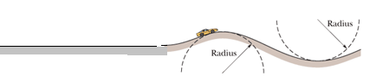

5. Impulse:   
Figure below gives, as a function of time *t*, the force component *Fx* that acts on a 3.00 kg ice block that can move only along the *x* axis. At *t* = 0, the block is moving in the positive direction of the axis, with a speed of 3.0 m/s.   
a. At *t* = 11 s, what is the net impulse delivered to the ball?   
b. At *t* = 11 s, what is the speed of the ice block?

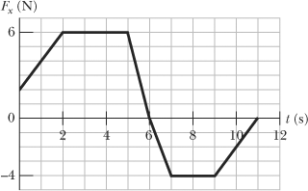

6. Momentum, Collisions and Conservation of Momentum:

|  |  |  |  |  |
| --- | --- | --- | --- | --- |
|  |  |  |  |  |

I. Define momentum, identify it as a vector or scalar, and state its SI unit.

II. State the law of conservation of momentum.

III. In the figure below, a 3.0 kg box of running shoes slides on a horizontal frictionless table and collides with a 2.0 kg box of ballet slippers initially at rest on the edge of the table, at height *h* = 0.40 m. The speed of the 3.0 kg box is 4.0 m/s just before the collision. The two boxes stick together because of packing tape on their sides, after the collision, and travel, as shown below.  
a. Identify this collision. Is it elastic, inelastic, or completely inelastic?   
b. Using the conservation of momentum, find the speed of the boxes, just after the impact.  
c. How far from the edge of the table, horizontally, the boxes will strike the floor?

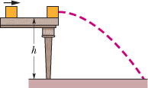

7. The script for an action movie calls for a small race car (of mass 1500 kg and length 3.0 m) to accelerate along a flattop boat (of mass 4000 kg and length 15 m), from one end of the boat to the other, where the car will then jump the gap between the boat and a somewhat lower dock. You are the technical advisor for the movie. The boat will initially touch the dock, as shown below. The boat can slide through the water without significant resistance; both the car and the boat can be approximated as uniform in their mass distribution.   
a. Determine the center of mass of the boat and car initially, when the car is at the far end.  
b. As the car moves to the left, what will happen to the boat?  
c. Determine what the width of the gap will be just as the car is about to make the jump.

http://edugen.wiley.com/edugen/courses/crs4957/halliday9118/halliday9118c09/image_n/nt0085-y.gif