PHYS 211 Problems in Conservation of Energy Name:___________________________

Kinetic energy:  Elastic Potential Energy = 

Gravitational Potential energy = 

_____________________________________________________________________________  
P15: In Fig. [8-33](http://edugen.wiley.com/edugen/courses/crs4957/halliday9118/halliday9118c08/halliday9118/halliday9118c08/halliday9118c08xlinks.xform?id=halliday9118c08-fig-0033), a runaway truck with failed brakes is moving downgrade at 130 km/h just before the driver steers the truck up a frictionless emergency escape ramp with an inclination of *θ* = 15°. The truck's mass is 1.2 × 104 kg. (a) What minimum length *L* must the ramp have if the truck is to stop (momentarily) along it? (Assume the truck is a particle, and justify that assumption.) Does the minimum length *L* increase, decrease, or remain the same if (b) the truck's mass is decreased and (c) its speed is decreased?

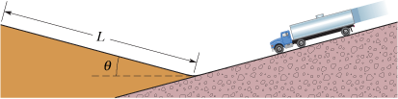

P24: A block of mass *m* = 2.0 kg is dropped from height *h* = 40 cm onto a spring of spring constant *k* = 1960 N/m (Fig. [8-37](http://edugen.wiley.com/edugen/courses/crs4957/halliday9118/halliday9118c08/halliday9118/halliday9118c08/halliday9118c08xlinks.xform?id=halliday9118c08-fig-0037)). Find the maximum distance the spring is compressed.

