PHYS 211 Gravitational PE Name:___________________________
1. Use the law of gravitation ($F=\frac{GMm}{r^{2}}$) and the definition of work to show that the gravitational potential energy at far distance, r is given by the following equation: G = 6.67 x 10⁻¹¹ N.m²/kg²

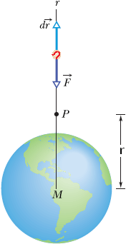
2. A projectile is fired vertically from Earth's surface with an initial speed of 4.4 km/s. Neglecting air drag, how far above the surface of Earth will it go?( M_{E} = 5.98 x 10²⁴kg, R_{E} = 6.37 x 10⁶ m)

3. Planet Roton, with a mass of 4.39 × 10²⁴ kg and a radius of 7000 km, gravitationally attracts a meteorite that is initially at rest relative to the planet, at a great enough distance to take as infinite. The meteorite falls toward the planet. Assuming the planet is airless, find the speed of the meteorite when it reaches the planet's surface.

