Spherical mirrors and lenses Remote Lab Name:____________________

Course:_______________Time:__________________Partners:____________________

For 1- 4, Since you will be sketching diagrams, just write the answers in paper and upload a picture in BB, unless you have a device where you can hand-write.

1. Watch the following video and answer the questions below:

<https://www.youtube.com/watch?v=R-uMcngNsSk>

1. Where do you find lenses?
2. Sketch the following lenses:

|  |  |
| --- | --- |
| Convex or Converging lens | Concave or Diverging lens |
|  |  |

1. Sketch a converging lens and show the following:  
   1. Optical center (O) 2. Principal axis 3. Aperture
2. What is a thin lens?
3. Using rays that are parallel to the principal axis and how they refract, show the focal point (F) and focal length (f) for the following, and identify the sign (real = + and virtual = -) for focal length:



1. What is the principle of reversibility of light?
2. What type of lens is in our eyes?

2. Watch the following video and answer the questions below:

<https://www.youtube.com/watch?v=plhECjM9-zQ&t=29s>

1. What object in the house can behave as a convex and concave mirror?
2. Sketch the following mirrors, identifying the coated and reflecting sides.

|  |  |  |
| --- | --- | --- |
| Plane mirror | Concave mirror | Convex mirror |
|  |  |  |

1. What is the angle of incidence for a light ray striking a plane mirror, perpendicular to the surface?  
    _______________________
2. Using rays that are parallel to the principal axis and how they reflect, show the focal point (F) and focal length (f) for the following, and identify the sign (real = + and virtual = -) for focal length:

|  |  |
| --- | --- |
| Concave or Converging mirror | Convex or Diverging mirror |
|  |  |

e. Using rays that are parallel to the principal axis, show how these rays get reflected from a plane mirror.   
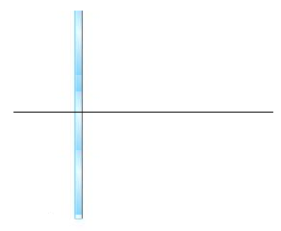  
Predict the focal length for a plane mirror. ______________

1. How are focal length (f) and the radius of curvature (R) are related for spherical mirrors?  
    ________________________________________

3. Theory: For a spherical mirror or thin lens (shown below), the focal length (*f*) is given by (*do* = object distance, *di* = image distance):

|  |  |
| --- | --- |
|  | lenson4 |

The object distance is from the object to the lens or mirror and the image distance is from the image to the lens or mirror.

Magnification, *m* is given by the following equations; (*Hi* = image height, *Ho* = object height). $m=\frac{H_{i}}{H_{0}}$

                    

Power (*P*) of a lens of focal length (*f*): $P=\frac{1}{f}$ 
 , *P* is in diopter (D) when f is in m.   
Eye prescriptions are written in diopter (D) for the power of the lenses. For the prescription shown below, both eyes need negative power (numbers under SPHERE) or focal length lens, which is a diverging or concave lens.

For the right eye, P = -2.0 = 1/f, so f = -1/2 m = -0.5 m = -50 cm.  
For the left eye, P = -2.5 = 1/f, so f = -1/2.5 m = -0.4 m = -40 cm.

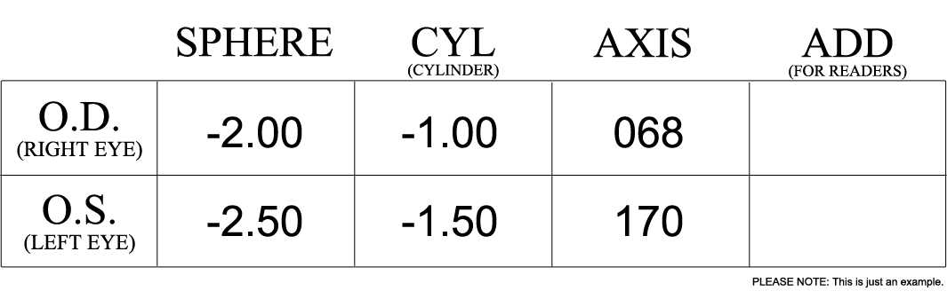

|  |  |  |
| --- | --- | --- |
| Sign Convention is summarized below: | | |
| Object & Image distances------> | Real--------> (+) | Virtual------> (-) |
| Focal Lengths----> | Convex lens🡪(+)  Concave mirror🡪(+) | Concave lens🡪 (-) Convex mirror🡪 (-) |

4. Draw rays to locate images for the following 6 cases.   
  
Watch the following video about how to draw ray diagrams for converging lens:

<https://us-lti.bbcollab.com/recording/22eed08cf9c04c77917258d61835a4c5>

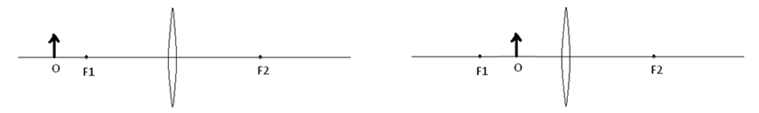

Watch the following video about how to draw ray diagrams for diverging lens:

<https://us-lti.bbcollab.com/recording/8613f81fac364e60a878c0bbed2ab961>

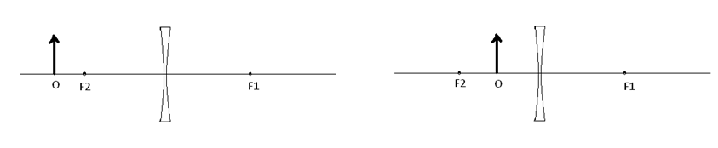

Watch the following video about how to draw ray diagrams for concave mirror:

<https://us-lti.bbcollab.com/recording/a7f3768a78274ca7afe155d3eb4cbc33>

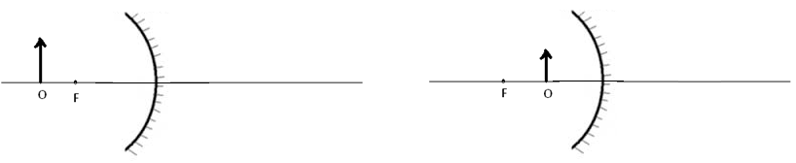

5. Visit the following simulation: (This section can be filled in electronically, including the data table in Excel)  
<https://www.physicsclassroom.com/Physics-Interactives/Refraction-and-Lenses/Optics-Bench/Optics-Bench-Refraction-Interactive>

Using the Interactive

The Optics Bench Interactive is shown in the iFrame, Lenses and Mirrors. There is a small hot spot in the top-left corner. Clicking/tapping the hot spot opens the Interactive in full-screen mode. Use the Escape key on a keyboard (or comparable method) to exit from full-screen mode.

1. Make the interactive full-screen mode. In the default setting, converging lens of focal length 20 cm will be chosen.
2. Move the object and determine the object distances for real images. Real image rays will be shown with solid lines and virtual image lines with broken lines.   
   ______________________________________________________________

Purpose: To investigate the magnifications of real images formed by a convex lens and determine the focal length. [You need to write a conclusion for this part only]

Apparatus: Above Simulation  
  
Procedure: Record the object height. Focal length is set at 20 cm. Change the object distance to 30 cm by moving the object and record the image distance and image height. Record the measurements for other object distances and complete the data table, including the calculated values.

DATA Object height = Ho = ______ Focal length = 20 cm.   
What is the power of this lens in diopter (D) =____________

|  |  |  |  |  |  |
| --- | --- | --- | --- | --- | --- |
| Measured values | | | Calculated values | | |
| Object  Distance, do (cm) | Image  Distance, di (cm) | Image Height, Hi (cm) | Focal Length, f (cm) | Magnification, m = Hi /Ho | Magnification, m = - di /do |
| 30 |  |  |  |  |  |
| 40 |  |  |  |  |  |
| 50 |  |  |  |  |  |
| 60 |  |  |  |  |  |
| 70 |  |  |  |  |  |
| 80 |  |  |  |  |  |

Also, plot a graph and obtain the focal length from the graph.