PHYS Lab on Spectra Name:______________________
1. Watch the following video and answer the questions below:
https://www.youtube.com/watch?v=jjy-eqWM38g
- What is light?

- How is the energy (E) of a photon of light related to its wavelength (λ)?

- What are spectra (plural for spectrum)?

- Expain the origin of light (or how light is produced)?

- Wavelength of light emitted by a body depends on the body’s _______________.

- Name three subatomic particles the atoms are made of?

- What is the analogy used for quantization of electron energy in the video?

- What is the key to the universe, according to the video?

- Name the device that measures the wavelength of light?_________________.

- What is Doppler effect?

- How do we know that the universe is expanding?

2. Energy levels of the electron of the hydrogen atom are shown below. Calculate and list the energy values, $E_{n}=-\frac{13.6}{n^{2}}$ eV, with the orbitals.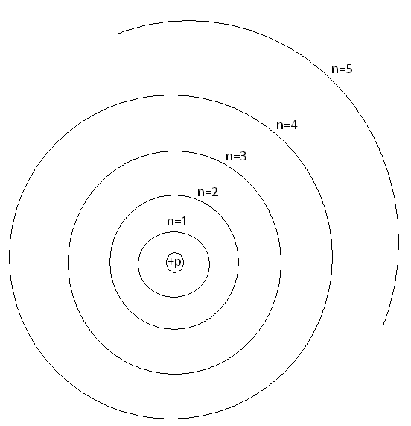
a. Watch this video for an understanding of electron transitions.
https://www.youtube.com/watch?v=wiINTUZoAiw
Identify one error made in the video____________________
b. Show the transitions of electron for the Lyman (Higher level1), Balmer (Higher level2), and Paschen (Higher level3) series in the above diagram.
c. A photon of light is emitted when the electron transitions to a lower energy. The wavelength (λ) of emitted light is given by:
$∆E=\frac{hc}{λ}$; h = 6.626x10⁻³⁴J.s and c = 2.998x10⁸m/s. 1eV=1.602x10⁻¹⁹J
1. Calculate the value of hc, in the unit eV.nm.

2. Calculate the 4 of the highest wavelengths (λ) of the Balmer series in nm, and enter them in the data table on page 4.

3. Visit this simulation: https://javalab.org/en/spectrum_of_hydrogen_en/
a. The simulation shows the light emission for the hydrogen atom. Make a note of the wavelength (λ), energy difference (ΔE), and energy levels involved for the light emitted.
λ = ____________ΔE = ____________Energy levels (E₁, E₂, etc) involved =_________
b. To find out the transitions to which electron orbit will result in the visible spectra:
Move Electron to get transition: | Wavelength (nm) | ΔE (eV) | Visible (Yes or No)
E₂ E₁
E₃ E₁
E₄ E₁
E₅ E₁
E₆ E₁
E₇ E₁
E₈ E₁
Move Electron to get transition: | Wavelength (nm) | ΔE (eV) | Visible (Yes or No)
E₃ E₂
E₄ E₂
E₅ E₂
E₆ E₂
E₇ E₂
E₈ E₂
E₉ E₂
Move Electron to get transition: | Wavelength (nm) | ΔE (eV) | Visible (Yes or No)
E₄ E₃
E₅ E₃
E₆ E₃
E₇ E₃
E₈ E₃
E₉ E₃
c. Go to Excel, and enter the wavelength, λ and absolute values of ΔE, $\left|∆E\right|$ values, for the visible spectrum. Also insert a column after the first column, and calculate 1/λ.
d. Plot $\left|∆E\right|$ versus 1/λ, determine the slope with unit. Slope = ______________
e. What is the theoretical value for the slope in the same unit?________________
f. Calculate the % difference for the above two values_______________________

4. Measuring the wavelengths using the Ocean Optics spectrometer:
Data for Balmer series of the H-spectrum:
Transition from | λ, calculated | λ, measured | %Difference | Intensity Count
3rd electron orbit to 2nd
4th electron orbit to 2nd
5th electron orbit to 2nd
6th electron orbit 2nd
a. Set up the fiber optic cable next to the hydrogen spectrum tube and turn on the tube.
b. Open the Ocean Optics program (OOIBase32, from desktop).
c. Click on the Toggle Cursor BUTTON (1st on right-top) to display the green vertical line (curser).
d. Click on a peak to move the cursor over the peak, use the arrow keys to align the cursor over the peak. Wavelength and intensity are read from the bottom-left corner.
e. Measure the wavelengths for the lines you observe. Record the measured values in the above data table, and calculate the %difference.
f. Adjust the position of the cable-head so that the intensity of the highest peak is close to the maximum count.
g. Click on the Global Snapshot button (3rd from top-left) and record the intensity counts for all the peaks.
5. Replace the hydrogen tube with the helium tube. Adjust the position of the cable-head so that the intensity of the highest peak is close to the maximum count.
Record the wavelengths and intensity counts for all the peaks of the helium spectrum.
DATA for He-spectrum:
Wavelength of the line | Intensity count of the line
6. Fluorescent light spectrum: Identifying peaks and measuring wavelength.
http://en.wikipedia.org/wiki/File:Fluorescent_lighting_spectrum_peaks_labelled.gif
Aim the fiber-optic cable at the ceiling light fixture, observe the spectrum of the fluorescent light bulb, and complete the following data table.
Peak Number | Wavelength of Peak (nm)
 | From wikipedia | Measured
1 | 405.4
2 | 436.6
3 | 487.7
4 | 542.4
5 | 546.5
6 | 577.7
7 | 580.2
8 | 584.0
9 | 587.6
10 | 593.4
11 | 599.7
12 | 611.6
13 | 625.7
14 | 631.1
15 | 650.8
16 | 662.6
17 | 687.7
18 | 693.7
19 | 708
20 | 712.3
21 | 760.0

