Name:_____________________________Date:_______________Time:____________
Partner(s):______________________________________Course:_________________
________________________________________________________________________
I. Pre-Lab on Oscilloscope:
1. Sketch V versus t graph of a DC signal, sine wave AC signal, and square wave AC signal below, inside the box.
DC signal | AC signal, sine wave | AC signal, square wave
------------------------------>t | ------------------------------>t | ------------------------------->t
2a. Look at the four AC signals and find out a distinguishing feature of alternating waves.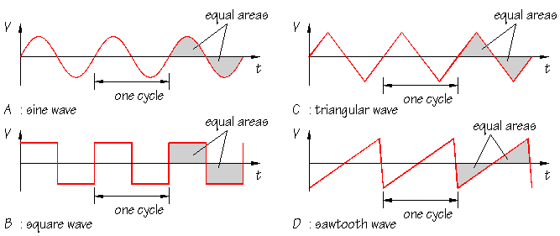
_____________________________________________________________________
_____________________________________________________________________
2b. What is the average voltage for the above signals?______________________
3. A sketch of V versus t graph of a sine wave AC signal is shown below. Also shown are the following: [https://en.wikipedia.org/wiki/Amplitude]
1. peak amplitude 2. peak-to-peak amplitude, 3. rms amplitude, and 4. period.
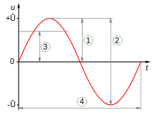
4. Define period and frequency of a wave:
Period:_______________________________________
Frequency:____________________________________
5. Write down the following equations:
a. Frequency in terms of period. _______________
b. rms amplitude in terms of peak amplitude._______________
6. Oscilloscope allows one to see signals, for example an ac signal:
An ac signal can be described with three properties; waveform, amplitude, and frequency. Instead of amplitude, peak-to-peak value or rms (root-mean-square) value can also be used. Describe the above three properties of the wall-outlet signal below:
a. ___________________ b. ____________________ c. ______________________
7. For the waves shown below, determine peak-to-peak value, amplitude, period, and frequency.
Peak-to-peak value: Measure the vertical divisions from trough to crest and multiply it by the VOLTS/DIV setting. Peak value is half the peak-to-peak value.
Period: Measure the horizontal divisions from one crest (or trough) to the next and multiply it by the TIME/DIV setting.
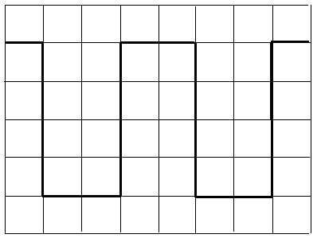 | 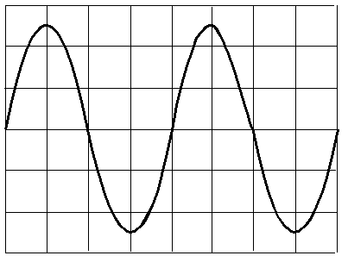
volt/div = 0.5V, time/div = 2 ms | volt/div = 2V, time/div = 1 µs
 | Sq. Wave | Sine Wave
1. The peak-to-peak amplitude of the signal
2. The peak amplitude of the signal
3. The period of the signal in second
4. The frequency of the signal in Hz
II. Purpose: To become familiar with the operation of an oscilloscope and to use it to investigate ac signals.
Apparatus: Oscilloscope, probe, function generator, AMPROBE digital multimeter , and an ac-adapter.
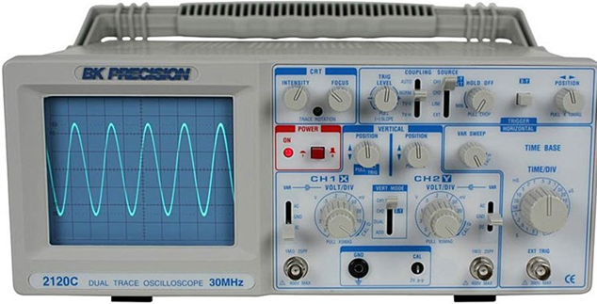
Theory: f = 1/T; peak amplitude = (peak-to-peak amplitude)/2, and rms amplitude = (peak amplitude)/1.414.
Calibration check of the oscilloscope:
- In the oscilloscope, set the input to GND (ground) and connect the scope-probe to the calibration signal of the scope.
- Turn on the scope, and you should see a horizontal trace, if you cannot see the horizontal trace call the instructor.
- Adjust the position controls and center the trace.
- Move the input from GND to AC, now you should see a square wave signal.
- Measure the peak-to-peak value and the period of the signal and complete the data table, II1.
AC-adapter:
- Write down the listed output voltage properties on the ac-adapter.
- Measure the output voltage with a digital multimeter.
- Connect the ac-adapter wires, white to red and black to black, to the oscilloscope probe and plug in the adapter. Measure the peak-to-peak value and the period of the signal and complete the data table, B2.
Function Generator:
- Connect the function generator, 50Ω Out Put, to the scope-probe wires. (Red to Red and Black to Black).
- Set the frequency to 1000 Hz and select sine wave.
- Measure the peak-to-peak value, determine the amplitude, and complete the data table B3.
- Set the amplitude to max, measure the period, and complete the data table B4.
DATA
II1. Calibration check:
1. The peak-to-peak amplitude of the signal |  | Are your measured values match the values listed on the front of the scope?__________  (If not call the instructor)
2. The peak amplitude of the signal
3. The period of the signal in second
4. The frequency of the signal in Hz
II2. Signal from an ac-adapter:
Listed values: Output voltage = ____________________ Frequency = __________
Measured values with a DMM: Output voltage = _______Frequency = _______
1. The peak-to-peak amplitude of the signal
2. The peak-amplitude of the signal
3. The rms value of the signal
4. The period of the signal in second
5. The frequency of the signal in Hz
Digital multimeters measure which one of the following amplitudes?________
a. peak amplitude b. peak-to-peak amplitude c. rms amplitude
II3. Function Generator: Change the amplitude for a constant frequency.
Frequency = 1000 Hz, Sine wave.
Amplitude from front dial of the function generator | From scope display readings
 | peak-to-peak amplitude | Peak-amplitude
min
1/4 turn
1/2 turn
3/4 turn
max
II4. Change the frequency for constant amplitude. Amplitude = max, Sine wave.
Frequency from the function generator display (Hz) | From Scope Display Readings
 | Period | Period (sec) | Frequency (Hz)
100
1000
10,000
100,000
500,000
1000,000
III. Purpose: To measure the inductance (L) of an inductor coil using the resonance of R-L-C circuit.
Apparatus: Oscilloscope, probe, function generator, inductor coil, resistance box, capacitance box, AMPROBE digital multimeter, and connecting wires.
Theory: Visit this RLC resonance applet using internet explorer browser and answer the following questions:
1. What is R?______________What is C?______________What is L?_______________
2. In this RLC circuit R, L, C, and the signal source are connected in______________.
3. Reactance of L is X_{l} and reactance of C is X_{c}. Change the frequency, f and describe what happens to X_{l} and X_{c} as the frequency is changed.
_________________________________________________________________________
4. Set C = 50 nF and keep L = 80 H. What is the resonance frequency, f₀ =_________
5. Change R and describe, what happens to the resonance peak?
_________________________________________________________________________
6. Set C = 50 nF and R = 5 kohm. Change L and describe what happens to the resonance peak?
______ ______ __________________________________________________________
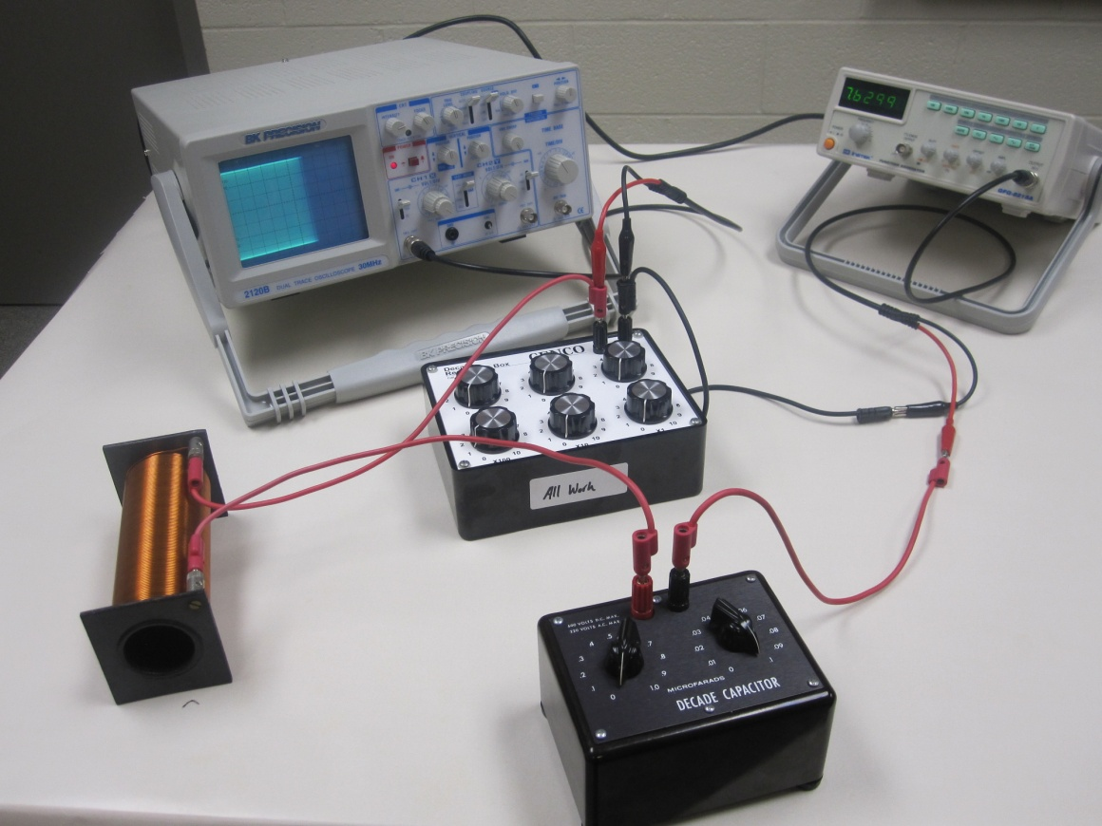
For a series R-L-C circuit, the resonance frequency (f) is given by, where L = inductance and C = capacitance; (Unit of inductance is Henry, H)
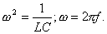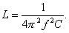
Procedure:
1. Measure the inductance, L of the solenoid by directly connecting it to the AMPROBE digital multimeter.
2. Set up the above circuit with R= 100 ohm, C = 0.1 µF, and Function Generator: sinewave, 10k, max AMPL.
a. First connect the following in series: function generator, decade capacitor, inductor coil (solenoid), and decade resistance box.
b. Then, connect the oscilloscope across the decade resistance box.
c. Make sure to keep the common ground.
3. Vary the frequency until the signal in the scope display is a maximum. This will happen at the resonance.
4. Record the resonance frequency (f) from the function generator, calculate L, and complete the data table.

Capacitance, C (µF) | Resonance frequency from function generator display, f (kHz) | Inductance, L (H)
L from AMPROBE Digital Multimeter
0.1
0.08
0.06
0.05
0.03
0.01
Average Inductance, L from Resonance
% Difference
5. Keep C = 0.01 µF. Measure the peak-to-peak voltage across the resistance, V_{ptp} as a function of frequency, for 5 kHz, 10 kHz, 15 kHz, 18 kHz, 20 kHz, 23 kHz, 25 kHz, 27 kHz, 30 kHz, 35 kHz, 40 kHz, 45 kHz, and 50 kHz.
Frequency (kHz) | V_{ptp} (volt)
5
10
15
18
20
23
25
27
30
35
40
45
50
6. Tabulate your data in excel and make an X-Y scatter plot V_{ptp} versus f, with a smooth line connecting data points, and see whether the resonance peak agrees with the data from Procedure-4 above.
________________________________________________________
Resonance peak frequency from V_{ptp} versus f plot: =_________________
Attach your plot and write a conclusion for III.

