PHYS 202L RESISTANCE Name:________________________
Partner(s):_______________________________________________________________
Purpose I: To investigate the resistance of metal wires and determine the resistivity.
Apparatus: Resistance apparatus, metal wires: nichrome and stainless steel, galvanometer sensor, digital multimeter, and banana-plug wires (1-black and 2-red).
Theory: Resistance, R of a metal wire of length L and cross-sectional area A is given by:
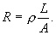 where, ρ is the resistivity.
According to Ohm’s law, $V=IR$ or $V=I\frac{ρL}{A}$ or $V= \frac{Iρ}{A}L$
The plot of V versus L will yield a slope of Iρ/A. Knowing A and I, the resistivity can be determined.
The plot of V versus A, will yield a curve. Knowing L and I, the resistivity can be determined, using an appropriate fit.
Procedure:
Wire Installation
- On the Resistance Apparatus, move the Reference Probe and the Slider Probe to the Park position. The probes should be as far left and right respectively as possible so the probe lifts up to allow installation of the sample wire. They will click into position.
- Turn the two black handles counterclockwise to open the clamps to allow the sample wire to slide into position.
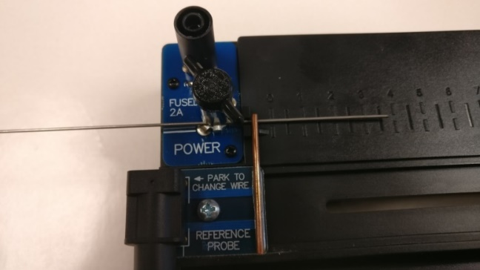
- Install the nichrome wire in the apparatus. Slide from left or right using the white line-up hash marks. Figure below shows the left hand side as the wire slides in. Note that on the right hand side, the wire is on the far side of the silver clamp (with black handle), but on the left hand side the wire will be on the near side of the clamp as shown. This prevents the wire from bowing as you tighten the clamps.
- Tighten the clamps by turning the black handles clockwise.

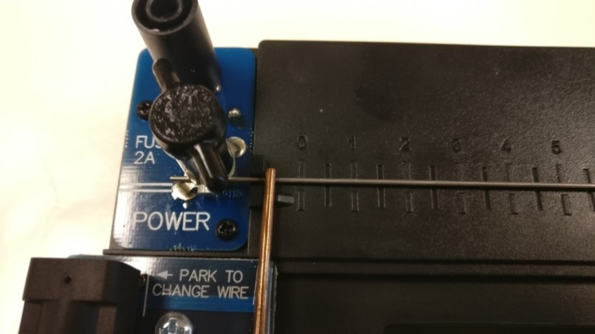 | 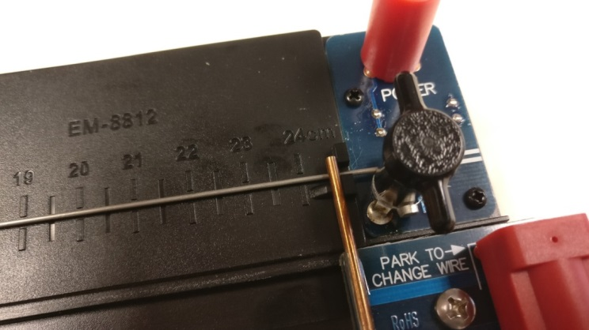

Length dependence
- Set up the following circuit and have the construction checked by instructor. Turn on the power to the interface. DMM set to measure DC current upto 10A, connected using COM and 10A. Connect the + from the interface to the + 10A of the DMM.
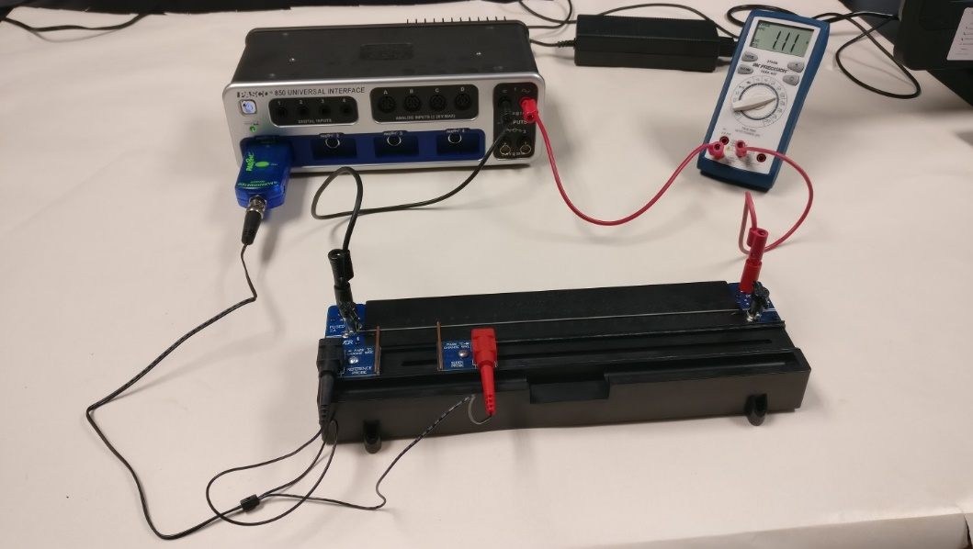
- Position the reference probe (black) at the 0 cm mark and the slider probe (red) at the 4 cm mark.
- The ammeter should read zero now. TARE the galvanometer sensor.
- Open PASCO Capstone from the desktop.
- Click “Hardware setup” under tools on the left and make sure that the interface is identifying the Galvanometer sensor.
- Click “Hardware setup” again to close it.
- Open “Table/Graph” display, first one. On the first column, click “Select Measurement”, choose “Create New”, and select “User-Entered data”. Enter Length (cm) for this column as title, and enter the values 4, 8, 12, 16, 20, and 24.
- Click “Continuous Data” in the bottom, and choose “Keep Mode”.
- Choose the second column for “Voltage (V)”.
- Click “Signal Generator”, under tools on the left, choose DC waveform, and set the current limit to 1.1 A.
- Click “On”, now the DMM should read the current.
- Record the current, I from the DMM, in the data table below.
- Click “Signal Generator” again to close it.
- Click “Preview” on the bottom, voltage data will be displayed, increase the voltage data digits to 4.
- Click “Keep Sample” to collect the voltage data for the length, 4 cm.
- Change the length to 8 cm, collect the voltage data, and continue this for other lengths.
- Stop the data collection.
- Maximize the graph display, high-light the data, and find the slope.
- Copy and save the graph.
- Measure the diameter of the wire with a micrometer, calculate the cross-sectional area, and calculate the resistivity of the metal.
- Repeat the measurements for stainless steel and thin brass, and complete the data table.
Area Dependence
- For the thin brass wire (smallest area) keep the length at 24 cm.
- Click “Preview” again, change the first column to Area (cm²), and enter the following areas of brass wires: 0.00203, 0.00519, 0.00811, and 0.0127.
- Click the first column of the Voltage data.
- Click “Keep Sample” to collect the voltage data for the thinnest brass wire.
- Record the current, I from the DMM, in the data table below.
- Change the wire to the next thinnest, collect the voltage data, and continue this for other brass wires. Altogether 4 wires.
- Stop the data collection.
- Maximize the graph display, high-light the data, fit the data with an appropriate curve, and determine the resistivity.
- Copy and save the graph.
- Write a conclusion for purpose I only.

DATA: Length dependence
slope = Iρ/A $ρ=\frac{slope ×A}{I}$
Wire Type | Diameter (cm) | Cross-Sectional Area (cm²) | I (A) | Slope (V/cm) | Resistivity, ρ (µΩ.cm)  Measured | Resistivity, ρ (µΩ.cm)  Accepted | % Error
Nichrome |  |  |  |  |  | 110
Stainless Steel |  |  |  |  |  | 80
Brass (Thin) |  |  |  |  |  | 7.3

DATA: Area Dependence
Current = I = ___________ Length = 24 cm
Coefficient of the fit = ____________________
Measured resistivity for brass = _______________
Conclusion:
Purpose II: To investigate various combinations of resistors.
Apparatus: Three resistors, DMM (digital multi meter), and 5-banana plug wires.
Theory: When two or more resistances are connected in series the equivalent resistance, R_{S} is given by;
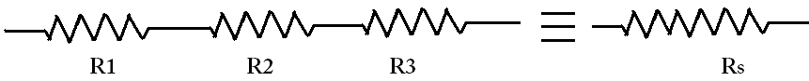
When two or more resistances are connected in parallel the equivalent resistance, R_{P} is given by:
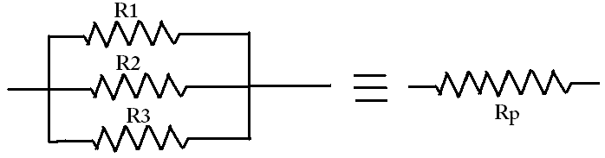
Procedure:
1. Determine the values of the three resistors using the resistor color code.
2. Measure the values of the three resistors using the digital multimeter (DMM).
3. Observe the tolerance values and record them in the data table.
 | R₁ | R₂ | R₃
From resistor color code
From digital multi- meter
Tolerance
4. Connect R₁ and R₂ in series and measure the equivalent resistance. Also calculate it.
5. Connect R₁ and R₂ in parallel and measure the equivalent resistance. Also calculate it.
Diagram | Measured | Calculated
R₁ and R₂ in series:
R₁ and R₂ in parallel:
6. Rank the values of R₁, R₂, R₁ series R₂, R₁ parallel R₂ in descending order:

7. Connect the three resistors in various combinations and obtain various values of resistances. Measure the equivalent resistances. Also calculate the equivalent resistances using the measured values for R₁, R₂, and R₃.
8. Identify the lowest and highest resistance values in the table.
Resistor combination diagram | Resistance Values
 | Measured | Calculated

