PHYS 202L RESISTANCE Name:________________________
Partner(s):_______________________________________________________________
Purpose I: To investigate the resistance of a metal wire using a digital multi meter (DMM).
Apparatus: DMM, one long metal (nichrome) wire (≈100 cm), connector box, micrometer, and meter stick.
Theory: Resistance, R of a metal wire of length L and cross-sectional area A is given by:
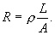
The plot of R versus L will yield a slope of ρ/A. Knowing A, the resistivity can be determined.
Procedure:
Variation of resistance with length:
- Set the DMM to measure resistances and connect it to the connector box.
- Connect one end of the long metal wire to one of the terminals of the connector box.
- Measure 10 cm length of wire, (do not cut the wire) and connect it to the other terminal so that there is exactly 10 cm of wire between the terminals.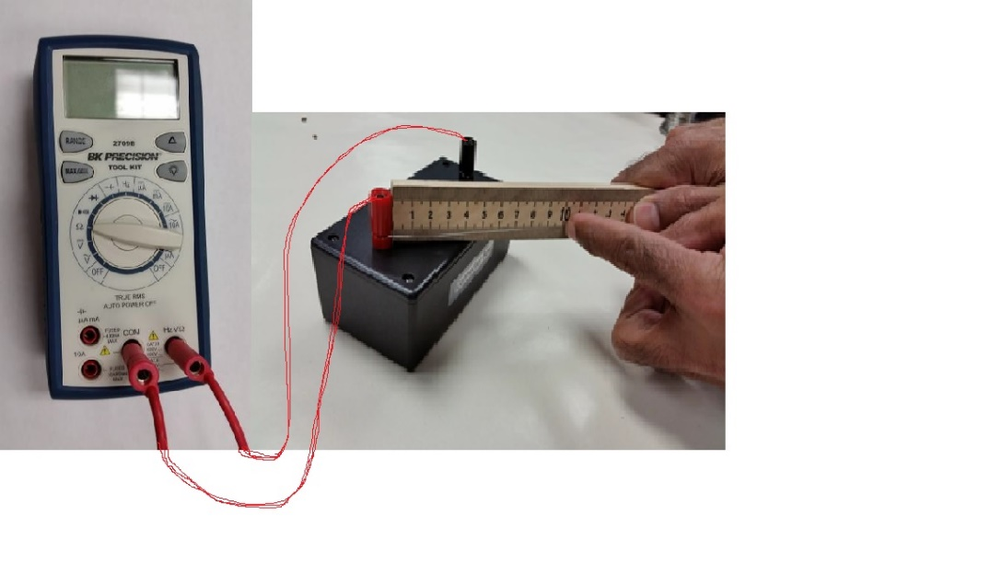
- Record the resistance value and repeat the above procedure for other lengths: 20, 30, 40, 50, 60, 70, 80, 90, 100 cm.
- Plot a graph, R versus L, determine its slope, and attach the graph to your report.
- Measure the diameter of the wire with a micrometer, calculate the cross-sectional area, and calculate the resistivity of the metal.
Variation of resistance with diameter:
- Fold the wire into half and then again half to make 4 equal pieces.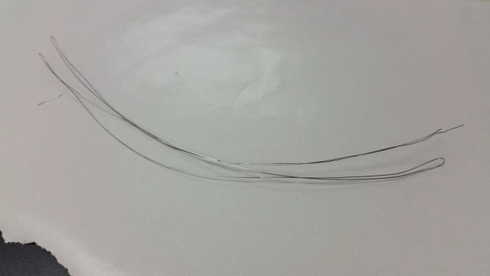 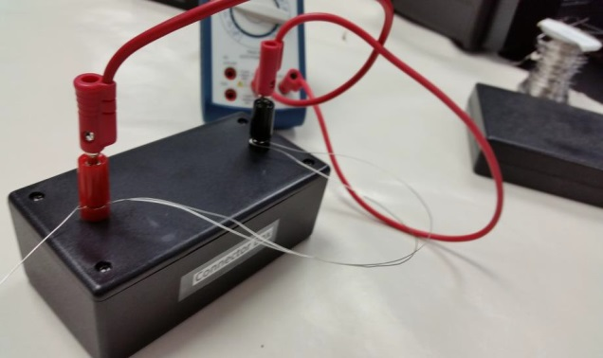
- Measure the resistance of one fold, two folds, three folds, and four folds.
- Tabulate your data, plot an appropriate graph, and see what happens.
- Add an appropriate trend line, and obtain resistivity from your fit.
- Attach your graph to the report.
DATA
Variation of resistance with length:
Slope of R versus L, graph:_________________
Diameter of wire = __________________ Cross-Sectional area of wire =________________
Experimental resistivity of wire = _________________
Accepted resistivity of wire = 1.00 x 10⁻⁴ ohm.cm. % Error = __________________
Variation of resistance with diameter:
Slope or Coefficient of the fit = _________________
Length of wire = __________________ Cross-Sectional area (for 1 fold) =_______________
Experimental resistivity of wire = _________________
Accepted resistivity of wire = 1.00 x 10⁻⁴ ohm.cm.
% Error = __________________
Write Conclusion for Purpose I.

Purpose II: To investigate various combinations of resistors.
Apparatus: Three resistors, DMM (digital multimeter), and 5-banana plug wires.
Theory: When two or more resistances are connected in series the equivalent resistance, R_{S} is given by;
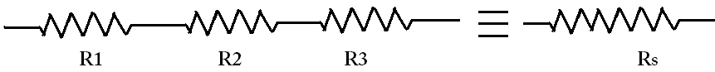
When two or more resistances are connected in parallel the equivalent resistance, R_{P} is given by:
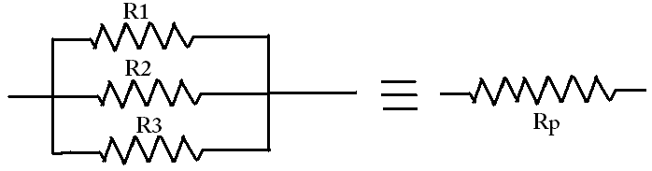
Procedure:
1. Determine the values of the three resistors using the resistor color code.
2. Measure the values of the three resistors using the digital multimeter (DMM).
3. Observe the tolerance values and record them in the data table.
 | R₁ | R₂ | R₃
From resistor color code
From digital multi- meter
Tolerance
4. Connect R₁ and R₂ in series and measure the equivalent resistance. Also calculate it.
5. Connect R₁ and R₂ in parallel and measure the equivalent resistance. Also calculate it.
Diagram | Measured | Calculated
R₁ and R₂ in series:
R₁ and R₂ in parallel:
6. Rank the values of R₁, R₂, R₁ series R₂, R₁ parallel R₂ in descending order:

7. Connect the three resistors in various combinations and obtain various values of resistances. Measure the equivalent resistances. Also calculate the equivalent resistances using the measured values for R₁, R₂, and R₃.
8. Identify the lowest and highest resistance values in the table.
Resistor combination diagram | Resistance (R) Values |  | Rank the R values from High to Low
 | Measured | Calculated

