PHYS 202L Reflection and Refraction Name:___________________________________
Partner(s):__________________________________________________Day/Time:__________
Activity: Determine the relationship between plane mirror size and object size for full view of the object.
Apparatus: Plane mirror.
Theory: (Image from OpenStax, College Physics)
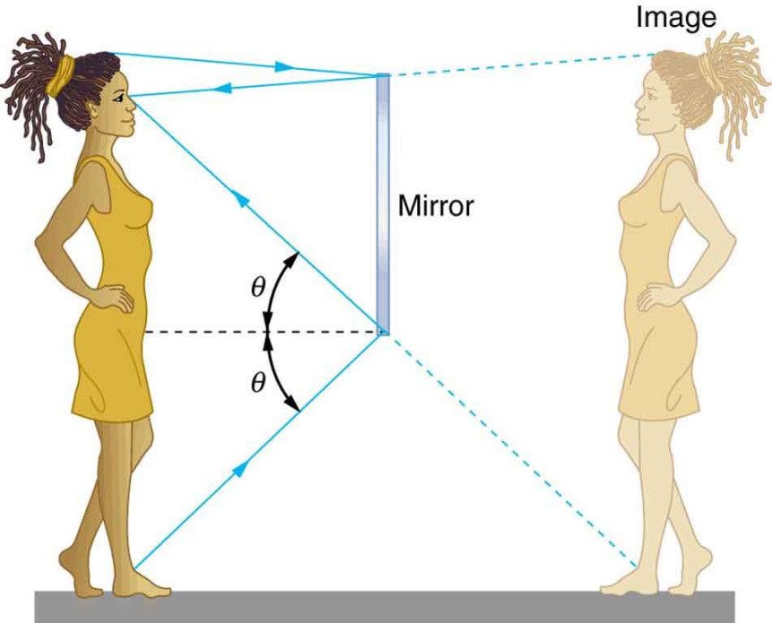
a. Measure the size, length or width, of the plane mirror.______________
b. Hold the plane mirror vertically and see your face, and measure the size of your face as seen in the mirror. ________________
c. Predict a relationship between mirror size and object size in mirror. _____________________
d. What minimum size mirror necessary to see the entire body of a person whose height is 6 feet. ________________
e. Does the above answer depend on how far you keep the mirror?________________
f. Write down the following three properties of the image in a plane mirror:
1. Magnification
2. Upright or Inverted
3. Real or Virtual
Purpose: Verify the law of reflection and the law of refraction and determine the index of refraction of glass and water.
A. Reflection: Plane Mirror
Apparatus: Two plane mirrors, white sheets of paper, an object, and Reflect/View red-mirror.
θ (degrees) | # of images
180
(use one mirror)
120
90
72
60
51.4
45

1. Determining the number of images for two plane mirrors kept at a
particular angle (θ) between them. For θ = 90⁰ is shown below, with
three images.
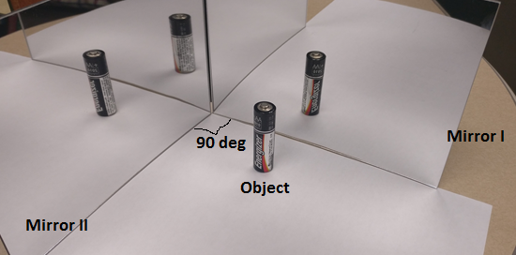
Predict a formula for the number of images in terms of the angle (θ) between two plane mirrors:
# of images = _____________________________
2. Determining the image distances, given the object distances: Draw a line in the middle of the paper, and mark objects at 2, 4, 6, 8, 10 cm. Place the Reflect/View red-mirror along the line, the writings of Reflect/View facing you, and locate the images. Remove the mirror and measure the image distances, and record them in the data table below.
Reflect/View red-mirror
Object Distance (cm) | Image Distance (cm)
2
4
6
8
10

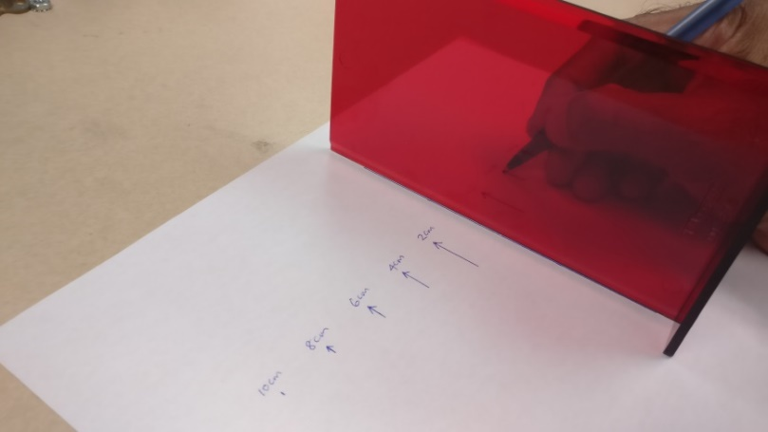

B. The law of reflection: (Image from OpenStax, College Physics).
The law of reflection says that the angle of incidence is equal to the angle of reflection.
θ_{i} = θ_{r}.
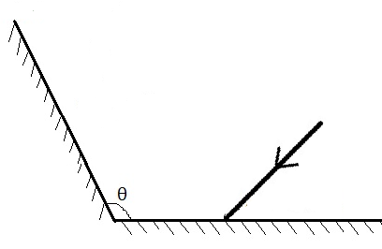
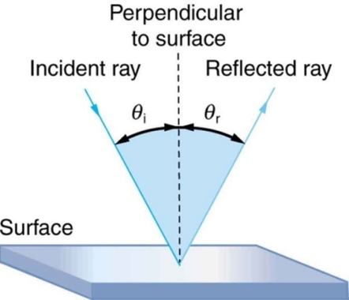
In the above figure a ray of light is striking the mirror with an angle of incidence of 35⁰. Θ = 110⁰. What will be the angle of reflection on the second mirror?
- Attach a sheet of white paper to the cardboard using thumb tacks.
- Draw a line near the middle-top of the paper.
- Use the protractor and draw the incident ray for a particular incident angle which is the angle between the incident ray and normal.
- Use the rubber band to hold the mirror to the wooden block.
- Set the mirror (with the wooden block) on the paper so that the reflecting surface is along the line.

θ_{i} (degree) | θ_{r} (degree)
20
40
60
80

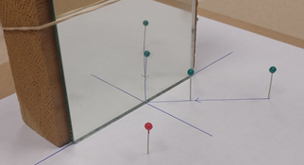

- Place two pins (green) along the incident ray.
- Place the red pin so that the two images of the green pins and the red pin lines up.
- Draw the reflected ray and measure the angle of reflection, which is the angle between the reflected ray and normal.
- Repeat the above procedures for other incident rays, and complete the data table.
- Attach your worksheet(s) with your partner’s names to the lab-handout.
- Look at your data and state whether the law of reflection is verified or not in your conclusion.
C. Law of Refraction (Snell’s Law):
When light travels from a material with refractive index n₁ into a material with refractive index n₂ the refracted ray, the incident ray, and the normal lie in the same plane. The angle of refraction θ₂ is related to the angle of incidence θ₁ by:
n₁ sin θ₁ = n₂ sin θ₂
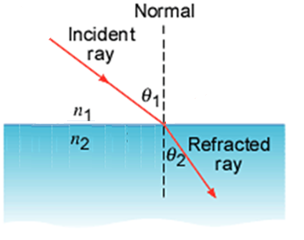
1. Index of refraction of a glass plate
a. Attach a sheet of white paper to the cardboard using thumb tacks.
b. Lay the glass plate on the paper, draw the outline, and remove the glass plate.
c. Draw a line (RN) normal to one of the wider sides of the glass plate using a protractor.
d. Draw lines RA, RB, and RC such that the angles ARN = 35⁰, BRN = 45⁰, and CRN = 55⁰.
e. Place the glass plate and stick pins at R and A, vertically. Sighting through the opposite side and through the glass, place a pin A’, adjacent to the face of the block, so that it is aligned with pins at R and A.
f. Mark and label the locations of the pins.
g. Repeat the above procedures for other incident angles, and complete the data table.
h. Attach your worksheet(s) with your partner’s names to the lab-handout.
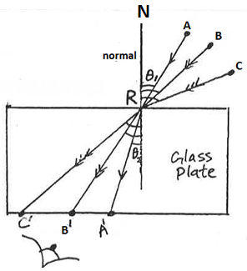
n₁ = 1 for air, n₂ = n = index of refraction of glass
 | θ₁ | θ₂ | n
ARA’
BRB’
CRC’
Average
Accepted |  |  | 1.52
% Error

2. Index of refraction of water
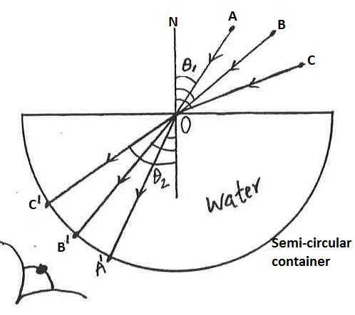
a. Attach a sheet of white paper to the cardboard using thumb tacks.
b. Lay the semicircular container in the middle, on the paper and draw the outline, mark the center O of the diameter, and remove the container.
c. Draw a line (ON) normal to the diameter as shown using a protractor.
d. Draw lines OA, OB, and OC such that the angles AON = 35⁰, BON = 45⁰, and CON = 55⁰.
e. Place the container and fill it with water.
f. Stick pins at O and A, vertically. Sighting through the circular side and through the water, place a pin A’, adjacent to the circular face, so that it is aligned with pins at O and A.
f. Mark and label the locations of the pins.
g. Repeat the above procedures for other incident angles, and complete the data table.
h. Attach your worksheet(s) with your partner’s names to the lab-handout.
 | θ₁ | θ₂ | n
AOA’
BOB’
COC’
Average
Accepted |  |  | 1.33
% Error

D. Prism glass plate: Minimum Deviation
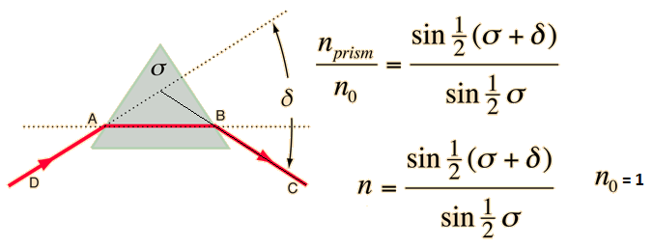
http://hyperphysics.phy-astr.gsu.edu/hbase/geoopt/prism.html
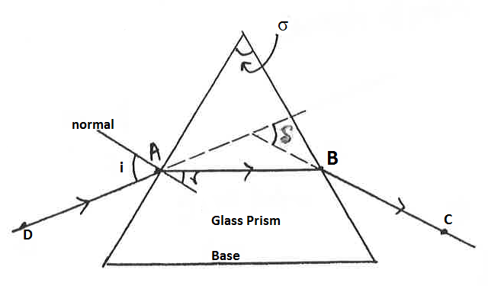
- Attach a sheet of white paper to the cardboard using thumb tacks.
- Lay the glass prism on the paper and draw the outline.
- Remove the prism and draw the line AB parallel to the base.
- Place the prism back and stick pins vertically at A and B.
- Sighting through one side, through the glass, place pins C and D so that all four pins are aligned. Mark and label the pins.
- Trace the ray DABC, measure the apex angle σ and minimum deviation δ, and calculate the index of refraction, n.___________________________
- Draw a normal at A, measure i and r, calculate n. using Snell’s law. ________________
- Attach your worksheet(s) with your partner’s names to the lab-handout.
- Write an overall conclusion for the purpose on page 2.

