PHYS 202L Reflection and Refraction Name:___________________________________
Partner(s):__________________________________________________Day/Time:__________
A. Reflection: Plane Mirror
1. Determining the number of images for two plane mirrors kept at a particular angle (θ) between them. For θ = 90⁰ is shown below, with three images.
θ (degrees) | # of images
180
(use one mirror)
120
90
72
60
51.4
45

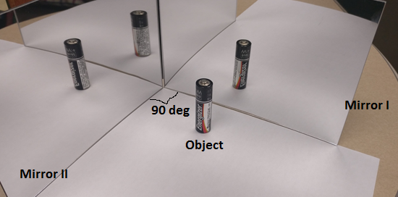

Predict a formula for the number of images in terms of the angle (θ) between two plane mirrors:
# of images = _____________________________

2. Determining the image distances, given the object distances: Draw a line in the middle of the paper, and mark objects at 2, 4, 6, 8, 10 cm. Place the Reflect/View red-mirror along the line, the writings of Reflect/View facing you, and locate the images. Remove the mirror and measure the image distances, and record them in the data table below.
Reflect/View red-mirror
Object Distance (cm) | Image Distance (cm)
2
4
6
8
10

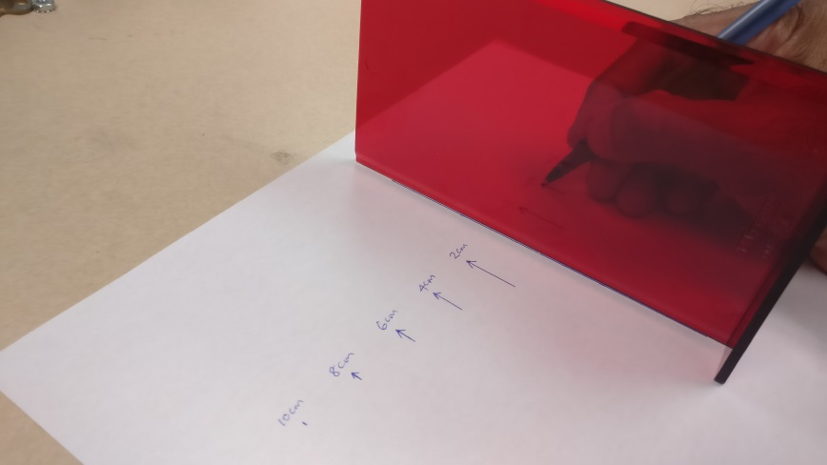
3. Plane mirror size and object size relationship: (Image from OpenStax, College Physics).
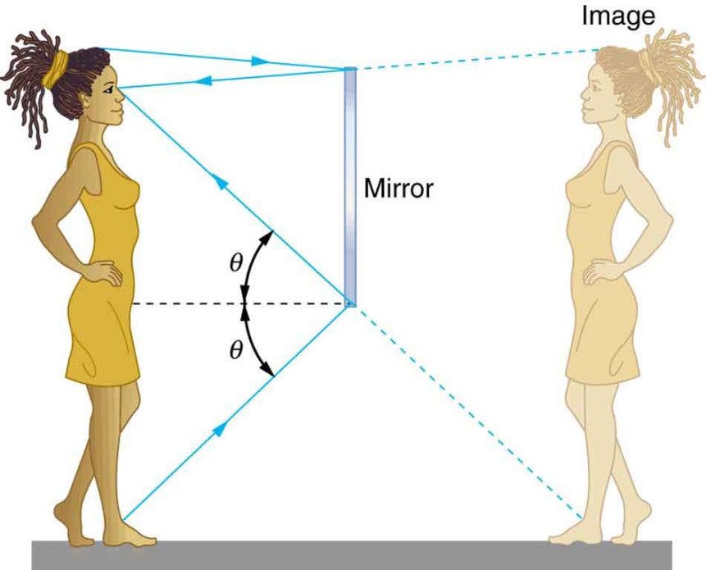
a. Measure the size, length or width, of the plane mirror.______________
b. Hold the plane mirror vertically and see your face, and measure the size of your face as seen in the mirror. ________________
c. Predict a relationship between mirror size and object size in mirror. _____________________
d. What minimum size mirror necessary to see the entire body of a person whose height is 6 feet. ________________
4. The law of reflection: (Image from OpenStax, College Physics).
The law of reflection says that the angle of incidence is equal to the angle of reflection.
θ_{i} = θ_{r}.
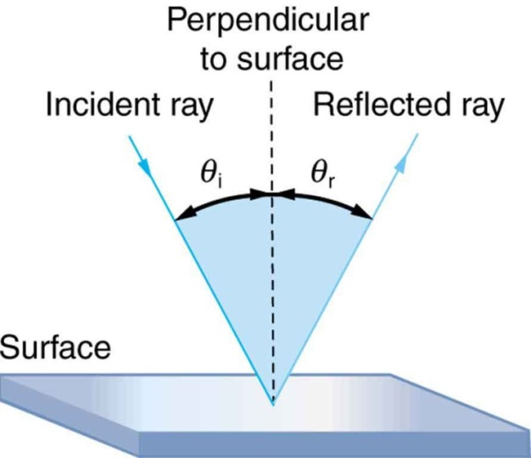
- Attach a sheet of white paper to the cardboard using thumb tacks.
- Draw a line near the middle-top of the paper.
- Use the protractor and draw the incident ray for a particular incident angle which is the angle between the incident ray and normal.
- Use the rubber band to hold the mirror to the wooden block.
- Set the mirror (with the wooden block) on the paper so that the reflecting surface is along the line.

θ_{i} (degree) | θ_{r} (degree)
20
30
40
50
60
70
80

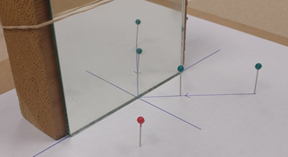

- Place two pins (green) along the incident ray.
- Place the red pin so that the two images of the green pins and the red pin lines up.
- Draw the reflected ray and measure the angle of reflection, which is the angle between the reflected ray and normal.
- Repeat the above procedures for other incident rays, and complete the data table.
- Attach your worksheet(s) with your partner’s names to the lab-handout.

- Look at your data and state whether the law of reflection is verified or not?
_________________________________________________________________
_________________________________________________________________

B. Law of Refraction (Snell’s Law) :
When light travels from a material with refractive index n₁ into a material with refractive index n₂ the refracted ray, the incident ray, and the normal lie in the same plane. The angle of refraction θ₂ is related to the angle of incidence θ₁ by:
n₁ sin θ₁ = n₂ sin θ₂
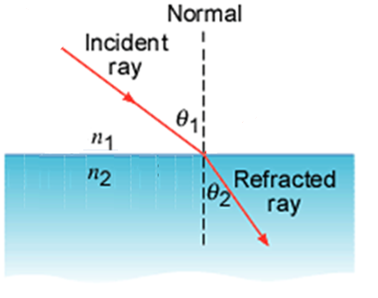
1. Index of refraction of a glass plate
a. Attach a sheet of white paper to the cardboard using thumb tacks.
b. Lay the glass plate on the paper, draw the outline, and remove the glass plate.
c. Draw a line (RN) normal to one of the wider sides of the glass plate using a protractor.
d. Draw lines RA, RB, and RC such that the angles ARN = 35⁰, BRN = 45⁰, and CRN = 55⁰.
e. Place the glass plate and stick pins at R and A, vertically. Sighting through the opposite side and through the glass, place a pin A’, adjacent to the face of the block, so that it is aligned with pins at R and A.
f. Mark and label the locations of the pins.
g. Repeat the above procedures for other incident angles, and complete the data table.
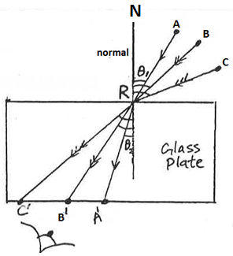
n₁ = 1 for air, n₂ = n = index of refraction of glass
 | θ₁ | θ₂ | n
ARA’
BRB’
CRC’
Average
Accepted |  |  | 1.52
% Error

2. Index of refraction of water
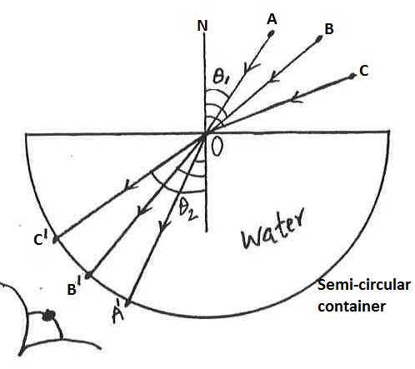
a. Attach a sheet of white paper to the cardboard using thumb tacks.
b. Lay the semicircular container in the middle, on the paper and draw the outline, mark the center O of the diameter, and remove the container.
c. Draw a line (ON) normal to the diameter as shown using a protractor.
d. Draw lines OA, OB, and OC such that the angles AON = 35⁰, BON = 45⁰, and CON = 55⁰.
e. Place the container and fill it with water.
f. Stick pins at O and A, vertically. Sighting through the circular side and through the water, place a pin A’, adjacent to the circular face, so that it is aligned with pins at O and A.
f. Mark and label the locations of the pins.
g. Repeat the above procedures for other incident angles, and complete the data table.
 | θ₁ | θ₂ | n
AOA’
BOB’
COC’
Average
Accepted |  |  | 1.33
% Error

D. Prism glass plate: Minimum Deviation
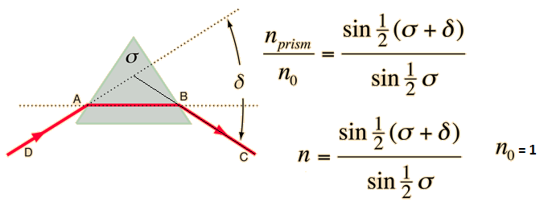
http://hyperphysics.phy-astr.gsu.edu/hbase/geoopt/prism.html
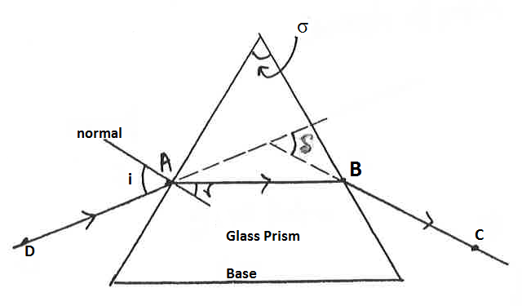
- Attach a sheet of white paper to the cardboard using thumb tacks.
- Lay the glass prism on the paper and draw the outline.
- Remove the prism and draw the line AB parallel to the base.
- Stick pins at A and B.
- Sighting through one side, place pins C and D so that all four pins are aligned, through the glass. Mark and label the pins.
- Trace the ray diagram, measure the apex angle σ and minimum deviation δ, and calculate the index of refraction, n.___________________________
- Draw a normal at A, measure i and r, calculate n. ___________________________
- Write an overall conclusion for the entire lab.

