Joule's Law and Heat Transfer Name: ________________________
Partner(s):___________________________________________________________
A. Joule's equivalent of heat
Purpose: To measure the Joule's equivalent of heat by the electrical method.
Apparatus: PC and interface, temperature sensor, heating-coil, power supply (PS3010U), calorimeter: jacket and cup, electronic balance, cold-water (<20ºC), ice, and banana-plug wires (Red and Black).
Theory: We will use electrical energy to heat a certain amount of cold-water. Electrical energy is measured in Joules and heat is measured in calories. In this activity we will look at a version of Joule's experiment, which gives a relationship between calorie and Joule.
To do this we need to measure the amount of electrical energy we supply and the amount of heat energy the water, calorimeter-cup, and heater gains. Neglecting heat loss to the room, we could find the relationship between calorie and Joule.
Electrical energy, E is given by: E = IVt; where I = current, V = voltage, and t = time.
Thermal energy or Heat gained, Q is given by: Q = M_{w}C_{w}ΔT + M_{c}C_{c}ΔT +M_{h}C_{h}ΔT;
where M_{w} is the mass of water, C_{w} is the specific heat of water, M_{c} is the mass of the calorimeter cup, C_{c} is the specific heat of the calorimeter cup, M_{h} is the mass of the heater, C_{h} is the specific heat of the heater, and ΔT is the change in temperature.
Joule's equivalent of heat, J is given by; J = E/Q.
Procedure:
- Find the mass of the calorimeter cup, and fill it with cold tap-water (<20ºC) about 4/5 full, and find the mass of the cup with water.
- Place the calorimeter cup inside the jacket, immerse the heater coil in the water, immerse the temperature sensor in the water, and connect the temperature sensor to analog input A of the interface. Make sure that the power for the interface is turned on.
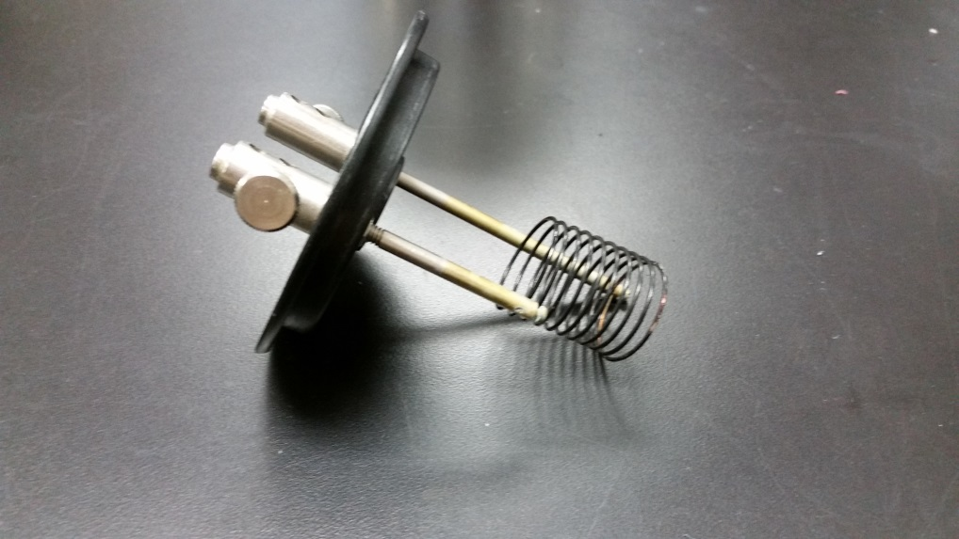
- Turn on the power supply and set the voltage to about 5 volt.
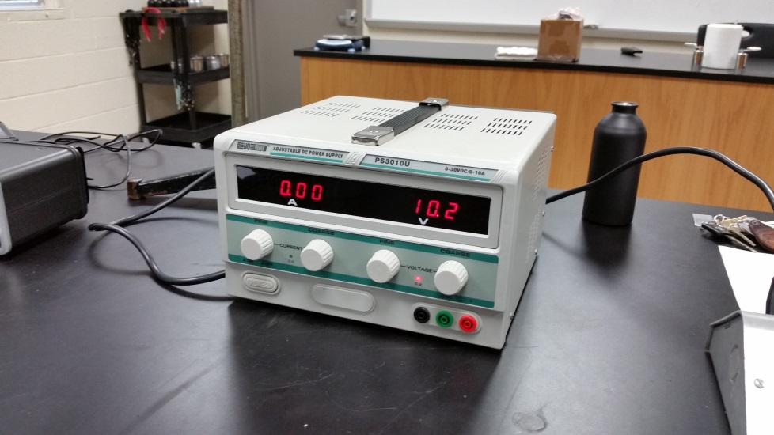
- Connect the red and black banana-plug wires to the heater-coil, and connect the other end of the red wire to the red output of the power supply. Do not connect the black wire to the black output of the power supply yet. You will do this when you click Record, simultaneously.
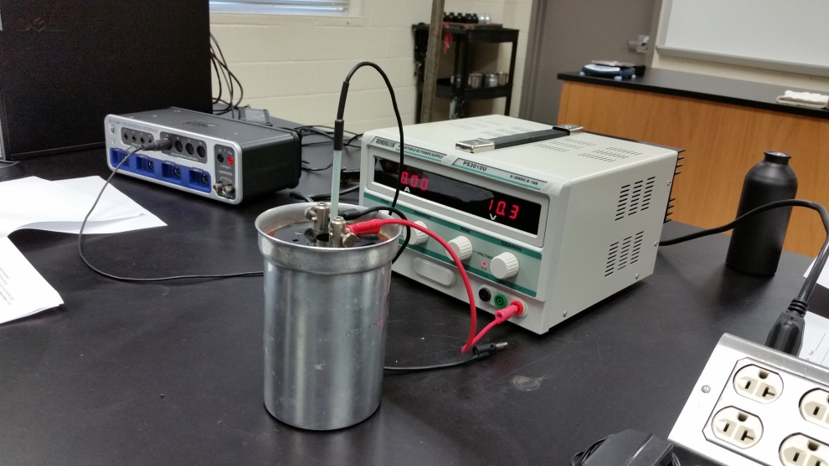
- Setting up the interface to measure temperature:
a. Open PASCO Capstone software from the desktop.
d. Click Hardware Setup under Tools on the left, click on the interface input where the temperature sensor is connected and select Temperature Sensor. Click Hardware Setup again to close it.
e. Click Recording Conditions at the bottom, and do the following:
I. Leave the Start Condition, as is, none.
II. For the Stop condition, set Time Based, for a Record time of 600 s, and O.K. f. Double-Click Graph under Displays on the right, click Select Measurement, and select Temperature.
f. Click Record and at the same time plug-in the black wire to the black output of the power supply.
- Stir the water gently with the temperature sensor.
- It is important that you stir the water well during the experiment, especially just before time reaches 10 minutes.
- When the time reaches about 9 minutes, continue stirring, until and after the data collection stops.
- Record the current and voltage readings and unplug the power cord for the power supply.
- Complete the data table and write a conclusion.
DATA:
Mass of calorimeter cup = M_{c} = __________Mass of cup + water = __________
Mass of water = M_{w} =_______ Current = I = _______ Voltage = V = _________
Initial temp. = ______Final temp. =______Change in temp. = ΔT = ___ Time = t = 600 s
Electrical energy supplied = E = I V t = ___________ Joule
Heat energy gained = Q = M_{w}C_{w}ΔT + M_{c}C_{c}ΔT + M_{h}C_{h}ΔT = ___________ calorie
(Use C_{w} = 1 cal/(g.Cº), C_{c} = 0.215 cal/(g.Cº), M_{h}C_{h}= 2.5 cal/Cº)
Assuming no heat loss to the room; Q calories = E Joules.
Experimental value: 1 calorie = __________ Joule.
Theoretical value: 1 calorie = 4.186 Joule.
% Error = _____________________

B. Heat Transfer
Purpose: To investigate what properties affect the heat transfer from a hot object.
Apparatus: Temperature sensors (2), PC w/interface, two cans: one painted black, and hot water.
Theory: $P_{rad}=σεAT^{4}$; ε = represents the emissivity of the object’s surface, which has a value between 0 and 1, depending on the composition of the surface.
For a black body, ε = 1.
Procedure:
- Connect one temperature sensor to analog input A and the other to analog input B.
- Place the A probe in the unpainted can and B probe in the painted can, and place the cans on the lab table.
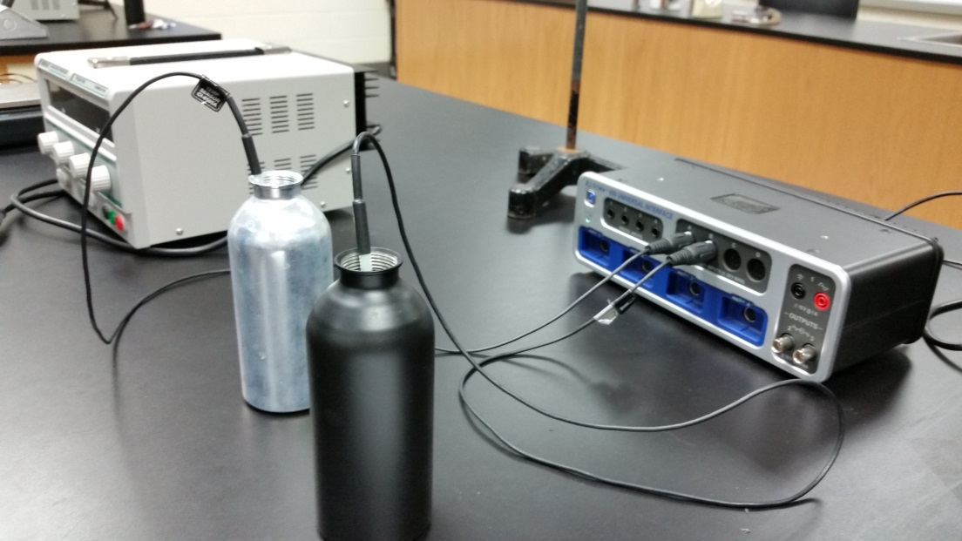
- Setting up the interface for monitoring the temperatures for 15 minutes:
a. Open PASCO Capstone software from the desktop.
b. Click Hardware Setup under Tools on the left, click on the interface input where the sensor is connected and select Temperature Sensor. Do the same for the other temperature sensor. Click Hardware Setup again to close it.
c. Click Recording Conditions at the bottom, and do the following:
I. Leave the Start Condition, as is, none.
II. For the Stop condition, set Time Based, for a Record time of 900 s, and O.K.
d. Double-click Graph under displays on the right, click Select Measurement on the Y-axis, and select Temperature Ch A.
e. Click the Add new Y-axis button, 7th from right of the Graph Display Buttons.
f. Click Select Measurement on the Y-axis, and select Temperature Ch B.
g. Do not Click Record now. We need to pour equal amount of hot water.
- Carefully pour equal amount of hot water into the two cans, maintaining equal starting temperatures for both.
- Click Record and start the data collection. Do not stir the cans. Let them cool by themselves.
- Data collection will stop automatically after 15 minutes.
- Maximize the graph display and attach a copy to your report.
Questions:
1. Which can cool down faster? Explain why.
2. When the cans are cooling, which processes transfer heat?
3. When the cans are cooling, which process is dominant? Why?
4. When a can is cooling, does it cool faster at the beginning or towards the end? Explain Why? (Include an appropriate data from your measurement in your explanation)

