PHYS 202 Equations Sheet You may tear this page

1. Force on a moving electric charge in a magnetic field: .

2. Force on a moving electric charge in an electric field. 

3. Centripetal force:

4. Force on a current in a magnetic field. 

5. Magnetic field (*B*) produced by a long straight electric current (*I*) at a perpendicular distance (*r*) is : ; (In SI units, μ0= 4πx10-7)

6. Faraday’s law of induction and Magnetic flux:   

7. Equations for transformers and power loss during transmission are shown below:   
  P = IV  V = IR   
8. Reactance (XC) of a capacitor and Reactance (XL) of an inductor:  
 

9. Impedance (Z) and Resonant frequency (*f0*) of a series RCL circuit:

sgt3s03 resFreq

10. Electromagnetic waves:

11. Circumference, C and Area, A of a circle (radius *r*): $C=2πr$ $A= πr^{2}$ 
 Area of a rectangle = length x width. Area of a triangle =

12. Proton charge = 1.6 x 10-19C Proton mass = 1.673 x 10-27 kg  
 Electron charge = -1.6 x 10-19C Electron mass = 9.11 x 10-31 kg

PHYS 202 Spring 2024 Test #3 Name:_____________________________

A. Select the correct answer for the multiple choices questions and write your answer in the line next to the question number.

____1. The angular difference between the magnetic north and the geographical north is called the

a. angle of declination b. angle of rotation

c. angle of dip d. angle of latitude  
  
____2. A horseshoe magnet and a current-carrying wire are shown in the drawing. The wire is carrying a current supplied by the battery connected to the wire as shown below. What is the direction of the magnetic force on the wire, in between the poles?

a. Up b. Down   
c. To the Left d. To the Right   
e. in f. out

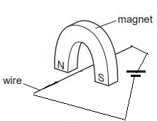

_____3. Among the electromagnetic waves, which one is associated with temperature and heat?  
_____4. Among the electromagnetic waves, which one is associated with skin cancer?  
Answers for 3 & 4

a. radio wave b. ultraviolet c. Gamma d. X-ray e. Infrared

_____5. Who is credited with the development of alternating current electrical system:  
_____6. Who is credited with the first accurate measurement of the speed of light:  
Answers for 5 & 6  
a. Maxwell b. Henry c. Tesla d. Hertz e. Faraday f. Michelson

_____7. Which one of the following is a unit for magnetic field?

_____8. Which one of the following is a unit for magnetic flux?

_____9. Which one of the following is a unit for magnetic power?

Answers for 7,8,9  
a. N.m/s b. N/(C.m) c. N/(A.m) d. N.s/(A.m) e. N/(A.s) f. N.m/A

____10. Identify two quantities (among 1-6) that are the same between the primary and secondary windings of an ideal transformer?  
a. 1 and 2 b. 2 and 3 c. 3 and 4 d. 4 and 5 e. 5 and 6 f. 3 and 6

1. voltage 2. current 3. power   
4. # of turns 5. magnetic flux 6. magnetic field

____11. Magnetic field lines (B = 0.6 T) are passing through   
a rectangular loop of length 12 cm and width 8.0 cm as shown.  
The angle between the magnetic field and the normal to the   
loop-surface, θ = 250. What is the magnetic flux through   
the loop?  
a. 57.6 T.cm2 b. 24.3 T.cm2 c. 96.6 T.cm2 d.



d. 52.2 T.cm2 e. 96.0 T.cm2 f. 12.0 T.cm2

12-14) Various circuit elements are shown below.   
_____12. Which one represents an inductor?  
_____13. Which one represents a transistor?  
_____14. Which one represents a wire?  
Answers for 12-14

____15. What is the angle between the electric and magnetic fields in an electromagnetic wave?  
a. 00 b. 450 c. 900 d. 1200 e. 1800

____16. Which one of the following is an unmodulated career wave?

____17. Which one of the following is an AM wave?  
____18. Which one of the following is a FM wave?

|  |  |
| --- | --- |
| Answers for 16,17,18 | Figure for Q19,20 |
|  |  |

____19. Using the plot above, determine the resonance frequency?  
a. 10 rad/s b. 105 rad/s c. 106 rad/s d. 107 rad/s e. 100 rad/s

____20. Using the plot above, determine the *Irms* for the 3.5-ohm resistor at the resonance?   
a. 0.4 mA b. 0.45 mA c. 0.8 mA d. 1.0 mA e. 1.4 mA f. 5.0 mA

B1. Four currents of equal magnitude are passing through 4 long conductors (1,2,3,4) located along the corners of a square (side length = 6 cm) as shown below. The currents are perpendicular to the page and the direction of current flow is either a cross (going into the page) or dot (coming out of the page). Using the right-hand-rule #2 and vector addition, determine the direction of the net magnetic field at the center of the square, C due to all 4 currents.

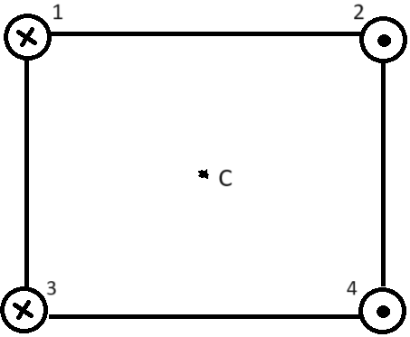

Magnetic field by a long straight electric current is: ; (μ0= 4πx10-7 SI)  
  
B2. If the magnitude of the currents in conductors 1 & 4 is 4.5 A and conductors 2 & 3 don’t carry any currents, calculate the net magnetic field (magnitude and direction) at the center, C.

C. For the planet Earth shown do the following in the picture:

1. Locate the north and south geographic poles.

2. Locate the north and south magnetic poles.

3. Sketch the overall magnetic field lines.

|  |  |
| --- | --- |
| Force (*F*) on a moving charge in a circular motion is given by: | Centripetal force is given by: |
| $$F=qvBSinƟ$$ |  |

D1. Using the above two equations, Derive an expression for the mass of the charge particle in circular motion in terms of velocity, charge, magnetic field, and radius.

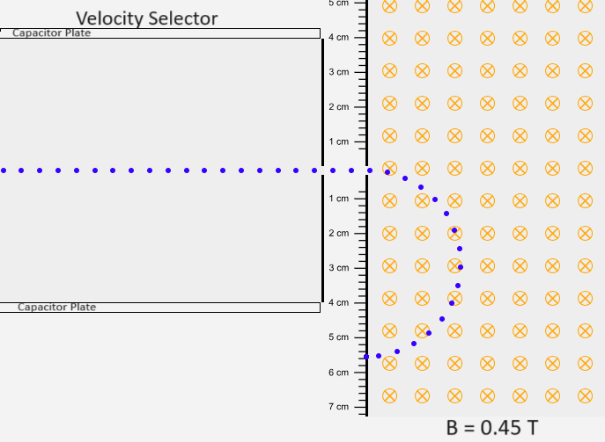

D2. A charge particle passes through a velocity selector and enter a perpendicular magnetic field, B = 0.45T, which is directed into the page, as shown above.   
1. What is the sign for the charge? _______________________  
2. For the velocity selector, Show the charges in the capacitor plates and the magnetic field between the plates, for this to work.   
3. If the magnitude of the charge is 5.5 µC and it travels at a speed of 1.8 x 107 m/s, calculate the mass of the charge particle.

E. Faraday’s law of induction:  Ohm’s law: V = IR $f=\frac{1}{T}$

A loop of wire has the initial shape shown in the drawing. The top part of the wire is bent into a semi-circle of radius 25 cm as shown, which can be rotated with the handle. A constant magnetic field of magnitude 0.45 T is directed perpendicularly out of the paper.

|  |  |
| --- | --- |
| Initial Shape of the loop | Shape of the loop after ¼ a revolution |
|  |  |

1. Sketch the shape of the loop in the box above when the semi-circular side is rotated through ¼ of a revolution.

2. What is the change in magnetic flux when the semi-circular side is rotated through ¼ of a revolution, starting from the position shown?

3. If the above ¼ of a revolution takes 2.5 ms, what is the average induced emf in the loop?

4. If the resistance shown in the loop is 2.8 ohm, what is the induced current?

5. Show the direction of the induced current in the loop?

6. What is the period and frequency of the above rotation?

7. Sketch the induced emf as a function of time for few periods.