PHYS 202 Spring 2022 Test #2 Equations Sheet

Heat transfer: $Q=mc∆T$ $Q=mL$ Electric current = I = $\frac{Charge}{Time}$  
  
Ohm’s law: V = IR Electric Power = P = IV Electrical energy =IVt

Resistance in terms of resistivity and dimensions: $R=ρ\frac{L}{A}$

|  |  |  |  |
| --- | --- | --- | --- |
| Electric potential due to a point charge (q) at a distance r: | Electric potential in terms of EPE and point charge (q): | Electric field due to a point charge (q) at a distance r: | Electric field (E) from potential gradient: |
| $$V=k\frac{q}{r}$$ | $$V=\frac{EPE}{q}$$ | $$E=k\frac{q}{r^{2}}$$ | $$\vec{E}=-\frac{∆V}{∆X}$$ |

Capacitors:   

|  |  |  |
| --- | --- | --- |
| 9. Combination | Resistors | Capacitors |
| Series |  |  |
| Parralel |  |  |

Time constant of an RC circuit = RC. math172

PHYS 202 Spring 2022 Test #2 Name:___________________________

I. Select the correct answer for the following multiple-choice questions and write your answer in the line next to the question number.

____1. The *electromotive force* is also known as  
a. Force b. Current c. Power d. Energy e. Voltage

____2. The *electron volt* is a unit of  
a. Voltage b. Current c. Power d. Energy e. Force

____3. An appliance with a power rating of 2200-W is connected to a 120-volt outlet. What is the current through the appliance?

a. 10 A b. 1 A c. 18 A d. 12 A e. 5 A

____4. Estimate the cost of electricity for operating a dozen 15-W LCD panels for 4 hours a day for 20 days a month for nine months. Assume a cost of 8 cents per kWh.

a. $ 0.52 b. $ 0.86 c. $ 1.15 d. $ 1.30 e. $ 10.37

____5. Which one of the following biomedical application deals with eye?  
a. EKG b. ECG c. EEG d. ERG e. CEG

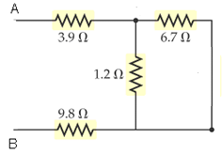

____6. Which one of the following you should do as the first step,   
to find the equivalent resistance between A and B for the network   
shown:

1. Combining 1.2 Ω and 6.7 Ω in series
2. Combining 1.2 Ω and 6.7 Ω in parallel
3. Combining 3.9 Ω, 1.2 Ω, and 9.8 Ω in series
4. Combining 3.9 Ω, 6.7 Ω, 1.2 Ω, and 9.8 Ω in series

____7. For the above circuit, what will be the voltage across the 9.8 Ω resistor when a 9.0V battery is connected between A and B?

1. 3.0 V b. 5.9 V c. 6.0 V d. 9.0 V e. 12 V

____8. Which one of the following is placed between capacitor plates to increase the capacitance?  
a. Conductor b. Insulator c. Dielectric d. Resistance e. Semiconductor

____9. Determine the length necessary to obtain a resistance of 0.456 Ω using a Cu wire of radius 0.090 mm. Resistivity of Cu = ρ = 1.72 x 10-6 Ω.cm.

a. 57.6 cm b. 65.7 cm c. 67.5 cm d. 130 cm e. 270 cm

____10. Two parallel capacitor plates, separated by, d = 0.30 cm,   
are connected across a 9-V battery. What is the magnitude of the  
electric field between the plates?  
a. 100 V/m b. 200 V/m c. 300 V/m d. 3000 V/m e. 30 V/m

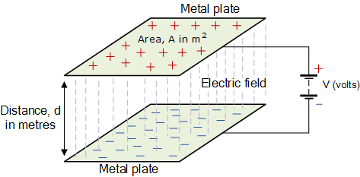

____11. Which one of the following is a vector?

a. Electric potential b. Electric field c. Electric energy d. Electric power

12-13) Two charges –Q and +Q with equal magnitudes are located as shown below. Point A is at equal distance from the charges.   
_____12. What is the net electric field at A?  
_____13. What is the net electric potential at A?

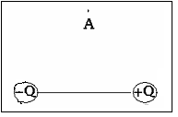

a. Vertical and down b. Vertical and up

c. Horizontal and to the right d. Horizontal and to the left

e. There is none

___14. What is the charge in the 5 µF capacitor for the circuit shown below?

1. 18 µC

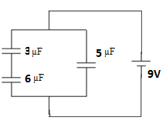

1. 27 µC
2. 45 µC
3. 54 µC
4. 63 µC

____15. What is the SI unit for RC, where R is the resistance and C is the capacitance?  
a. meter b. coulomb c. volt d. second e. farad f. ohm

16-17) Refer to the circuit shown below:

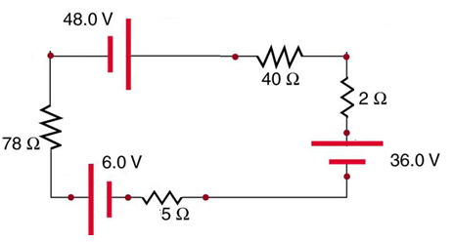

____16. What is the direction of current for the circuit shown?  
a. Clockwise b. Counter clockwise

____17. Determine the magnitude of the current for the circuit shown?  
a. 0.048 A b. 0.14 A c. 0.62 d. 0.72 A e. 0.41 A

18-20) A 6-V battery, capacitor (uncharged), bulb, and a switch are connected as shown below.

____18. What will be direction of the current at the instant, the switch is closed?

a. Clockwise b. Counter clockwise

____19. What will be the potential difference across the bulb   
at the instant, the switch is closed?

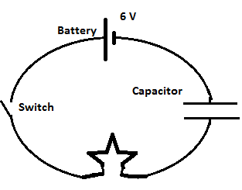

____20. What will be the potential difference across the bulb   
after a long time, from the instant the switch is closed?  
Answers for 19 & 20  
a. 0 b. 1.5 V c. 3 V d. 6 V

II. At a distance *r* from a point charge Q, the electric potential, V is given by: .

1. Identify electric potential as a vector or scalar and state its SI unit.

2. Calculate the total electric potential at D, due to the three charges shown below. Use three significant figures. Coulomb constant, k = 8.99 x 109 (SI).

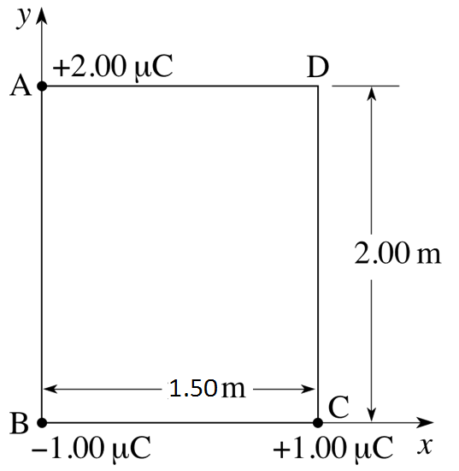

III. Combine all the resistances into a single one, between A & B, for the circuit shown:

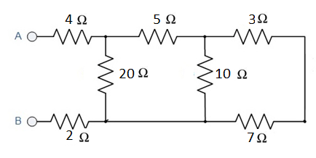

IV. Kirchhoff’s Rules.

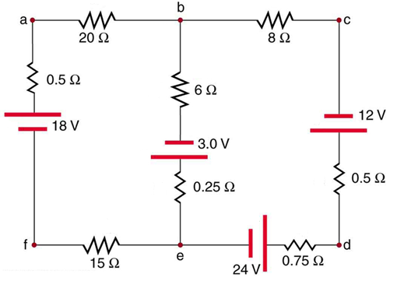

For the circuit shown above:

1. Assign three unknown currents: x, y, and z.

2. Identify the low and high potentials for the resistors   
and batteries.

3. Write down the potential differences across the   
resistors in terms of the assigned currents and the   
given resistance values.

4. Write down the junction rule equation using the   
assigned currents.

5. Write down the loop rule equation, for 2 different loops. [No need to solve the equations]

math172



Time constant = τ = *RC*

1. Above equation gives the charge on a capacitor as a   
function of time during discharging. Sketch the charge, q   
as a function of time for the above discharging of a   
capacitor (C) through a resistor (R), inside the box.

2. If the capacitance is 1.2 F and the resistance is 3.0 ohm, calculate the RC time constant.

3. If the voltage used to charge the above capacitor is 6.0 volt, calculate the charge when the capacitor is fully charged?

4. Calculate the stored energy when the capacitor is fully charged?

5. Calculate the amount of charge in the capacitor after 5.0 seconds of discharging.