PHYS 202 Spring 2016 Test #2 Equations Sheet

1. Ohm’s law: V = IR 2. Electric Power = P = IV 3. Electrical energy =IVt

4. Resistance in terms of resistivity and dimensions:

5. Capacitors:   

|  |  |
| --- | --- |
| 6. Electric potential due to a point charge (Q) at a distance r: | 7. Electric field (E) from potential gradient: |
| sgt2VduetoQ |  |

|  |  |  |
| --- | --- | --- |
| Combination | Resistors | Capacitors |
| Series |  |  |
| Parralel |  |  |

PHYS 202 Spring 2016 Test #2 Name:___________________________

I. Select the correct answer for the following multiple choice questions and write your answer in the line next to the question number.

1-2) Refer to the figure below of a rectangular block of material. The resistance depends on the path that the current takes and the cross-sectional area. The drawing shows a situation in which the battery is connected as shown.   
  
___1. To calculate the resistance what length should be used?

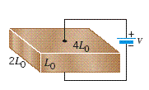

1. *L0* b. 2*L0* c. 3*L0* d. 4*L0*

___2. To calculate the resistance what cross sectional area   
 should be used?  
 a. *L0*2 b. 2*L0*2 c. 4*L0*2 d. 8*L0*2  
  
____3. The *electromotive force* is also known as  
a. Force b. Current c. Power d. Energy e. Voltage

____4. An appliance with a power rating of 1200-W is connected to a 120-volt outlet. What is the current through the appliance?

A. 10 A B. 1 A C. 0.1 A D. 12 A E. 5 A

____5. In a common household circuit, devices are connected in

A. Series B. Parallel

____6. Which one of the following biomedical application deals with brain waves?  
a. EKG b. ECG c. EEG d. ERG e. CEG

____7. Which one of the following you should do as the first step, to find the equivalent resistance between A and B for the network shown below:

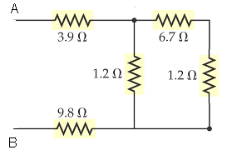

a. Combining 1.2 Ω and 6.7 Ω in parallel

b. Combining 3.9 Ω, 1.2 Ω, and 9.8 Ω in series

c. Combining 3.9 Ω, 6.7 Ω, 1.2 Ω, and 9.8 Ω in series

d. Combining 1.2 Ω and 6.7 Ω in series

e. Combining 1.2 Ω and 1.2 Ω in parallel

8-9) A light bulb is connected to a battery as shown below.   
____8. What is the direction of the current flow?   
____9. What is the direction of the electron flow?  
Answers for 8 & 9  
a. Clockwise b. Counterclockwise

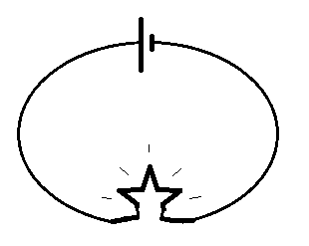

|  |  |
| --- | --- |
| Electric potential due to a point charge (Q) at a distance r: | Electric field (E) from potential gradient: |
| sgt2VduetoQ |  |

____10. Different charge distributions of +2q and – q are shown below. In which case the electric potential at P is the highest?

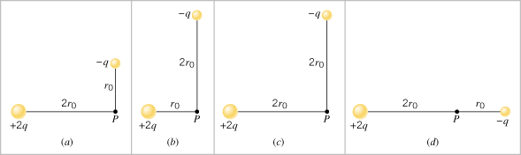  
11-12) The sketch below shows cross sections of equipotential surfaces between two charged conductors that are shown in solid grey. Various points on the equipotential surfaces near the conductors are labeled **A**, **B**, **C**, ..., **I**.  
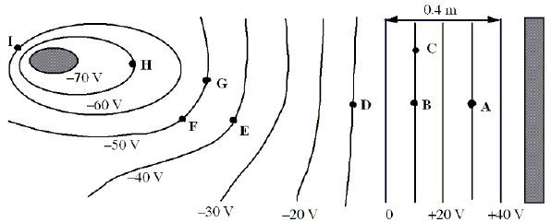

__11. Identify the charges on the conductors in the diagram above.

___12. What is the magnitude of the electric field at point **A**?  
a. 10 V/m b. 25 V/m c. 30 V/m d. 75 V/m e. 100 V/m  
  
___13. For the circuit shown in the right, the battery voltage is 6V.  
What is the current, I shown in the diagram?   
a. 0.67 A b. 1.5 A c. 0.33 A d. 1.0 A e. 2.0 A

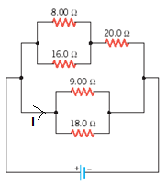

____14. What is the direction of current for the circuit shown?  
a. Clockwise b. Counter clockwise

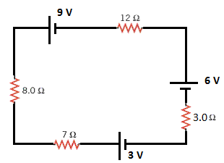

____15. Determine the magnitude of the current for the circuit shown?  
a. 0.38 A b. 0.40A c. 0.50 A d. 0.60 A e. 0.20 A   
  
  
16 & 17) A battery, capacitor (uncharged), and a switch are connected as shown.  
____16. What will be the potential difference across the capacitor   
at the instant, the switch is closed?  
____17. What will be the potential difference across the capacitor   
after a long time, from the instant the switch is closed?  
Answers for 16 & 17  
a. 0 b. 1.5 V c. 3 V d. 6 V

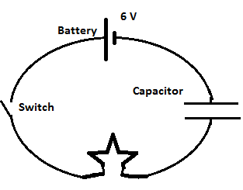

|  |  |  |
| --- | --- | --- |
| II. Combining Capacitors | Series |  |
| Parallel |  |

a. Determine the equivalent capacitance between *A* and *B* for the circuit below.  
b. What will be the charge in the 1µF capacitor, when a 12V battery is connected between A & B.

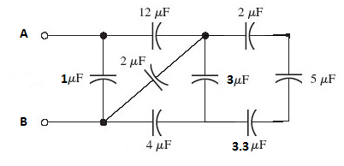

III. At a distance *r* from a point charge Q, the electric potential, V is given by: .

1. Sketch the electric potential, V as a function of distance for a positive charge and a negative charge below:

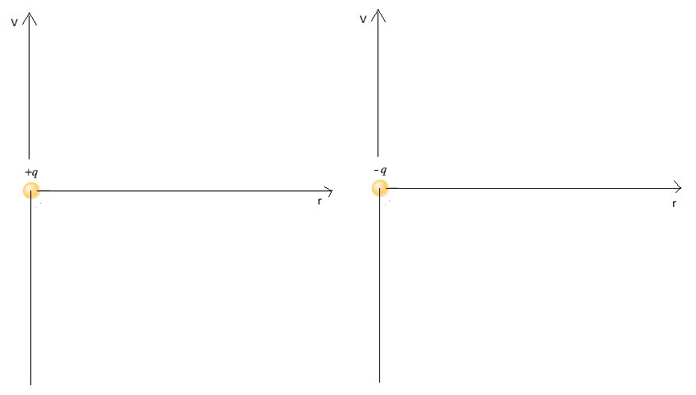

2. Calculate the total potential at P, due to the three charges shown below. Use three significant figures. Coulomb constant, k = 8.99 x 109 (SI).

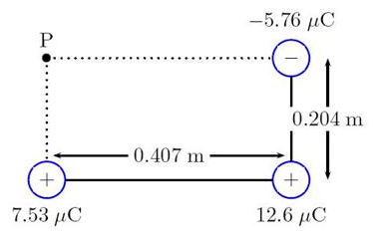

IV. Kirchhoff’s Rules.

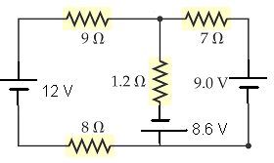  
For the circuit shown above:

1. Assign the three unknown currents.

2. Identify the low and high potentials for the resistors and batteries.

3. Write down the potential differences across the resistors in terms of the assigned currents and resistances.

4. Write down the junction rule equation using the assigned currents.

5. Write down the loop rule equation, relating the assigned currents, for 2 different loops.