PHYS 202 Spring 2024 Test #1 Name:_____________________________

Tf = (9/5) Tc + 32,  Tk = Tc + 273 $∆T_{F}=\frac{9}{5}∆T_{C}$ $∆T_{K}=∆T_{C}$

________________________________________________________________________

A) For the following questions write your answers in the space next to the question #.

____1. Which one of the following temperatures is approximately equal to the typical temperature of a classroom?

1. 373 K b. 23 0F c. 23 0C d. 73 0C e. 73 K

____2. Express the temperature 4.2 K in oF unit?

a. 39.6 b. – 117 c. – 269 d. – 452 e. – 484

____3. What is the difference in Fo of the two temperatures, -35oC and 62oC?

a. 54 Fo b. 15 Fo c. 36 Fo d.- 2.7 Fo e. 175 Fo

____4. What is the thermometric property of an ear thermometer?

a. Length of a liquid column b. Voltage c. Pressure of a gas  
d. Infrared radiation e. Ultraviolet radiation

The linear coefficients of thermal expansion are:

α steel = α concrete = 12x10-6(Co)-1, α aluminum = 23x10-6(Co)-1, α copper = 17x10-6(Co)-1.

____5. Concrete sidewalks are always laid in sections, with gaps between each section. For example, the drawing shows four identical 2.4-m sections, the outer two of which are against immovable walls. The three identical gaps between the sections are provided so that thermal expansion will not create the thermal stress that could lead to cracks. What is the minimum gap width necessary to account for an increase in temperature of 32 C°?  
a. 0.92 x 10-3m b. 1.0 x 10-3m c. 1.2 x 10-3m d. 1.3 x 10-3m e. 1.4 x 10-3m

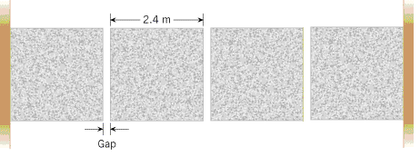



____  
____6. For the highest accuracy, which of the material is ideal for a  
tape rule for year-round outdoor use?  
____7. Anti-scalding device shown to the right uses actuator  
spring to block the flow of hot water. For better results the spring  
should be made of:  
Answers for 6 & 7: a. Aluminum b. Steel c. Copper

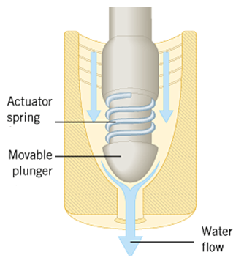

____8. The third law of thermodynamics is,   
a. The law of conservation of energy.

b. Heat flows spontaneously from a substance at a higher temperature to a substance at a lower temperature.

c. Heat flows spontaneously from a substance at a lower temperature to a substance at higher temperature.   
d. If two systems individually in thermal equilibrium with a third system, then the two systems are in thermal equilibrium with each other.  
e. It is not possible to lower the temperature of any system to absolute zero in a finite number of steps.

____9. Suppose you want to heat a gas so that its temperature will be as high as possible. Would you heat it under which one of the following conditions?  
a. constant pressure b. constant volume c. constant temperature

____10. Conductors have free_____________.   
a. Protons b. Neutrons c. Atoms d. Nucleons e. Electrons

____11. What is the three dimensional shape of one of the equipotential surfaces for an isolated point charge?  
a. plane b. circle c. sphere d. parabola e. ellipse

____12. An object is charged by induction using a negatively charged rod. What type is the charge on the charged object?  
a. Positive b. Negative c. No charge

_____13. Two identical charges +Q and +Q with equal magnitudes are located as shown below. Point A is at equal distance from the charges. What is the net electric field at A?  
a. Vertical and down b. Vertical and up

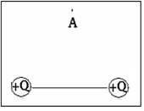

c. Horizontal and to the right d. Horizontal and to the left

14-15) Deals with the electric field lines of two charges.  
Magnitudes are Q1 and Q2 as shown:

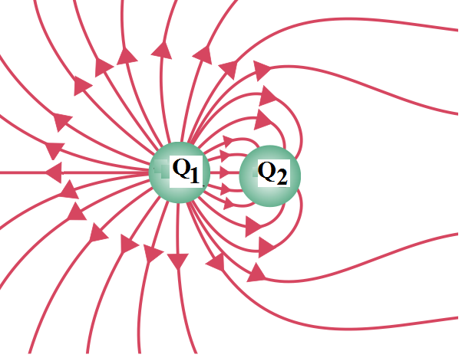

____14. The polarities of the charges are,

a. Q1 is positive and Q2 is negative

b. Q2 is positive and Q1 is negative

c. Both are positive d. Both are negative  
____15. The ratio Q1/Q2 is given by,  
a. 1 b. 2 c. 3 d. 4 e. 5

B. How many coulombs of positive charge are there in 2.5 kg of lead?  
(qp= +1.6 x 10-19C, NA= 6.022 x 1023)

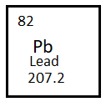

C. A piece of ice at -130C is transferred to 180 gram of water at 250C in an insulated cup with negligible specific heat. The entire ice melts and the final temperature of the water is 150C. Determine the mass of the ice.

Specific heat of ice = 2000 J/(kg.K), Specific heat of water = 4186 J/(kg.K), Latent heat of fusion of ice = 33.5 x 104 J/kg.

PV = nRT, R = 8.31 J/(mol.K) ∆U = Q - W. W= P.∆V   
D. An ideal gas is taken through the three processes (A→B, B→C, and C→A) shown in the drawing. States A and B are at temperature 320 K.  
1. Determine the number of moles of the gas?

2. Name the process **AB** _______________ **BC**________________& CA___________.  
  
3. For the three processes shown in the drawing, fill in the missing entries in the following table. Areas: rectangle = length x width, triangle = 0.5 x base x height.

|  |  |  |  |  |  |  |  |  |  |  |  |  |  |  |  |  |  |
| --- | --- | --- | --- | --- | --- | --- | --- | --- | --- | --- | --- | --- | --- | --- | --- | --- | --- |
| V = 0.01 m3 and P = 105 Pa. | |  |  |  |  | | --- | --- | --- | --- | | Process | ∆U | Q | W | | A→B | a. | b. | 3800 J | | B→C | -1500 J | d. | c. | | C→A | f. | g. | e. |   4. Net work for A-> B-> C-> A = |

E. Coulomb’s law is given by: F:\PHYS202\Study Guides\sgt2CouLaw.gif Coulomb’s constant = k = 9 x 109 (SI)  
1. Express the SI unit of the Coulomb’s constant:__________________________

2. Figure below shows three point charges that lie along the *x* axis in a vacuum, with no gravity.   
a. Draw a free-body diagram for the charge *q2*.  
b. Determine the magnitude and direction of the net electrostatic force on *q*2.



|  |  |  |  |  |
| --- | --- | --- | --- | --- |
|  |  |  |  |  |

F. Figure below shows an alpha particle passing between two charged   
metal plates that create an electric field of 1250 N/C, perpendicular to   
the particle’s initial horizontal velocity. The horizontal distance it travels   
in the uniform field is 25 cm and it deflects 3.5 cm vertically.   
(a) Sketch the electric field between the plates.  
(b) Sketch the path of the particle as it travels between the plates and exits.   
(c) What is the vertical acceleration of the alpha particle?   
[mα = 6.64 x 10-27kg, qα = 3.2 x 10-19C]

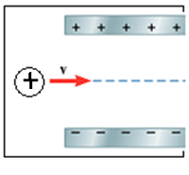

(d) How long it takes to cross the plates?

(e) What is the initial horizontal velocity of the alpha particle?