PHYS 202 Combining Resistors Name:______________________Due 2/8/18 12:30

When resistors (*R1*, *R2*, *R3*) are connected in series the equivalent resistance (*Rs*) is given by,



When resistors (*R1*, *R2*, *R3*) are connected in parallel the equivalent resistance (*Rp*) is given by,



1. Give an explanation for the first equation above.

2. Two resistors with resistance values a and b are in parallel, show that the equivalent resistance is given by the following equation:

3. Find the equivalent [resistance](javascript:parent.xlinkeyword('u0028')) between points *A* and *B* for the resistor network shown below. *R1* = 4Ω, *R2* = 6Ω, *R3* = 10Ω.

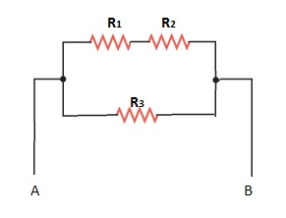

4. Find the equivalent [resistance](javascript:parent.xlinkeyword('u0028')) between points *A* and *B* for the resistor network shown below. . *R1* = 3Ω, *R2* = 6Ω, *R3* = 7Ω.

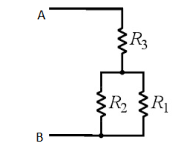

5. Find the equivalent [resistance](javascript:parent.xlinkeyword('u0028')) between points a and b for the resistor network shown below.

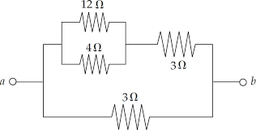

6. Find the equivalent [resistance](javascript:parent.xlinkeyword('u0028')) between points *A* and *B* for the resistor network shown below.

