PHYS 202 Farsightedness Name:___________________________
1. For a farsighted eye, show the formation of the image for distant objects below.
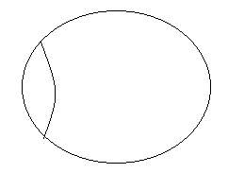
2. For a farsighted eye, show the formation of the image for nearby objects below.
3. For a farsighted eye, show how a lens can be used to correct the vision below, and identify the type of lens necessary.
4. A farsighted person has a near point located 110 cm from the eyes. What power of (a) contact lenses and (b) spectacle lenses are needed for the person to read a book held 25.0 cm from the eyes.
Assume the spectacle lens is held 1.50 cm away from the eye by eyeglass frames.
$$P=\frac{1}{f}=\frac{1}{d_{o}}+\frac{1}{d_{i}}$$

PHYS 202 Nearsightedness Name:___________________________
1. For a nearsighted eye, show the formation of the image for nearby objects below.
2. For a nearsighted eye, show the formation of the image for distant objects below.
3. For a nearsighted eye, show how a lens can be used to correct the vision below, and identify the type of lens necessary.
4. A nearsighted person has a far point of 65 cm from the eyes. What power of (a) contact lenses and (b) spectacle lenses are needed to restore normal vision?
Assume the spectacle lens is held 1.50 cm away from the eye by eyeglass frames.
$$P=\frac{1}{f}=\frac{1}{d_{o}}+\frac{1}{d_{i}}$$

