PHYS 202 Double-Slit Interference Name:_______________________________
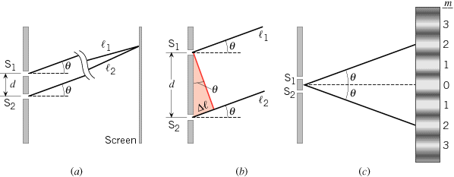
Path Difference = d Sin(θ)
For Bright Fringes: d Sin(θ) = mλ; m = 0, 1,2,3,…
For Dark Fringes: d Sin(θ) = (m+ 1/2)λ; m = 0, 1,2,3,…

8. What is the separation between two slits for which 610-nm orange light has its first maximum at an angle of 30.0º ?

11. What is the wavelength in nm of light falling on double slits separated by 2.00 μm if the third-order maximum is at an angle of 60.0º ?

6. (a) At what angle is the first-order maximum for 450-nm wavelength blue light falling on double slits separated by 0.0500 mm? (b) If the double-slit to screen distance is 94 cm, calculate the fringe width.

PHYS 202 Single-Slit Diffraction Name:_______________________________
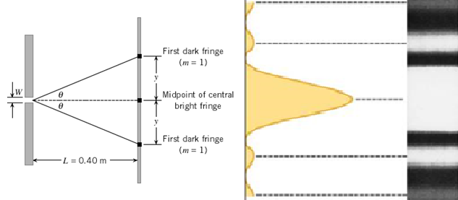
For Dark Fringes: W Sin(θ) = mλ; m = 1,2,3,…
46. (a) What is the width of a single slit that produces its first minimum at 60.0º for 600-nm light?

48. Calculate the wavelength of light that produces its first minimum at an angle of 36.9º when falling on a single slit of width 1.15 μm .

43. (a) At what angle is the first minimum for 650-nm light falling on a single slit of width 0.16 mm?
(b) If the slit-screen distance is 94 cm, calculate the width of the central bright fringe.

