PHYS 202 First Law of TD: ∆U = Q – W Name:\_\_\_\_\_\_\_\_\_\_\_\_\_\_\_\_\_\_\_\_\_\_\_   
Ideal gas law: PV = nRT. Int. Energy of a monatomic gas:

1. (P28, CJ10) A monatomic ideal gas expands from point *A* to point *B* along the path shown in the drawing.

a. Determine the work done by the gas.

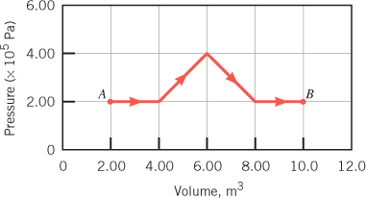

b. The temperature of the gas at point *A* is 185 K. What is its temperature at point *B*?

c. How much heat has been added to or removed from the gas during the process?

2. (P98, CJ10) An ideal gas is taken through the three processes (A→B, B→C, and C→A) shown in the drawing. In general, for each process the internal energy *U* of the gas can change because heat *Q* can be added to or removed from the gas and work *W* can be done by the gas or on the gas. For the three processes shown in the drawing, fill in the five missing entries in the following table.

|  |  |  |  |  |  |  |  |  |  |  |  |  |  |  |  |  |  |
| --- | --- | --- | --- | --- | --- | --- | --- | --- | --- | --- | --- | --- | --- | --- | --- | --- | --- |
| pict_15_28 | |  |  |  |  | | --- | --- | --- | --- | | Process | ∆U | Q | W | | A→B | b. | +561 J | a. | | B→C | +4303 J | c. | +3740 J | | C→A | d. | e. | -2867 J | |

OpenStax Problems:

2. How much heat transfer occurs from a system, if its internal energy decreased by 150 J while it was doing 30.0 J of work?

4. What is the change in internal energy of a system which does  of work while  of heat transfer occurs into the system, and  of heat transfer occurs to the environment?

13. A hand-driven tire pump has a piston with a 2.50-cm diameter and a maximum stroke of 30.0 cm. (a) How much work do you do in one stroke if the average gauge pressure is  (about 35 psi)? (b) What average force do you exert on the piston, neglecting friction and gravitational force?

14. Calculate the network output of a heat engine following path ABCDA in the figure below.

