PHYS 202 Coulomb’s law Name:____________________________
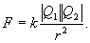 Coulomb’s constant = k = 9 x 10⁹ (SI)
1. Figure below shows three point charges that lie along the x axis in a vacuum. Determine the magnitude and direction of the net electrostatic force on q₁.
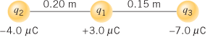

2. In the Bohr model of the hydrogen atom, the electron is in a circular orbit about the nuclear proton at a radius of 5.29 x 10⁻¹¹ m as shown below. The mass of the electron is 9.11 x 10⁻³¹ kg. Determine the speed of the electron. [Centripetal Force = $F_{C}=\frac{mv^{2}}{r}$
