Speed of Sound in Air Name:_____________________________
Partner(s):___________________________ Course: ________________ Time:_______
Purpose: Determine the speed of sound in air using different methods.
Introductory Video: https://www.youtube.com/watch?v=wXRNKz0xMOU&t=
A. Temperature Method
Apparatus: PC with interface and temperature sensor.
Theory: Speed of sound in air (in m/s) at temperature T (in Kelvin) is given by;
$v=\sqrt{\frac{γRT}{M}}$
where γ = 1.40 (ratio of specific heats for air),
R = 8.3145 J/(mol.K) (Gas constant), and
M = average molar mass of air in Kg.
Procedure
1. Write down the percentages of the three most abundant gases (avoid H₂O) found in the Earth’s lower atmosphere using the website shown below: (Scroll down to Table 7a-1) http://www.physicalgeography.net/fundamentals/7a.html
2. Write down the atomic masses for the above three gases using this periodic table: https://ptable.com/#Properties
3. Calculate the average molar mass of air (in Kg) using the above three abundant gases found in the Earth’s lower atmosphere.

4. Measure the room temperature using a temperature sensor, interface, and PC:
a. Make sure that the power for the interface is turned on.
b. Plug in the temperature sensor to analog input A, white arrow on top.
c. Open PASCO Capstone software from the desktop.
d. Click Hardware Setup under Tools on the left, click on the interface input where the sensor is connected and select Temperature Sensor. Click Hardware Setup again to close it.
e. Double-Click Digits under Displays on the right, click Select Measurement, and select Temperature.
f. Click Record.
5. Calculate the speed of sound.
DATA:
Room temperature, t = ___________⁰C = _________K.
Speed of sound (using temperature) = V = ____________
B. Air-Column Resonance Method
Apparatus: Resonance tube apparatus with water and speaker, audio signal generator, stand w/clamp, sound sensor, interface, and water.
Theory: In wind instruments the wind (air) is made to resonate. Resonance makes the sound audible. In this investigation a small speaker, connected to an audio signal generator, will generate sound of required frequencies. The speaker is held above the open end of the resonance tube, which has water. The water level can be changed by lowering/raising the reservoir can.
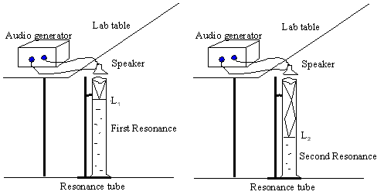
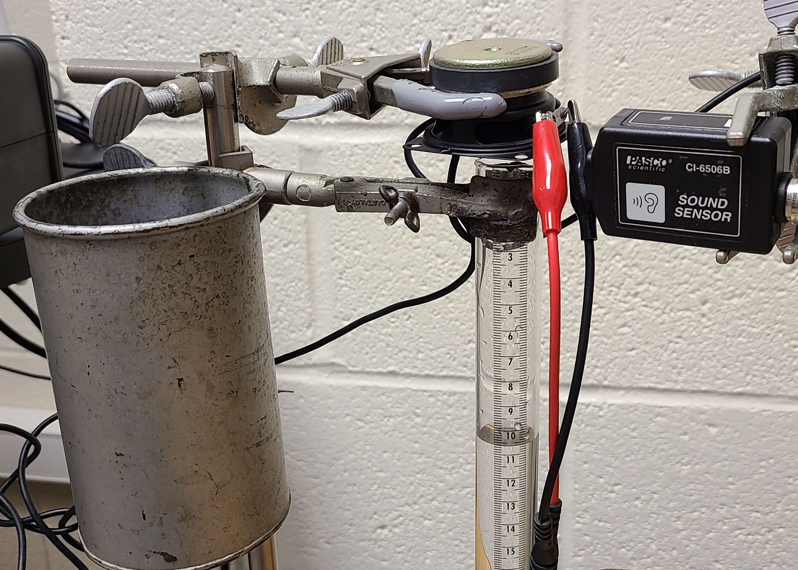
Procedure:
1. Connect the speaker to the audio generator, turn on the generator, set the frequency to 400 Hz, and place the sound sensor close to the top of the tube.
2. Turn on the Pasco 850 interface, and connect the sound sensor to analog input A.
3. Open PASCO Capstone software from the desktop.
4. Click Hardware Setup under Tools on the left, click on the interface input where the sensor is connected, and select Sound Sensor. Click Hardware Setup again to close it.
5. On the right, by clicking, Open FFT display.
6. On the FFT display, for the Y-axis, choose Intensity, and change the sample rate to 2.0 kHz.
7. Click Record and as you lower the water level, observe FFT display, locate the water level for the first maximum intensity. This will be the first resonance, L₁.
8. If you keep on lowering you will observe the maximum intensity again at the second resonance, L₂.
9. Repeat the above procedures for other frequencies and complete the data table.
10. The wavelength, λ is given by: λ = 2 (L₂ - L₁).
11. The speed of sound in air, V is given by: V = λ∙f, f = frequency.
DATA
Dial  Frequency  (Hz) | First  Resonance  Point, L₁ (cm) | Second Resonance Point, L₂ (cm) | Change in Resonance Points,  L₂-L₁ (cm) | Wavelength, λ (cm) | Speed of sound, V (cm/s) | Speed of sound, V (m/s)
400
500
600
Average Speed of Sound
C. Echo Method
Apparatus: Sound sensor, interface, PC, long cardboard tube, and meter stick.

Theory:
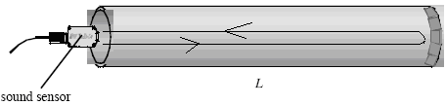
In this echo method, a sound pulse is made to travel along the tube, and the initial pulse and the reflected pulse are detected with a sound sensor.

If the length of the tube is L, then the round trip distance of travel is 2L. If the travel time is t, then the speed of sound, v is given by;

Procedure:

1. Turn on the Pasco 850 interface, and connect the sound sensor to analog input A.

2. Open PASCO Capstone software from the desktop.

3. Click Hardware Setup under Tools on the left, click on the interface input where the sensor is connected, and select Sound Sensor. Click Hardware Setup again to close it.
4. Click Recording Conditions, in the bottom-panel, and do the following.
a. Start Condition:
Condition type = Measurement Based
Data Source = Sound Intensity
Condition = Is above
Value = 1
b. Stop Condition:
Condition type = Time Based
Record time = 0.5s
c. Click, OK.

5. Double-Click Scope under Displays on the right, click Select Measurement on the Y-axis, and choose Sound Intensity.
6. Place the cardboard tube on the laboratory table and hold the sound sensor close to the open end.

7. Click Record, and snap your fingers at the open end of the tube as shown below.
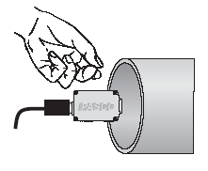
8. If the pulse is not captured, repeat procedure 7. If the pulse is visible, but not the echo, drag the x-axis scale numbers until the pulse and echo are visible as shown below.
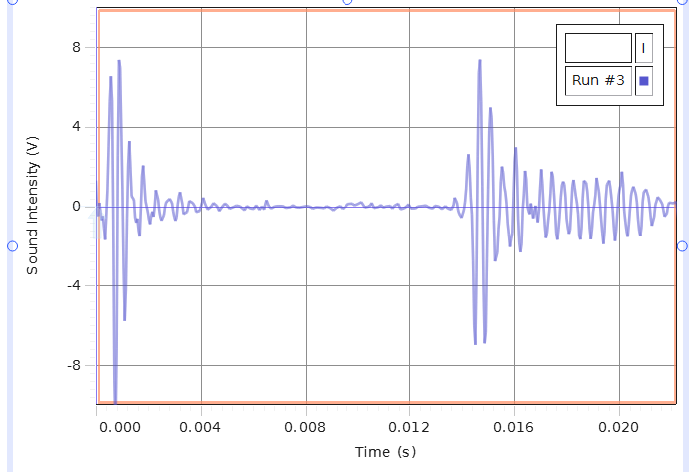
9. Click the Show Coordinates button (on top), right-click the coordinate, and select Tool Properties, and change the significant figure to 4.
10. Use the Show Coordinates tool to find the time for initial pulse, time for echo, and travel time and complete the data table below.
11. Repeat the measurements and complete the Data table below.
Length of tube  (m) | Round trip travel Distance (m) | Time for initial pulse (s) | Time for echo (s) | Round trip Travel Time  (s) | Speed of sound  (m/s)
Average speed of sound

12. Write a conclusion.

