PHYS 201L Archimedes’ Principle Name:___________________________
$F_{b}=m_{f}g$ or $F_{b}=ρ_{f}v_{f}g$ Density of water = 1 g/cm³ = 1000 kg/m³.
A. Follow the following link, watch the video, and answer the questions below: https://www.youtube.com/watch?v=eQsmq3Hu9HA
- Define mass using words, identify it as a vector or scalar, and state its SI unit.

- Define weight using words, identify it as a vector or scalar, and state its SI unit.

- What determines that an object will float or sink in a fluid?

- State Archimedes’ principle.

- Do the Horse problem from the video:
ARCHIMEDES' PRINCIPLE Remote Lab
Purpose: To verify Archimedes' principle and use it to determine the density of
a) heavy solids b) a light solid c) a liquid
Apparatus: Electronic balance (0.1g) with weigh below hook, analytical balance (0.001g), ring stand, lab-jack, string loop, wooden block, Al block, steel block, brass block, lead block, US coin nickel, hydrometer, 2- graduated cylinders (500-ml), copper sulfate solution, beaker(250 ml), vernier caliper, and wiper paper.
Theory:
Archimedes's principle - The buoyant force acting on a partially or fully submerged object in a fluid is equal to the weight of the fluid it displaces.
$F_{b}=m_{f}g$ or $F_{b}=ρ_{f}v_{f}g$ Density of water = 1 g/cm³ = 1000 kg/m³.
Procedure:
1) Watch this video.
2) As the mass is hanged from the hook, the mass in air is displayed. Record this mass in the Data Table, next page.
3) Observe the reading of the electronic balance, as the aluminum block is submerged, and describe it below. Also explain what you observe.
4) The scale reading when the block is fully submerged is the mass in water for the aluminum block. Record this in the data table, next page. Also, calculate the buoyant force in grams for aluminum block in the data table I.
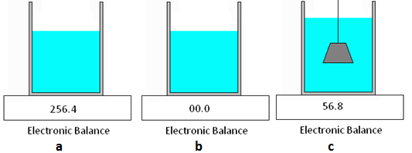
5) Watch this video and collect the data for mass of displaced water for aluminum block and complete the row for Al block in the data table I.
6) Watch this video and collect the buoyant force data for Steel, Brass, and Lead blocks and record the data in Data Table I, below.
7) Watch this video and collect the data for mass of displaced water for Steel, Brass, and Lead blocks and complete the rows for these blocks in the data table.
8) Watch this video and collect data for the nickel and complete Data Table I.
DATA Table I
 | Mass in air | Mass in water | ¹Buoyant Force in grams | Mass of displaced water | %Difference | ²Volume | Measured  Density | Accepted  Density  (g/cm³) | %Error
Al block |  |  |  |  |  |  |  | 2.7
Steel  block |  |  |  |  |  |  |  | 7.8
Brass block |  |  |  |  |  |  |  | 8.5
Lead block |  |  |  |  |  |  |  | 11.3
US coin³:  Nickel |  |  |  |  |  |  |  | 8.9
¹Buoyant force in grams = Mass in air - Mass in water.
²To find the volume of the metal block use Archimedes' principle and the fact that the density of water is 1 gram/cm³. $Buoyant force in grams=F_{b}=ρ_{f}v_{f}.$
³Use an analytical balance with 0.001g accuracy.
B. Density of a light solid (wooden block)
1) Find the mass of the wooden block using the electronic balance. Find the dimensions of the wooden block and calculate the volume of the wooden block. Use the mass and volume to calculate the density of the wooden block. Video for Data
Mass = ________ Length = _________ Width = _________ Height = ___________
Volume = __________ Density = ________________
2) Now you will find the volume of the wooden block using Archimedes' principle. Tie the wooden block with the string loop and hang the lead-sinker.
3) Find the buoyant force when the lead-sinker is in water while the wooden-block is in the air.
4) Find the buoyant force when both are in water.
5) Data from 3) and 4) above can be used to find the volume of the wooden-block.
Buoyant force when the lead-sinker is in water = ____________
Buoyant force when both are submerged in water = ____________
Buoyant force on the wooden block =_____________
Volume of the wooden block = ____________
% Difference for volume (between 1) and 5) above) = ___________
P1. An iron casting with cavities has a mass of 550-g in air and a mass of 420-g in water. What is the total volume of all the cavities in the casting? The density of iron (that is, a sample with no cavities) is 7.87 g/cm³. Video Help.

P2. The density of ice is 917 kg/m³, and the density of seawater is 1025 kg/m³. A swimming polar bear climbs onto a piece of floating ice that has a volume of 5.2 m³. What is the weight of the heaviest bear that the ice can support without sinking completely beneath the water? Video Help.
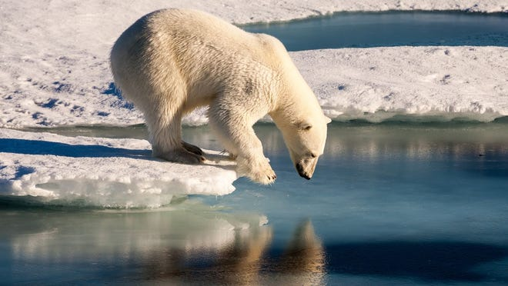

C. Density of a liquid
1. Describe the construction of a hydrometer and explain its operation.

2. Use a hydrometer and measure the density of water and CuSo₄ solution in g/cm³:
Density of water = ____________ Density of CuSo₄ solution = ______________
3. Using Archimedes’ principle:
 | Buoyant force in water¹ | Volume of object¹ | Buoyant force in CuSO₄ | Mass of CuSO₄ displaced | Density of CuSO₄
Al block
Steel Block
Lead sinker
Average density of CuSO₄
Density of CuSO₄ using hydrometer
% Difference
¹Copy the data from the first data table, DATA Table I.
D. Overall Conclusion for the entire lab, as it relates to the purpose.

