Remote Lab on Energy Name:________________________
- Watch this video. The wrecker ball didn't hit the chin of the professor, even though it broke the glass. Explain why?

- Refer your textbook and answer the following questions:
- Define kinetic energy (KE) using words and express it using an equation.

- Define gravitational potential energy (PE) using words and express it using an equation.

- What is mechanical energy (ME)?

- State the principle of conservation of mechanical energy?

- State the SI unit for energy and state whether energy a scalar or vector?

- Express the derived unit, joule (J) in terms of the base units.
Purpose: To investigate the motion of a cart down an inclined air-track and quantify its energy & acceleration.
Apparatus: Air-track, cart, electronic balance, metal can (to incline the air-track), photogate sensor w/cable, meter stick, transparent measuring tape with weight, lab stand, foot-ruler, Pasco 850-interface, and PC.
Theory: Potential Energy = Kinetic Energy =
Mechanical Energy = ME = PE + KE. Energy is a scalar.
Useful kinematic equation to find the acceleration: $v^{2}=v_{0}^{2}+2ax$.
UNITS:
 | Time | Mass | Force | Distance | Velocity | Acceleration | Energy
cgs | s | g | dyne | cm | cm/s | cm/s² | erg
SI | s | kg | newton, N | m | m/s | m/s² | joule, J
cgs- centimeter, gram, second; SI-International System;
PROCEDURE:
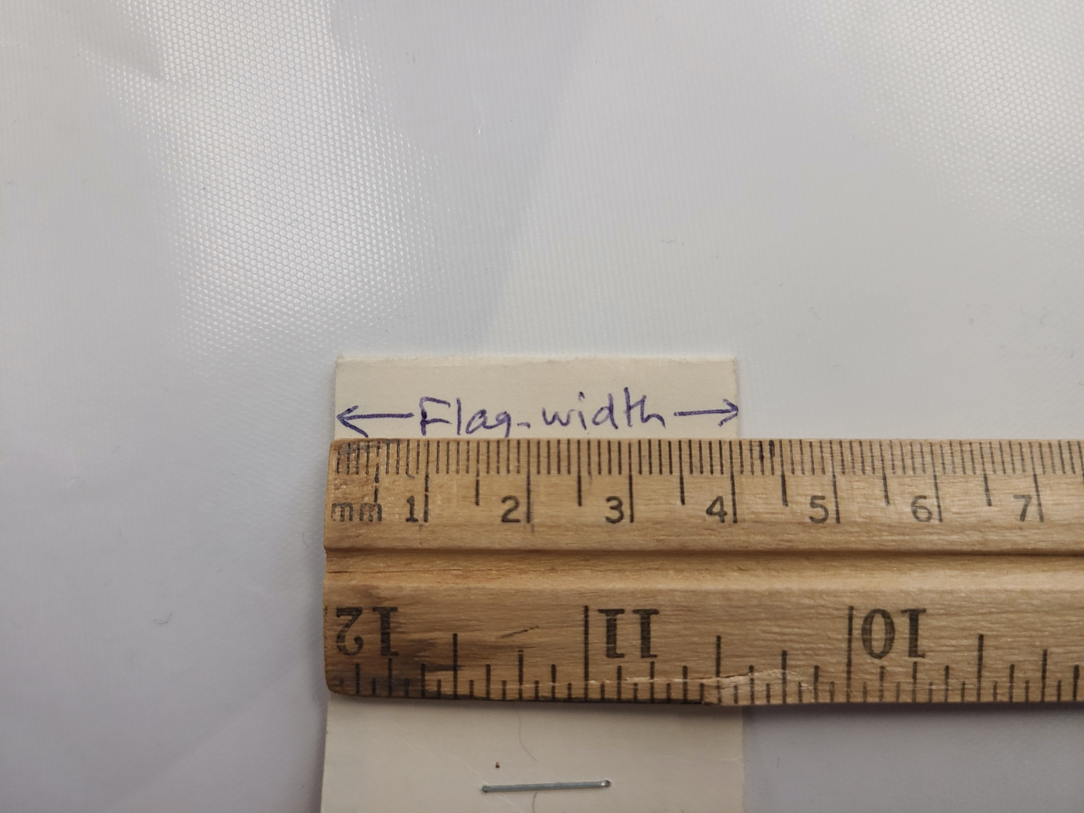
1. Watch the following videos about the apparatus and the experiment.
2. Record the mass (M) of the cart, starting position, and the Flag-Width
of the card on the cart.
3. Using the measurement shown in the above videos, Calculate the
kinetic energy of the cart at 125 cm (1.25 m) position in SI units.

4. Go to this page, and measure the height (h) for different positions (click the links), and record them in the data table: (Read the top of the white background, where the bottom of the track is located)
5. Record the velocities at different positions by watching the following videos:
Video1 and Video 2
DATA (Use SI units)
Mass of the cart = M = _______ Flag-Width of the card on the cart = __________
(This will be entered during Timer Set up with Capstone)
Starting position = _________ Initial velocity = 0 Accel. due to gravity = g = 9.8 m/s²
Photogate Position (m) | Height, h (m) | Velocity, v (m/s)
1.55
1.45
1.35
1.25
1.15
1.05
0.95
0.85
0.75
0.65
0.55
0.45
0.35
0.25
0.15

Angle of Incline

1. To find the angle of incline, θ the height of the metal can and the length (L) between the front leg and back legs of the air-track are needed.

2. Record the height of the metal can from the figure below and L by watching the video, Measuring L, and determine θ.
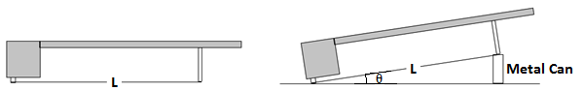

θ = ___________
DATA ANALYSIS
1. Enter the Photogate Position, Height, and Velocity (v) data in Excel
and create four more columns for Displacement, PE, KE, and ME, and
calculate them in SI units to 3 significant figures.
2. Plot PE, KE, and ME VERSUS Displacement; in a single graph.
3. Plot another graph, and obtain the acceleration along the track from the graph. Useful kinematic equation here is, $v^{2}=v_{0}^{2}+2ax$.
4. Also, obtain the acceleration along the track using the angle of incline and acceleration due to gravity, g = 9.8 m/s².
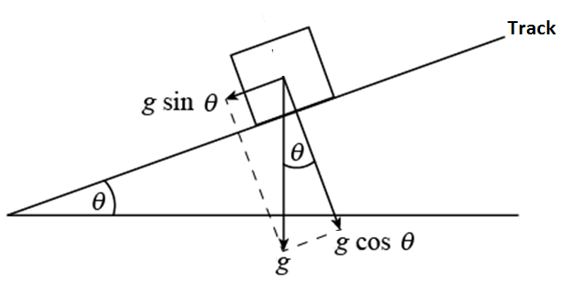
5. From the Excel data table, Mechanical energy = ME =___________
6. Acceleration along the track (from graph) a =__________

7. Acceleration along the track (using g and θ) a = _________
%Difference for the above accelerations =__________

8. Write a conclusion for the purpose.

