Energy PHYS 201L Name:________________________
Partner(s): ______________________________________________Day/Time:______
Refer your textbook (https://openstax.org/books/college-physics/pages/7-introduction-to-work-energy-and-energy-resources) and answer the following questions:
- Define kinetic energy (KE) using words and express it using an equation.

- Define gravitational potential energy (PE) using words and express it using an equation.

- What is mechanical energy (ME)?

- State the principle of conservation of mechanical energy?

- State the SI unit for energy and state whether energy a scalar or vector?

DATA (Use SI units)
Mass of the cart = M = _______ Flag-Width of the card on the cart = __________
(This will be entered during Timer Set up with Capstone)
Starting position = _________ Initial velocity = 0 Accel. due to gravity = g = 9.8 m/s²
Photogate Position (m) | Height, h (m) | Velocity, v (m/s)
1.55
1.45
1.35
1.25
1.15
1.05
0.95
0.85
0.75
0.65
0.55
0.45
0.35
0.25
Angle of Incline Collect the data necessary and calculate the angle of incline, θ.
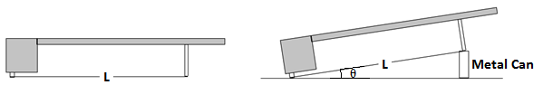
θ = ___________
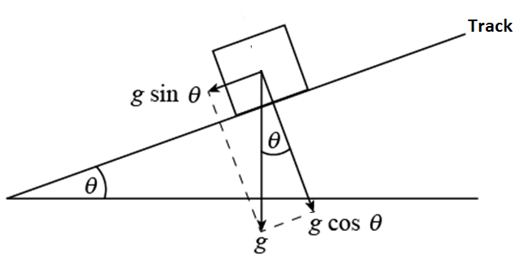
From the Excel data table, Mechanical energy = ME =___________

Acceleration along the track from Graph, a =__________

Acceleration along the track, using g and θ, a = ___________%Difference =__________

