Name:_____________________________________ Date: ________Time:__________
Partner(s):______________________________________________________________

Ballistic Pendulum Pre-Lab
1. Define momentum, identify it as a vector or scalar, and state its unit.

http://www.youtube.com/watch?v=4IYDb6K5UF8&feature=relmfu
2. State the principle of conservation of momentum.

3. A ball of mass 2-kg travelling to the right at 1.5 m/s collides head-on with another ball (mass = 3-kg) travelling to the left at 2.0 m/s. If the two balls stick together during the collision, what is the velocity (speed and direction) of the two balls after the collision?

http://www.youtube.com/watch?v=mFNe_pFZrsA&feature=related
4. Explain how the above demo illustrates the conservation of momentum.

Go to the following website and open Ballistic Pendulum in Chapter 9.
Listen to the audio introduction and answer the following questions:

5. What is a ballistic pendulum?

6. Which conservation principles are used in finding the initial velocity of the ball?

The Ballistic Pendulum and Projectile Motion

Purpose: To determine the initial velocity (u) of a projectile
A) By measuring its range and vertical distance of fall
B) By using the conservation of energy and momentum.

Apparatus: Ballistic pendulum, meter stick, white paper, carbon paper, tape, electronic balance, plumb-line, and small ruler.

Theory:

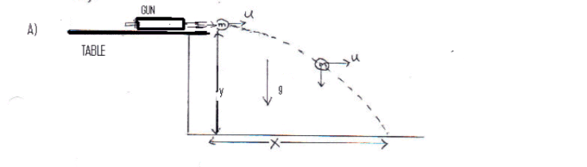
Using the kinematic equations for the above projectile motion, derive an expression for the initial horizontal velocity, u of the projectile in terms of Y, vertical distance of fall and g, acceleration due to gravity, and X, horizontal distance of travel.
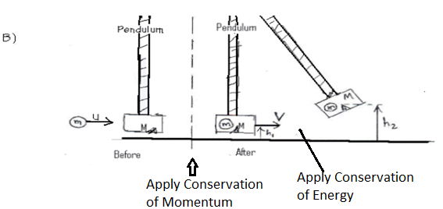
The collision is completely inelastic. The momentum is conserved but the kinetic energy is not conserved. During the collision, some of the energy is lost as heat. After the collision the energy is conserved. Just after the collision the pendulum & ball has kinetic energy and it is converted into gravitational potential energy when the pendulum & ball are raised to a height.
Use the conservation of momentum for the collision and conservation of energy after the collision, for raising the pendulum, and derive an expression for u in terms of m, M, g, h₂, and h₁.

Among the quantities you need to measure in this lab, which one(s) will have the highest error?

Procedure:
A) Measurement of the range and fall of a projectile.

1) Support the pendulum on the pawl and get the gun ready for firing.
2) The ball is fired horizontally to hit the floor. Fire the ball and determine approximately where it strikes the floor. Place a sheet of white paper on the floor so that the ball will hit it and secure the white paper to the floor with some tape. Place a carbon paper over the white paper. Fire the ball 4 more times.
3) Measure the range X and the vertical distance of fall, Y as shown in the diagram and complete the data table.

B) Ballistic pendulum

4) Get the gun ready for firing. Allow the pendulum to hang freely. When the pendulum is at rest, fire the ball into the pendulum bob. Record the notch number on the scale reached by the pawl when it catches the pendulum. Remove the ball from the pendulum.
5) Repeat procedure (4) 4 more times.
6) Compute the average value of the notch number. Set the pendulum with the pawl engaged in the average notch number, measure the height h₂ from the base of the apparatus to the index point on the pendulum.
7) With the pendulum hanging in its lowest position, measure the height h₁, from the base of the apparatus to the index point.
8) Record the mass of the pendulum, measure the mass of the ball, and complete the data table.
C) Write a conclusion

DATA TABLE:

A. Determination of the initial velocity (u) of a projectile from range and fall measurements:

Vertical distance of fall = Y = ________________________

Time of flight = t = __________________________

Average range = X =______________________Initial velocity = u =_______________________
B. Determination of the initial velocity (u) of a projectile using ballistic pendulum method.

Trial # | 1 | 2 | 3 | 4 | 5
Notch # of
Pendulum Catch
Average notch # =__________________

Height h₂ of pointer with pendulum catch in average notch number =_______________________

Height h₁ of pointer with pendulum freely suspended =__________________

Mass of ball m = ____________

Mass of pendulum M= ______________

Velocity of the pendulum & ball just after collision = V = ____________________

Initial velocity, u = ____________ % difference between results of parts A and B = _________

Use your data for part (B), in SI units, to answer the following questions.
1) Calculate the kinetic energy of the ball before the collision.

2) Calculate the kinetic energy of the ball and the pendulum bob just after the collision.

3) Calculate the energy loss due to the collision.

4) What fraction of the initial kinetic energy is lost?

5) Fraction of the initial kinetic energy lost = $\frac{M}{m+M}$. Calculate the ratio, and compare it. .

6) What happened to the lost energy?

