PHYS 201 WORK & POWER Name:________________________
Purpose: To investigate the work done and power developed by a person during walking & running up the steps.
Apparatus: foot-ruler, stop-watch, scale, building with 3 floors, and person.
Theory: Here we will look at WORK as defined below. We will assume that work only occurs when the force is sufficient to move the object. Work is a measure of what is done, not the effort applied in attempting to move the object. Work can be said to be energy in transit. Work has the same unit as energy.
Work = Force X Distance; Power = Work/Time.
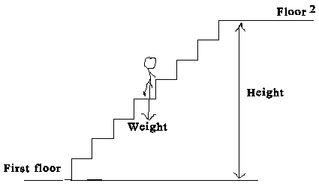
UNITS: (1 horse power = 1 hp = 746 W = 550 ft.lb/s)
 | Time | Distance | Mass | Weight | Velocity | Acceleration | Work | Power
cgs | s | cm | g | dyne | cm/s | cm/s² | erg | erg/s
SI | s | m | kg | newton, N | m/s | m/s² | joule,J | J/s = W
BE/USC | s | ft | slug | pound, lb | ft/s | ft/s² | ft.lb | ft.lb/s

PROCEDURE
1. Find the weight of the person who is going to do the walking and running.
2. Walk out to the steps and measure the height of each steps, # of steps, and determine the height for one level.
3. Time the walking and running.
4. Repeat 1-3 for two levels, and complete the data table.
DATA: Same person needs to do all the walking and running.
 | From 2nd floor to 3rd floor |  | From 1st floor to 3rd floor
 | Walking | Running | Walking | Running
Weight
Height
Time
Work
Power
Horse Power
Conclusion:

