PHYSICS 201  Equations Sheet | Translational Motion | Rotational Motion
PHYSICS 201  Equations Sheet | LINEAR | ANGULAR
Time | t | t
Displacement | x; (x = rθ) | θ
Velocity | v = Δx/Δt; (v = rω) | ω = Δθ/Δt
Acceleration | a = Δv/Δt; (a = rα) | α = Δω/Δt
Kinematic Equations | v = v₀ + at | ω = ω₀ + αt
Kinematic Equations | x = ½(v + v₀)t | θ = ½(ω + ω₀)t
Kinematic Equations | x = v₀t + ½ at² | θ = ω₀t + ½ αt²
Kinematic Equations | v² = v₀² + 2ax | ω² = ω₀² + 2αθ
Inertia | m = mass | I = Rotational inertia;
To create | force = F | torque = τ = LA· F
Newton's second law of motion | ΣF = ma | Στ = Iα
Newton's second law of motion | ΣF = Δp/Δt | Στ = ΔL/Δt
Work | F·x | τ·θ
Kinetic Energy | Translational Kinetic Energy = TKE = ½ mv² | Rotational Kinetic  Energy = RKE = ½ Iω²
Momentum | p = m·V | L = I·ω
Conservation of momentum | Σm_{i}v_{i} = Σm_{f}v_{f} | ΣI_{i}ω_{i} = ΣI_{f}ω_{f}
Conversion factors:
1 H = 3600 s, 1 Mile = 1608 m, 1 inch = 2.54 cm, 1 foot = 12 inch, 1 m = 3.281 ft, 1 kg = 1000 g.
1 m = 100 cm, 1 cm = 10 mm, 1 m = 1000 mm, 1 km = 1000 m, 1 LB (pound) = 4.448 N

Acceleration due to gravity = g = 9.8 m/s². 1 Revolution = 2π rad.
Frictional force = F_{fr}=μ_{k}F_{N} GPE = mgh
Pressure = Force/Area, Density = Mass/Volume, Buoyant Force: $F_{b}=ρ_{f}v_{f}g$

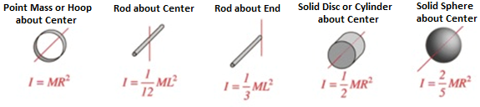

PHYS 201 Fall 2025 Test #3 Name:___________________________
I. For the following multiple-choice questions, write your answer in the line next to the question number. For questions 6, 8, and 10 show your work in the diagram.

____1. What is the angular speed in degree/hour of the hour hand of a standard analog watch? a. 6 b. 12 c. 15 d. 30 e. 36
____2. What is the angular speed in rad/s of the second hand of an analog watch?
a. 1.75 x 10⁻³ b. 0.105 c. 8.33 x 10⁻³ d. 8.73 x 10⁻³ e. 1.45 x 10⁻⁴
____3. The radius of each wheel on a bicycle is 0.40 m. The bicycle travels at 16 m/s. What is the angular velocity (in SI units) of the bicycle wheels (wheels do not slip)?
a. 2.5 b. 6.4 c. 16 d. 30 e. 40
4-5) Five hockey pucks are sliding across frictionless ice. The drawing shows a top view of the pucks and the three forces that act on each one. As shown, the forces have different magnitudes , and are applied at different points on the pucks.
____4. Which one of the five pucks is in Equilibrium?
____5. Which one of the five pucks has a net torque of 5FR, clockwise, about the center?
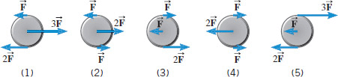

6-7) The drawing below illustrates an overhead view of a door and its axis of rotation. The axis is perpendicular to the page. There are four forces acting on the door, and they have the same magnitude.
6. Show the line-of-action and lever-arm for force F₄
in the diagram.
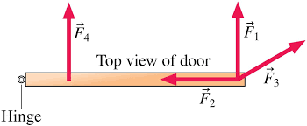
____7. Which force will provide zero torque,
about the axis of rotation?
a. F₁ b. F_{2.} c. F₃ d. F₄

8-10) Refer to the wheel system shown below. Its axis is at the center, perpendicular to the page. Assume F1 = 25-N, F2 = 50-N, inner radius = 60 cm, and outer radius = 150 cm.
8. Show the lever-arm for the force F₂ in the diagram.
____9. What is the net torque acting on the wheel?
a. 90 N.m, clockwise b. 75 N.m, counter-clockwise
c. 60 N.m, clockwise d. 60 N.m, counter-clockwise
e. 6000 N.m clockwise
10. Show the direction of rotation of the wheel in the diagram.
____11. Sit-ups are more difficult to do with your hands placed behind your head instead of on your stomach. This is because,
a. The mass is greater when the hands are placed behind the head instead on the stomach.
b. The mass is smaller when the hands are placed behind the head instead on the stomach.
c. The moment of inertia is greater when the hands are placed behind the head instead on the stomach.
d. The moment of inertia is smaller when the hands are placed behind the head instead on the stomach.

____12. A metal casting with air-cavities has a mass of 535-g in air and a mass of 367-g in water, when fully submerged. What is the total volume of all the cavities in the casting, in cm³? The density of this pure metal (that is, a sample with no cavities) is 8.9 g/cm³.
a. 168 cm³ b. 60.1 cm³ c. 108 cm³ d. 41.2 cm³ e. 127 cm³

____13. Workings of the fluid brake system can be explained using which one of these principles?
- Archimedes’ b. Pascal’s c. Bernoulli’s

____14. Which one of the following is a correct statement of Bernoulli’s principle?
a. A pressure change at any point in a confined incompressible fluid is not transmitted throughout the fluid.
b. A pressure change at any point in a confined incompressible fluid is transmitted throughout the fluid.
c. An increase in the speed of the fluid occurs simultaneously with a decrease in pressure or a decrease in the fluid's potential energy.
d. Buoyant force on an object submerged in a fluid is equal to the weight of the fluid it displaces.
e. An increase in the speed of the fluid occurs simultaneously with an increase in pressure or an increase in the fluid's potential energy.
f. Buoyant force on an object submerged in a fluid is not equal to the weight of the fluid it displaces.
__________________________end of MC questions_____________________________________

II. A solid sphere of mass 2.5 kg and diameter 12 cm is rolling with an angular velocity of 25 rad/s.
(a) Determine the rotational inertia (moment of inertia) of the solid sphere?
(b) Calculate the total kinetic energy of the solid sphere?

III. A uniform meter stick of weight 1.5 N is supported using two supports as shown below. Exact location of the support points can be read using the magnified portions.
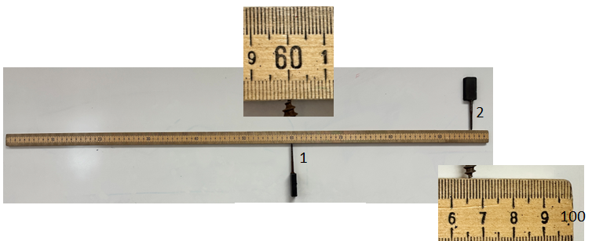
1. Location of the center of gravity of the meter stick.______________________

2. Location of the support point 1:________________________

3. Location of the support point 2:________________________

4. Draw a free body diagram for the meter stick in the diagram.

5. Determine the force exerted in support point 2.

IV. A uniform lunch tray is being held in one hand, as the drawing illustrates. The mass of the tray is 0.22 kg. On the tray is a 1.2 kg plate of food and a 0.45 kg cup of coffee. Draw a free-body-diagram and obtain the force, T (in SI unit) exerted by the thumb, to hold the plate horizontally.
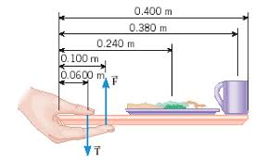

V. A soccer player extends her lower leg in a kicking motion by exerting a force with the muscle above the knee in the front of her leg. Starting from rest she produces an angular velocity of 25 rad/s by swinging her lower leg by 80 degrees.
1. Convert the 80 degrees in radians.

2. Calculate the angular acceleration of the kick.

3. Determine the torque, if her lower leg has a moment of inertia of 0.750 kg⋅m².

4. What is the force exerted by the muscle if its effective perpendicular lever arm is 1.90 cm?

VI. A house roof with an area of 190 m² is shown. Wind blows over the top with a speed of 45 m/s. The air inside the house is stagnant. The density of air is 1.29 kg/m³.
1. What is the pressure difference $P_{A}-P_{B}=?$
2. What is the force exerted on the roof due to the wind?

