PHYSICS 201  Equations Sheet | Translational Motion | Rotational Motion
PHYSICS 201  Equations Sheet | LINEAR | ANGULAR
Time | t | t
Displacement | x; (x = rθ) | θ
Velocity | v = Δx/Δt; (v = rω) | ω = Δθ/Δt
Acceleration | a = Δv/Δt; (a = rα) | α = Δω/Δt
Kinematic Equations | v = v₀ + at | ω = ω₀ + αt
Kinematic Equations | x = ½(v + v₀)t | θ = ½(ω + ω₀)t
Kinematic Equations | x = v₀t + ½ at² | θ = ω₀t + ½ αt²
Kinematic Equations | v² = v₀² + 2ax | ω² = ω₀² + 2αθ
Inertia | m = mass | I = Rotational inertia;
To create | force = F | torque = τ = LA· F
Newton's second law of motion | ΣF = ma | Στ = Iα
Newton's second law of motion | ΣF = Δp/Δt | Στ = ΔL/Δt
Work | F·x | τ·θ
Kinetic Energy | Translational Kinetic Energy = TKE = ½ mv² | Rotational Kinetic  Energy = RKE = ½ Iω²
Momentum | p = m·V | L = I·ω
Conservation of momentum | Σm_{i}v_{i} = Σm_{f}v_{f} | ΣI_{i}ω_{i} = ΣI_{f}ω_{f}
Conversion factors:
1 H = 3600 s, 1 Mile = 1608 m, 1 inch = 2.54 cm, 1 foot = 12 inch, 1 m = 3.281 ft, 1 kg = 1000 g.
1 m = 100 cm, 1 cm = 10 mm, 1 m = 1000 mm, 1 km = 1000 m, 1 LB (pound) = 4.448 N

Acceleration due to gravity = g = 9.8 m/s². 1 Revolution = 2π rad.
Frictional force = F_{fr}=μ_{k}F_{N} GPE = mgh
Pressure = Force/Area, Density = Mass/Volume, Buoyant Force: $F_{b}=ρ_{f}v_{f}g$

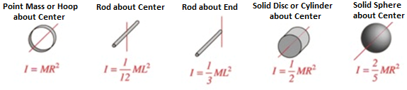

PHYS 201 Fall 2025 Test #3 Name:___________________________
I. For the following multiple-choice questions, write your answer in the line next to the question number. For questions 6, 8, and 10 show your work in the diagram.

____1. What is the angular speed in degree/hour for the rotation of Earth?
a. 6 b. 12 c. 15 d. 30 e. 36
____2. What is the angular speed in rad/s of the minute hand of an analog watch?
a. 1.75 x 10⁻³ b. 0.105 c. 8.33 x 10⁻³ d. 8.73 x 10⁻³ e. 1.45 x 10⁻⁴
____3. The radius of each wheel on a bicycle is 0.40 m. The bicycle travels at 16 m/s. What is the angular velocity (in SI units) of the bicycle wheels (wheels do not slip)?
a. 2.5 b. 6.4 c. 16 d. 30 e. 40
4-5) Five hockey pucks are sliding across frictionless ice. The drawing shows a top view of the pucks and the three forces that act on each one. As shown, the forces have different magnitudes , and are applied at different points on the pucks.
____4. Which one of the five pucks is in Equilibrium?
____5. Which one of the five pucks has a net torque of 2FR, counterclockwise, about the center?
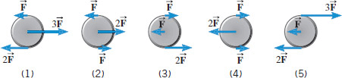

6-7) The drawing below illustrates an overhead view of a door and its axis of rotation. The axis is perpendicular to the page. There are four forces acting on the door, and they have the same magnitude.
6. Show the line-of-action and lever-arm for force F₃
in the diagram.
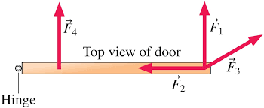
____7. Which force will provide the largest torque,
about the axis of rotation?
a. F₁ b. F_{2.} c. F₃ d. F₄

8-10) Refer to the wheel system shown below. Its axis is at the center, perpendicular to the page. Assume F1 = 25-N, F2 = 50-N, inner radius = 60 cm, and outer radius = 150 cm.
8. Show the lever-arm for the force F₁ in the diagram.
____9. What is the net torque acting on the wheel?
a. 90 N.m, clockwise b. 75 N.m, clockwise
c. 60 N.m, clockwise d. 60 N.m, counter-clockwise
10. Show the direction of rotation of the wheel in the diagram.
____11. Sit-ups are more difficult to do with your hands placed behind your head instead of on your stomach. This is because,
a. The mass is greater when the hands are placed behind the head instead on the stomach.
b. The mass is smaller when the hands are placed behind the head instead on the stomach.
c. The moment of inertia is greater when the hands are placed behind the head instead on the stomach.
d. The moment of inertia is smaller when the hands are placed behind the head instead on the stomach.

____12. A metal casting with air-cavities has a mass of 535-g in air and a mass of 367-g in water, when fully submerged. What is the total volume of all the cavities in the casting, in cm³? The density of this pure metal (that is, a sample with no cavities) is 8.9 g/cm³.
a. 168 cm³ b. 60.1 cm³ c. 108 cm³ d. 41.2 cm³ e. 127 cm³

____13. When you are in a swimming pool your reduced weight can be explained using which one of these principles?
- Archimedes’ b. Pascal’s c. Bernoulli’s

____14. Which one of the following is a correct statement of Archimedes’ principle?
a. A pressure change at any point in a confined incompressible fluid is not transmitted throughout the fluid.
b. A pressure change at any point in a confined incompressible fluid is transmitted throughout the fluid.
c. An increase in the speed of the fluid occurs simultaneously with a decrease in pressure or a decrease in the fluid's potential energy.
d. Buoyant force on an object submerged in a fluid is equal to the weight of the fluid it displaces.
e. An increase in the speed of the fluid occurs simultaneously with an increase in pressure or an increase in the fluid's potential energy.
f. Buoyant force on an object submerged in a fluid is not equal to the weight of the fluid it displaces.
__________________________end of MC questions____________________________________
II. While punting a football, a kicker rotates her leg about the hip joint. The moment of inertia of the leg is 3.75 kg⋅m² and its rotational kinetic energy is 175 J.
(a) What is the angular velocity of the leg? (b) What is the velocity of tip of the punter’s shoe if it is 1.05 m from the hip joint?

III. A uniform meter stick of weight 1.2 N is supported using two supports as shown below. Exact location of the support points can be read using the magnified portions.

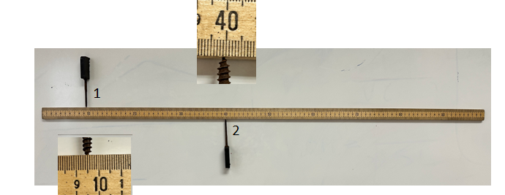
1. Location of the center of gravity of the meter stick.______________________

2. Location of the support point 1:________________________

3. Location of the support point 2:________________________

4. Draw a free body diagram for the meter stick in the diagram.

5. Determine the force exerted in the support point 2.

IV. For the forearm side plank pose shown below draw a free-body diagram and determine the force exerted by the floor on the forearm. Assume that the horizontal forces can be neglected, mass of the person is 65 kg, distance between the contact points with the floor is 1.9 m, and her center of gravity is located 0.6 m from the forearm contact point.
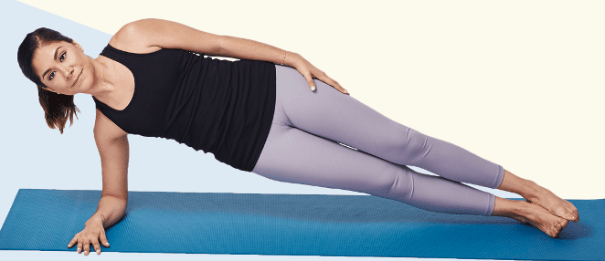
V. The triceps muscle in the back of the upper arm extends the forearm. This muscle in a professional boxer exerts a force of 2.00×10³ N with an effective perpendicular lever arm of 3.00 cm, producing an angular acceleration of the forearm of 120 rad/s². What is the moment of inertia of the boxer’s forearm?

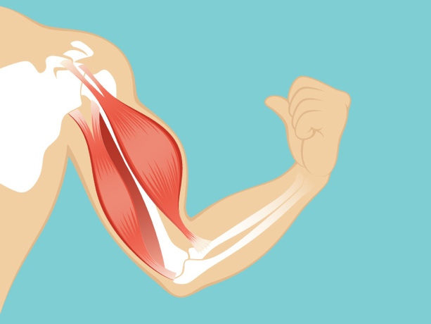

VI. The aorta carries blood away from the heart at a speed of about 40 cm/s and has a radius of approximately 1.1 cm. The aorta branches eventually into a large number of tiny capillaries that distribute the blood to the various body organs. In a capillary, the blood speed is approximately 0.07 cm/s, and the radius is about 6 x 10⁻⁴ cm. Treat the blood as an incompressible fluid and use these data to determine the approximate number of capillaries in the human body.
