PHYSICS 201  Equations Sheet | Translational Motion | Rotational Motion
PHYSICS 201  Equations Sheet | LINEAR | ANGULAR
Time | t | t
Displacement | x; (x = rθ) | θ
Velocity | v = Δx/Δt; (v = rω) | ω = Δθ/Δt
Acceleration | a = Δv/Δt; (a = rα) | α = Δω/Δt
Kinematic Equations | v = v₀ + at | ω = ω₀ + αt
Kinematic Equations | x = ½(v + v₀)t | θ = ½(ω + ω₀)t
Kinematic Equations | x = v₀t + ½ at² | θ = ω₀t + ½ αt²
Kinematic Equations | v² = v₀² + 2ax | ω² = ω₀² + 2αθ
Inertia | m = mass | I = Rotational inertia;
To create | force = F | torque = τ = LA· F
Newton's second law of motion | ΣF = ma | Στ = Iα
Newton's second law of motion | ΣF = Δp/Δt | Στ = ΔL/Δt
Work | F·x | τ·θ
Kinetic Energy | Translational Kinetic Energy = TKE = ½ mv² | Rotational Kinetic  Energy = RKE = ½ Iω²
Momentum | p = m·V | L = I·ω
Conservation of momentum | Σm_{i}v_{i} = Σm_{f}v_{f} | ΣI_{i}ω_{i} = ΣI_{f}ω_{f}
Conversion factors:
1 H = 3600 s, 1 Mile = 1608 m, 1 inch = 2.54 cm, 1 foot = 12 inch, 1 m = 3.281 ft, 1 kg = 1000 g.
1 m = 100 cm, 1 cm = 10 mm, 1 m = 1000 mm, 1 km = 1000 m, 1 LB (pound) = 4.448 N

Acceleration due to gravity = g = 9.8 m/s². 1 Revolution = 2π rad.
Frictional force = F_{fr}=μ_{k}F_{N} GPE = mgh
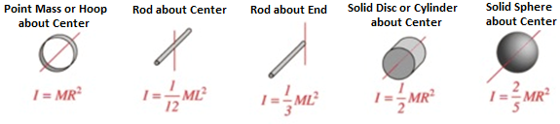
Pressure = Force/Area, Density = Mass/Volume, Buoyant Force: $F_{b}=ρ_{f}v_{f}g$

PHYS 201 Fall 2025 Test #3 Name:___________________________
I. For the following multiple-choice questions, write your answer in the line next to the question number. For questions 6, 8, and 10 show your work in the diagram.

____1. What is the angular speed in degree/minute of the minute hand of an analog watch? a. 6 b. 12 c. 15 d. 30 e. 36
____2. What is the angular speed in rad/s of the hour hand of an analog watch?
a. 1.75 x 10⁻³ b. 0.105 c. 8.33 x 10⁻³ d. 8.73 x 10⁻³ e. 1.45 x 10⁻⁴
____3. The radius of each wheel on a bicycle is 0.40 m. The bicycle travels at 16 m/s. What is the angular velocity (in SI units) of the bicycle wheels (wheels do not slip)?
a. 2.5 b. 6.4 c. 16 d. 30 e. 40
4-5) Five hockey pucks are sliding across frictionless ice. The drawing shows a top view of the pucks and the three forces that act on each one. As shown, the forces have different magnitudes , and are applied at different points on the pucks.
____4. Which one of the five pucks is in Equilibrium?
____5. Which one of the five pucks has a net torque of FR, counterclockwise, about the center?
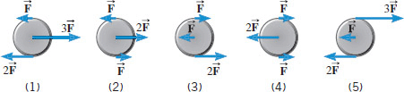

6-7) The drawing below illustrates an overhead view of a door and its axis of rotation. The axis is perpendicular to the page. There are four forces acting on the door, and they have the same magnitude.
6. Show the line-of-action and lever-arm for force F₃
in the diagram.
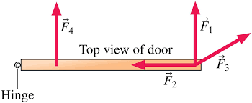
____7. Which force will provide the largest (no) torque,
about the axis of rotation?
a. F₁ b. F_{2.} c. F₃ d. F₄

8-10) Refer to the wheel system shown below. Its axis is at the center, perpendicular to the page. Assume F1 = 25-N, F2 = 50-N, inner radius = 60 cm, and outer radius = 150 cm.
8. Show the lever-arm for the force F₁ in the diagram.
____9. What is the net torque acting on the wheel?
a. 90 N.m, clockwise b. 75 N.m, clockwise
c. 60 N.m, clockwise d. 60 N.m, counter-clockwise
10. Show the direction of rotation of the wheel in the diagram.
____11. Sit-ups are more difficult to do with your hands placed behind your head instead of on your stomach. This is because,
a. The mass is greater when the hands are placed behind the head instead on the stomach.
b. The mass is smaller when the hands are placed behind the head instead on the stomach.
c. The moment of inertia is greater when the hands are placed behind the head instead on the stomach.
d. The moment of inertia is smaller when the hands are placed behind the head instead on the stomach.

____12. A metal casting with air-cavities has a mass of 535-g in air and a mass of 367-g in water, when fully submerged. What is the total volume of all the cavities in the casting, in cm³? The density of this pure metal (that is, a sample with no cavities) is 8.9 g/cm³.
a. 168 cm³ b. 60.1 cm³ c. 108 cm³ d. 41.2 cm³ e. 127 cm³

____13. Lift force on an airplane can be explained using which one of these principles?
- Archimedes’ b. Pascal’s c. Bernoulli’s

____14. Which one of the following is a correct statement of Pascal’s principle?
a. A pressure change at any point in a confined incompressible fluid is not transmitted throughout the fluid.
b. A pressure change at any point in a confined incompressible fluid is transmitted throughout the fluid.
c. An increase in the speed of the fluid occurs simultaneously with a decrease in pressure or a decrease in the fluid's potential energy.
d. Buoyant force on an object submerged in a fluid is equal to the weight of the fluid it displaces.
e. An increase in the speed of the fluid occurs simultaneously with an increase in pressure or an increase in the fluid's potential energy.
f. Buoyant force on an object submerged in a fluid is not equal to the weight of the fluid it displaces.
____________________________________end of MC questions___________________________
II. A man holds a 145-N ball in his hand, with the forearm horizontal, as shown in the drawing. He can do this with the help of the flexor muscle and the upper arm bone pushing the forearm at the elbow joint. The forearm weighs 19 N.
1. Complete the free-body diagram by showing the rest of the forces
acting in the forearm in the diagram.
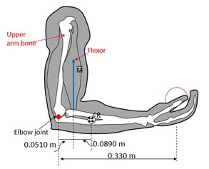
2. Determine the force exerted by the upper arm bone.

III. Consider the 12.0 kg motorcycle wheel shown. Assume it to be approximately an annular ring with an inner radius of 0.280 m and an outer radius of 0.330 m. The motorcycle is on its center stand, so that the wheel can spin freely.
1. If the drive chain exerts a force of 1900 N at a radius of 6.00 cm,
what is the torque?
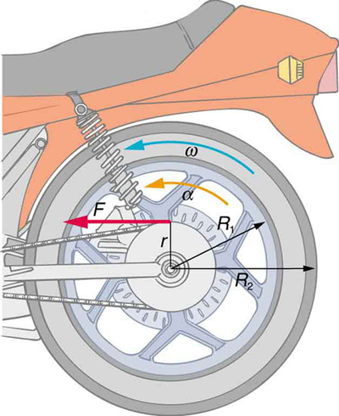

2. Calculate the rotational inertia of the wheel?
I (annular ring) = 0.5 M (R₁² +R₂²)

3. what is the angular acceleration of the wheel?

4. How long, starting from rest, does it take to reach an angular velocity of
80.0 rad/s?

5. What is the kinetic energy of the wheel at the above angular velocity?

IV. An airplane wing is designed so that the speed of the air across the top of the wing is 251 m/s when the speed of the air below the wing is 225 m/s. The density of the air is 1.29 kg/m³. What is the lifting force on a wing of area 24.0 m²?
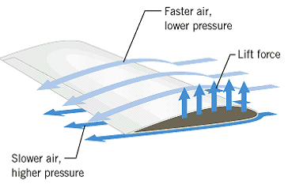

V. A uniform meter stick of weight 1.2 N is supported using two supports as shown below. Exact location of the support points (1 & 2) can be read using the magnified portions.

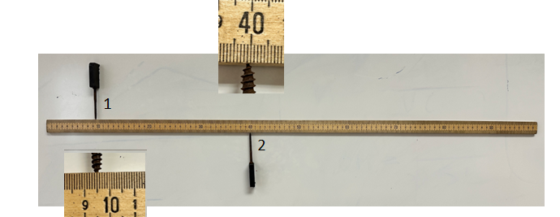
1. Location of the center of gravity of the meter stick.______________________

2. Location of the support point 1:________________________

3. Location of the support point 2:________________________

4. Draw a free body diagram for the meter stick in the diagram.

5. Determine the force exerted in the support point 1.

VI. 1. State the law of conservation of angular momentum.

2. A person, stretching his hands out and holding two masses (6.5 kg each), as shown is rotating at an angular speed of 2.5 rad/s. What will be the angular speed if he drops both masses while holding this position? Assume that each of the masses are 0.8 m from the axis of rotation and the rotational inertia of the person and stool (without the masses in hands) is 7.2 kg.m².
