PHYSICS 201  Equations Sheet | Translational Motion | Rotational Motion
 | LINEAR | ANGULAR
Time | t | T
Displacement | x; (x = rθ) | θ
Velocity | v = Δx/Δt; (v = rω) | ω = Δθ/Δt
Acceleration | a = Δv/Δt; (a = rα) | α = Δω/Δt
Kinematic Equations | v = v₀ + at | ω = ω₀ + αt
 | x = ½(v + v₀)t | θ = ½(ω + ω₀)t
 | x = v₀t + ½ at² | θ = ω₀t + ½ αt²
 | v² = v₀² + 2ax | ω² = ω₀² + 2αθ
Inertia | m = mass | I = Rotational inertia;
To create | force = F | torque = τ = LA· F
Newton's second law of motion | ΣF = ma | Στ = Iα
 | ΣF = Δp/Δt | Στ = ΔL/Δt
Work | F·x | τ·θ
Kinetic Energy | Translational Kinetic Energy = TKE = ½ mv² | Rotational Kinetic  Energy = RKE = ½ Iω²
Momentum | p = m·V | L = I·ω
Conservation of momentum | Σm_{i}v_{i} = Σm_{f}v_{f} | ΣI_{i}ω_{i} = ΣI_{f}ω_{f}
Conversion factors:
1 H = 3600 s, 1 Mile = 1608 m, 1 inch = 2.54 cm, 1 foot = 12 inch, 1 m = 3.281 ft, 1 kg = 1000 g.
1 m = 100 cm, 1 cm = 10 mm, 1 m = 1000 mm, 1 km = 1000 m, 1 LB (pound) = 4.448 N

Acceleration due to gravity = g = 9.8 m/s². 1 Revolution = 2π rad.
Frictional force = F_{fr}=μ_{k}F_{N} GPE = mgh
Area of a circle of radius r, A_{circle} = π r² . Area of a rectangle of length l, and width w, A_{rec}=l x w; Area of a triangle, A_{triangle}= 0.5 x base x height.
Volume of a cylinder of radius r and height h; V= π r²h; Volume of a sphere = (4/3) π r³.

PHYS 201 Fall 2023 Test #3 Name:___________________________
I. For the following multiple choice questions, write your answer in the line next to the question number.
____1. What is the angular speed in degree/hour of the hour hand of an analog clock?
a. 6 b. 12 c. 15 d. 30 e. 36

____2. What is the angular speed in rad/s of the hour hand of an analog watch?
a. 1.75 x 10⁻³ b. 0.105 c. 8.33 x 10⁻³ d. 8.73 x 10⁻³ e. 1.45 x 10⁻⁴
____3. The radius of each wheel on a bicycle is 0.40 m. The bicycle travels at 16 m/s. What is the angular velocity (in SI units) of the bicycle wheels (wheels do not slip)?
a. 2.5 b. 6.4 c. 16 d. 30 e. 40
____4. The drawing illustrates an overhead view of a door and its axis of rotation. The axis is perpendicular to the page. There are four forces acting on the door, and they have the same magnitude. Which force will provide the highest torque, about the axis of rotation?
a. F₁
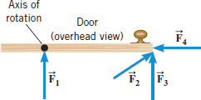
b. F₂
c. F₃
d. F₄

5. Show the line of action and the lever-arm for the force F₃ in the diagram.

6-7) Five hockey pucks are sliding across frictionless ice. The drawing shows a top view of the pucks and the three forces that act on each one. As shown, the forces have different magnitudes , and are applied at different points on the pucks.
____6. Which one of the five pucks is in Equilibrium?
____7. Which one of the five pucks has a net torque of 5FR, about the center?
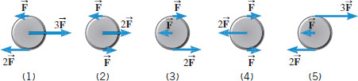
8-10) A uniform meter stick is supported at the 70 cm mark using a knife-edge clamp of mass 19 g (g =gram). Balance is obtained when a 56 g mass is suspended at the 80 cm mark.
8. Draw a free-body diagram for the meter stick.
____9. What is the mass of the meter stick?
a. 8 g b. 11 g c. 28 g d. 112 g
8.
____10. What is the normal force at the support point?
a. 0.82 N b. 1.0 N c. 84 N d. 103 N
II. Three forces are applied to a solid cylinder of mass 15 kg (see the drawing). The magnitudes of the forces are F₁ = 35 N, F₂ = 27 N, and F₃ = 18 N. The radial distances are R₂ = 0.25 m and R₃ = 0.12 m. The forces F₂ and F₃ are perpendicular to the radial lines labeled R₂ and R₃.
a. Find the angular acceleration (magnitude and direction)
of the cylinder about the axis of rotation.
b. If the cylinder is at rest initially, how long will it take for
the cylinder to reach 100 rad/s?
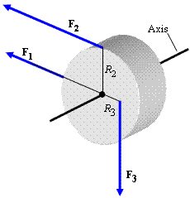

III. A playground merry-go-round (a disk) has a mass of 130 kg and a radius of 2.5 m. A 16 kg child stands at the center and the system (merry-go-round and child) is rotating with an angular velocity of 4.5 rad/s, assume I_{i}ω_{i} = I_{f}ω_{f}.
1. What will happen to the angular velocity if the child walks towards the edge? Explain your answer.

2. Calculate the angular velocity of the system when the child reaches the edge?

IV. The drawing shows a person, mass = 69 kg, doing forearm push-ups. Distance between the forearm contact point and feet is 1.8 m and the distance between the person’s center of gravity and the feet is 1.2 m. Draw a free-body-diagram, show the distances, and find the force exerted by the floor on each foot, assuming the person holds this position.
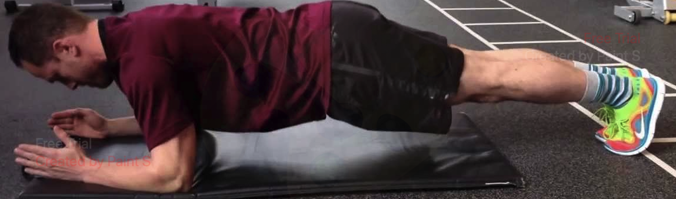

V. A bowler holds a bowling ball (M = 8.2 kg) in the palm of his hand. His upper arm is vertical; his lower arm (2.1 kg) is horizontal.
(a) Draw a free-body diagram for the forearm.
(b) Determine the force of the biceps muscle on the lower arm.
