PHYSICS 201  Equations Sheet | Translational Motion | Rotational Motion
 | LINEAR | ANGULAR
Time | t | T
Displacement | x; (x = rθ) | θ
Velocity | v = Δx/Δt; (v = rω) | ω = Δθ/Δt
Acceleration | a = Δv/Δt; (a = rα) | α = Δω/Δt
Kinematic Equations | v = v₀ + at | ω = ω₀ + αt
 | x = ½(v + v₀)t | θ = ½(ω + ω₀)t
 | x = v₀t + ½ at² | θ = ω₀t + ½ αt²
 | v² = v₀² + 2ax | ω² = ω₀² + 2αθ
Inertia | m = mass | I = Rotational inertia;
To create | force = F | torque = τ = LA· F
Newton's second law of motion | ΣF = ma | Στ = Iα
 | ΣF = Δp/Δt | Στ = ΔL/Δt
Work | F·x | τ·θ
Kinetic Energy | Translational Kinetic Energy = TKE = ½ mv² | Rotational Kinetic  Energy = RKE = ½ Iω²
Momentum | p = m·V | L = I·ω
Conservation of momentum | Σm_{i}v_{i} = Σm_{f}v_{f} | ΣI_{i}ω_{i} = ΣI_{f}ω_{f}

Pressure = Force/Area P_{abs} = P_{atm} + P_{G} Density = Mass/Volume
Pressure (P) due to depth h of fluid of density ρ; P = ρgh.
1 atm = 1.013 x 10⁵ N/m² = 76 cm.Hg = 760 mm.Hg

Buoyant force: $F_{b}=ρ_{f}v_{f}g$

The density of the air is 1.29 kg/m³; Density of water = 1000 kg/m³ = 1 g/cm³; Acceleration due to gravity = g = 9.8 m/s². 1 Revolution = 2π rad.
Area of a circle of radius r, A_{circle} = π r² .Area of a rectangle of length l, and width w, A_{rec}=l x w; Area of a triangle, A_{triangle}= 0.5 x base x height.
Volume of a cylinder of radius r and height h; V= π r²h; Volume of a sphere = (4/3) π r³.
Frictional force = F_{fr}=μ_{k}F_{N} GPE = mgh

PHYS 201 Fall 2022 Test #3 Name:___________________________
I. For the following multiple-choice questions, write your answer in the line next to the question number.

____1. What is the angular speed in degree/hour of the hour hand of an analog watch?
a. 6 b. 12 c. 15 d. 30 e. 36

____2. What is the angular speed in rad/s of the hour hand of an analog watch?
a. 1.75 x 10⁻³ b. 0.105 c. 8.33 x 10⁻³ d. 8.73 x 10⁻³ e. 1.45 x 10⁻⁴
____3. The radius of each wheel on a bicycle is 0.400 m. The bicycle travels a distance of 3.0 km. How many revolutions does each wheel make (wheels do not slip)?
a. 7.5 b. 1200 c. 2400 d. 6000 e. 7500
____4. The drawing illustrates top view of a door and its hinge/axis of rotation. The axis is perpendicular to the page. There are four forces acting on the door, and they have the same magnitude. Which force will provide the highest torque, about the axis of rotation?
a. F₁
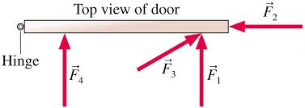
b. F₂
c. F₃
d. F₄

____5. For the above question, which force,
provide no torque about the axis of rotation?
a. F₁ b. F₂ c. F₃ d. F₄

6-7) Five hockey pucks are sliding across frictionless ice. The drawing shows a top view of the pucks and the three forces that act on each one. As shown, the forces have different magnitudes , and are applied at different points on the pucks.
____6. Which one of the five pucks is in Equilibrium?
____7. Which one of the five pucks has a net torque of 5FR, about the center?
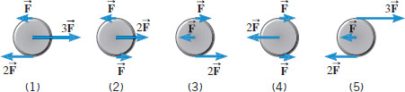

____8. A twin-sized air mattress used for camping has dimensions of 70 cm by 150 cm by 10 cm when blown up. The weight of the mattress is 17.0 kg. How heavy a person could the air mattress hold if it is placed in freshwater?
a. 17.0 kg b. 88 kg c. 105 kg d. 122 kg e. 170 kg
____9. What is the pressure difference between the top and bottom of a 645-m high skyscraper? Assume that the density of air is a constant 1.29 kg/m³.
a. 76 cm. of Hg b. 6321 Pa c. 76 Pa d. 832 Pa e. 8154 Pa
____10. The purpose of a water tower is to provide storage capacity
and to provide sufficient pressure in the pipes that deliver the water
to customers. The drawing shows a spherical reservoir, which is
vented to the atmosphere at the top and full. What height must be
used to find the gauge pressure at the faucet in house B?
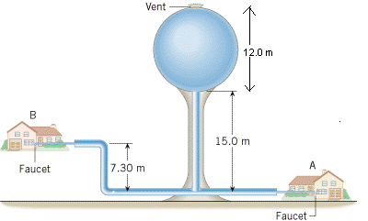
a. 7.3 m b. 15 m c. 19.7 m
d. 27 m e. 34.3 m

____11. Which one of the following is a correct statement of Pascal’s principle?
a. Any change in the pressure applied to a completely enclosed fluid is transmitted undiminished to all parts of the fluid and the enclosing walls.
b. Any fluid applies a buoyant force to an object that is partially or completely immersed in it; the magnitude of the buoyant force is greater than the weight of the fluid that the object displaces.
c. Gauge pressure is the pressure measured by a pressure gauge. It is the difference between the absolute pressure and atmospheric pressure.
d.
Any fluid applies a buoyant force to an object that is partially or completely immersed in it; the magnitude of the buoyant force is less than the weight of the fluid that the object displaces.
e. Any fluid applies a buoyant force to an object that is partially or completely immersed in it; the magnitude of the buoyant force equals the weight of the fluid that the object displaces.

____12. Sit-ups are more difficult to do with your hands placed behind your head instead of on your stomach. This is because,
a. The mass is greater when the hands are placed behind the head instead on the stomach.
b. The mass is smaller when the hands are placed behind the head instead on the stomach.
c. The moment of inertia is greater when the hands are placed behind the head instead on the stomach.
d. The moment of inertia is smaller when the hands are placed behind the head instead on the stomach.

____13. A metal casting with air-cavities has a mass of 535-g in air and a mass of 367-g in water, when fully submerged. What is the total volume of all the cavities in the casting, in cm³? The density of this pure metal (that is, a sample with no cavities) is 8.9 g/cm³.
a. 168 cm³ b. 60.1 cm³ c. 108 cm³ d. 41.2 cm³ e. 127 cm³

________End of MC questions______________________________________________

II. A 1220-N uniform beam is attached to a vertical wall at one
end and is supported by a cable at the other end. A 1960-N crate
hangs from the far end of the beam.
a. Draw a free-body diagram for the beam and identify
all the forces.
b. Resolve the tension in the cable into horizontal and
vertical components.
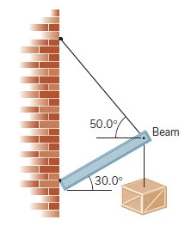

III. Consider the 12.0 kg motorcycle wheel shown in Figure. Assume it to be approximately an annular ring with an inner radius of 0.280 m and an outer radius of 0.330 m. The motorcycle is on its center stand, so that the wheel can spin freely.
(a) Calculate the rotational inertia of the wheel? I (annular ring) = 0.5 M(R₁² +R₂² )
(b) If the drive chain exerts a force of 2200 N at a radius of 5.00 cm, what is the angular acceleration of the wheel?
(c) How long, starting from rest, does it take to reach an angular velocity of 80.0 rad/s?
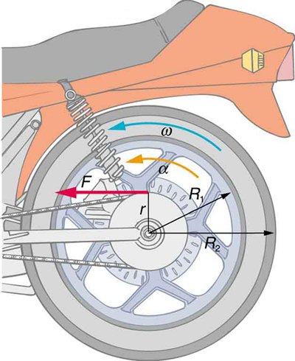

IV. Calculate the moment of inertia (in SI unit) of a skater assuming the following model: The skater is approximated as a cylinder (mass of 58 kg and radius 0.14 m), arms approximated as two long rods (mass of 0.89 kg and length 0.83 m for each) extend straight out from the axis of the cylinder, and solid spherical head (mass = 3 kg and radius = 0.12 m) attached to the top of the cylinder, as shown below.
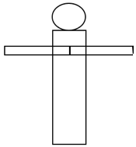
V. The drawing shows a person, mass = 96 kg, doing push-ups. Draw a free-body-diagram and find the force exerted by the floor on each foot (in SI unit), assuming that the person holds this position.
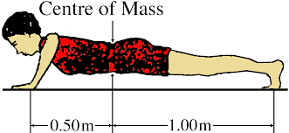

VII. A man holds a 125-N ball in his hand, with the forearm horizontal, as shown in the drawing. He can support the ball in this position because of the flexor muscle force,$\vec{M}$, which is applied perpendicular to the forearm and the force, $\vec{B}$, applied by the upper-arm bone. The forearm weighs 21.0 N and has a center of gravity as shown.
a) Show the weight of the ball and forearm in the diagram.
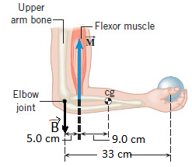
b) Find the magnitude of the force $\vec{B}$.

VII. A person, stretching his hands out and holding two masses (5.5 kg each), as shown is rotating at an angular speed of 3.5 rad/s. What will be the angular speed if he drops both masses while holding this position? Assume that each of the masses are 0.8 m from the axis of rotation and the rotational inertia of the person and stool (without the masses in hands) is 6.2 kg.m². 