PHYSICS 201  Equations Sheet | Translational Motion | Rotational Motion
 | LINEAR | ANGULAR
Time | t | T
Displacement | x; (x = rθ) | θ
Velocity | v = Δx/Δt; (v = rω) | ω = Δθ/Δt
Acceleration | a = Δv/Δt; (a = rα) | α = Δω/Δt
Kinematic Equations | v = v₀ + at | ω = ω₀ + αt
 | x = ½(v + v₀)t | θ = ½(ω + ω₀)t
 | x = v₀t + ½ at² | θ = ω₀t + ½ αt²
 | v² = v₀² + 2ax | ω² = ω₀² + 2αθ
Inertia | m = mass | I = Rotational inertia;
To create | force = F | torque = τ = LA· F
Newton's second law of motion | ΣF = ma | Στ = Iα
 | ΣF = Δp/Δt | Στ = ΔL/Δt
Work | F·x | τ·θ
Kinetic Energy | Translational Kinetic Energy = TKE = ½ mv² | Rotational Kinetic  Energy = RKE = ½ Iω²
Momentum | p = m·V | L = I·ω
Conservation of momentum | Σm_{i}v_{i} = Σm_{f}v_{f} | ΣI_{i}ω_{i} = ΣI_{f}ω_{f}
Conversion factors:
1 H = 3600 s, 1 Mile = 1608 m, 1 inch = 2.54 cm, 1 foot = 12 inch, 1 m = 3.281 ft, 1 kg = 1000 g.
1 m = 100 cm, 1 cm = 10 mm, 1 m = 1000 mm, 1 km = 1000 m, 1 LB (pound) = 4.448 N

Acceleration due to gravity = g = 9.8 m/s². 1 Revolution = 2π rad.
Frictional force = F_{fr}=μ_{k}F_{N} GPE = mgh
Area of a circle of radius r, A_{circle} = π r² .Area of a rectangle of length l, and width w, A_{rec}=l x w; Area of a triangle, A_{triangle}= 0.5 x base x height.
Volume of a cylinder of radius r and height h; V= π r²h; Volume of a sphere = (4/3) π r³.

PHYS 201 Fall 2021 Test #3 Name:___________________________

I. For the following multiple-choice questions, write your answer in the line next to the question number.

____1. What is the angular speed in degree/minute of the minute hand of an analog watch? a. 6 b. 12 c. 15 d. 30 e. 36

____2. What is the angular speed in rad/s of the minute hand of an analog watch?
a. 1.75 x 10⁻³ b. 0.105 c. 8.33 x 10⁻³ d. 8.73 x 10⁻³ e. 1.45 x 10⁻⁴
____3. The radius of each wheel on a bicycle is 0.35 m. The bicycle travels a distance of 1.5 km. How many revolutions does each wheel make (wheels do not slip)?
a. 525 b. 628 c. 682 d. 1194 e. 4286
____4. The drawing illustrates an overhead view of a door and its axis of rotation. The axis is perpendicular to the page. There are four forces acting on the door, and they have the same magnitude. Which force will provide the highest torque, about the axis of rotation?
a. F₁
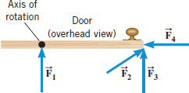
b. F₂
c. F₃
d. F₄

____5. For the above question, which pair of forces,
provide no torque about the axis of rotation?
a. F₁ and F₂ b. F₃ and F₄ c. F₁ and F₄ d. F₃ and F₂ e. F₁ and F₃

6-7) Five hockey pucks, each with a radius R, are sliding across frictionless ice. The drawing shows a top view of the pucks and the three forces that act on each one. As shown, the forces have different magnitudes , and are applied at different points on the pucks.
____6. Which one of the five pucks is in Equilibrium?
____7. Which one of the five pucks has a net torque of FR, clockwise, about the center?
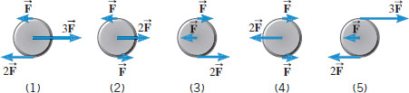
____8. Sit-ups are more difficult to do with your hands placed behind your head instead of on your stomach. This is because,
a. The mass is greater when the hands are placed behind the head instead on the stomach.
b. The mass is smaller when the hands are placed behind the head instead on the stomach.
c. The moment of inertia is greater when the hands are placed behind the head instead on the stomach.
d. The moment of inertia is smaller when the hands are placed behind the head instead on the stomach.

II. A ball of radius 12 cm is given an initial angular velocity of 9.5 rad/s. The ball rolls along a straight line for 6.5 seconds until it comes to rest. How far the ball travels (in m) during this time?

III. A uniform meter stick is supported at the 32 cm mark. Balance is obtained when a 85 gram mass is suspended at the 16 cm mark.
a. Draw a free-body diagram for the meter stick.
b. Find the mass of the meter stick.
c. Find the normal force, in SI units, exerted at the support point.

IV. In the figure below, point C is in equilibrium. Determine the values of F₁ and F₂ in lb.

V. Automobile Chevy volt, mass = 1550 kg (including its 4 wheels), moving with a velocity of 39 m/s.
a. Calculate the translational kinetic energy of the car in SI units.
b. If each of the rolling wheels, assumed to be a uniform disk, has a mass of 17 kg and radius 0.32 m, calculate the rotational kinetic energy for one wheel.
c. Calculate the total (rotational & translational) kinetic energy of the car.

VI. A playground merry-go-round with a child at the rim is rotating with an angular velocity of 3.5 rad/s. If the mass of the child is 29 kg, what will be the angular velocity of the merry-go-round as soon as the child jumps out along a radial direction? (Assume that the merry-go-round is a disk of mass 120 kg and radius 2.6 m)

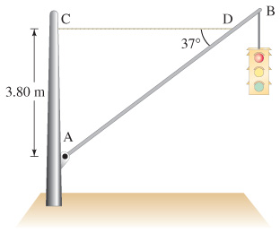
VII. A traffic light of weight 65 N is supported by
a uniform pole of weight 35 N, hinged at A, and
a horizontal cable, CD. Draw a free-body diagram
for the pole, identifying and showing all the
forces acting on it.

VIII. A bowler holds a bowling ball (M = 7.2 kg) in the palm of his hand. His upper arm is vertical; his lower arm (1.8 kg) is horizontal.
(a) Draw a free-body diagram for the forearm.
What is the magnitude of (b) the force of the biceps muscle on the lower arm and (c) the force between the bony structures at the elbow contact point?
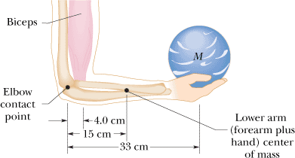

IX. A stationary bicycle is raised off the ground, and its front wheel (m=1.5 kg) is rotating at an angular velocity of 16 rad/s (see the drawing). The front brake is then applied for 4.0 s, and the wheel slows down to 3.1 rad/s. Assume that all the mass of the wheel is concentrated in the rim, the radius of which is 0.33 m. What is the frictional force that each brake pad applies to the rim?
