|  |  |  |
| --- | --- | --- |
| PHYSICS 201  Equations Sheet | Translational Motion | Rotational Motion |
| LINEAR | ANGULAR |
| Time | t | T |
| Displacement | x; (x = rθ) | Θ |
| Velocity | v = Δx/Δt; (v = rω) | ω = Δθ/Δt |
| Acceleration | a = Δv/Δt; (a = rα) | α = Δω/Δt |
| Kinematic Equations | v = v0 + at | ω = ω0 + αt |
| x = ½(v + v0)t | θ = ½(ω + ω0)t |
| x = v0t + ½ at2 | θ = ω0t + ½ αt2 |
| v2 = v02 + 2ax | ω2 = ω02 + 2αθ |
| Inertia | *m* = mass | *I* = Rotational inertia; |
| To create | force = F | torque = τ = LA·F |
| Newton's second law of motion | Σ**F** = m**a** | Σ**τ** = I**α** |
| Σ**F** = Δ**p**/Δt | Σ**τ** = Δ**L**/Δt |
| Work | *F·x* | *τ·θ* |
| Kinetic Energy | Translational Kinetic Energy = TKE = ½ mv2 | Rotational Kinetic  Energy = RKE = ½ Iω2 |
| Momentum | **p** = m·**V** | **L** = I·**ω** |
| Conservation of momentum | Σmivi = Σmfvf | ΣIiωi = ΣIfωf |

Pressure = Force/Area Pabs = Patm + PG Density = Mass/Volume

Pressure (P) due to depth h of fluid of density ρ; P = ρgh.  
1 atm = 1.013 x 105 N/m2 = 76 cm.Hg = 760 mm.Hg

The density of the air is 1.29 kg/m3; Density of water = 1000 kg/m3 = 1 g/cm3; Acceleration due to gravity = g = 9.8 m/s2.

Area of a circle of radius r, Acircle = π r2 .Area of a rectangle of length l, and width w, Arec=l x w; Area of a triangle, Atriangle= 0.5 x base x height.  
  
Volume of a cylinder of radius r and height h; V= π r2h; Volume of a sphere = (4/3) π r3.

Frictional force = *Ffr=μkFN* Buoyant force: $F_{b}=ρ_{f}v_{f}g$ GPE = mgh

Hooke’s law: $\vec{F}=-k\vec{x}$ Elastic PE = EPE = $\frac{1}{2}kx^{2}$  
Period of a simple pendulum: $T=2π\sqrt{\frac{L}{g}}$ Period of oscillating mass on spring: $T=2π\sqrt{\frac{m}{k}}$

**PHYS 201 Fall 2016 Test #3 Name:___________________________**

I. For the following multiple choice questions, write your answer in the line next to the question number.

____1. What is the angular speed in degree/hour of the hour hand of an analog watch?  
a. 6 b. 12 c. 15 d. 30 e. 36

____2. What is the angular speed in rad/s of the hour hand of an analog watch?

a. 1.75 x 10-3 b. 0.105 c. 8.33 x 10-3 d. 8.73 x 10-3 e. 1.45 x 10-4

____3. A merry-go-round at a playground is a circular platform that is mounted parallel to the ground and can rotate about an axis that is perpendicular to the platform at its center. The angular speed of the merry-go-round is constant, and a child at a distance of 1.4 m from the axis has a tangential speed of 2.2 m/s. What is the tangential speed of another child, who is located at a distance of 2.1 m from the axis?  
a. 1.5 m/s b. 3.3 m/s c. 2.2 m/s d. 5.0 m/s e. 0.98 m/s

____4. The drawing illustrates an overhead view of a door and its axis of rotation. The axis is perpendicular to the page. There are four forces acting on the door, and they have the same magnitude. Which force will provide the highest torque, about the axis of rotation?  
a. **F1**

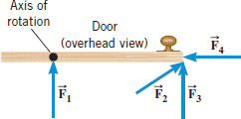

b. **F2**

c. **F3**

d. **F4**

5-6) Five hockey pucks are sliding across frictionless ice. The drawing shows a top view of the pucks and the three forces that act on each one. As shown, the forces have different magnitudes left-parenthesis Upper F comma 2 Upper F comma  or  3 Upper F right-parenthesis, and are applied at different points on the pucks.  
____5. Which one of the five pucks is in Equilibrium?  
____6. Which one of the five pucks has a net torque of 2*FR*?

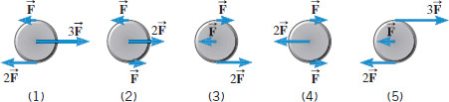

**___7. When a 54 kg man stands on a pogo stick, the spring is compressed 18 cm. What is the spring constant of the spring, in SI units? (g = 9.8 m/s2)**

1. **3.0 b. 29.4 c. 300 d. 2940 e. 29400**

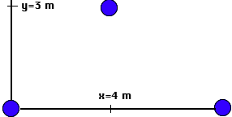

____8. The three 'point' 2 kg masses in the figure above are at (*x*,*y*) = (0,0), (4,3), and (8,0), respectively. What is the moment of inertia of the masses about the *x* axis?  
a. 18 kg.m2 b. 32 kg.m2 c. 128 kg.m2 d. 160 kg.m2

9-10) The purpose of a water tower is to provide storage capacity   
and to provide sufficient [pressure](javascript:parent.xlinkeyword('u0017')) in the pipes that deliver the water   
to customers. The drawing shows a spherical reservoir, which is   
vented to the atmosphere at the top and full.   
____9. What height must be used to find the gauge pressure at the   
faucet in house A?

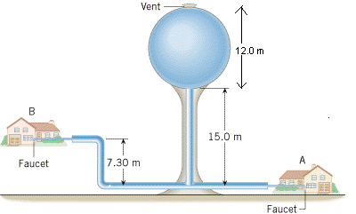

____10. What height must be used to find the gauge pressure at the   
faucet in house B?

Answers for 9 & 10

a. 15 m b. 27 m c. 7.3 m d. 19.7 m e. 34.3 m

____11. Which one of the following is a correct statement of Pascal’s principle?

____12. Which one of the following is a correct statement of Archimedes’s principle?

Answers   
a. Any change in the pressure applied to a completely enclosed fluid is transmitted undiminished to all parts of the fluid and the enclosing walls.

b. Any fluid applies a buoyant force to an object that is partially or completely immersed in it; the magnitude of the buoyant force is greater than the weight of the fluid that the object displaces.

c. Gauge pressure is the pressure measured by a pressure gauge. It is the difference between the absolute pressure and atmospheric pressure.

d.

Any fluid applies a buoyant force to an object that is partially or completely immersed in it; the magnitude of the buoyant force is less than the weight of the fluid that the object displaces.

e. Any fluid applies a buoyant force to an object that is partially or completely immersed in it; the magnitude of the buoyant force equals the weight of the fluid that the object displaces.

___13. Sit-ups are more difficult to do with your hands placed behind your head instead of on your stomach. This is because,

a. The mass is greater when the hands are placed behind the head instead on the stomach.

b. The mass is smaller when the hands are placed behind the head instead on the stomach.

c. The moment of inertia is greater when the hands are placed behind the head instead on the stomach.

d. The moment of inertia is smaller when the hands are placed behind the head instead on the stomach.

___14. A student is sitting on a frictionless spin-stool. She is holding heavy books in her hands, which are out stretched. She is given a spin and while she spins she brings the books close to her body. Which one of the following statements is true concerning the above event and why?

A) The angular speed of the system decreases because the moment of inertia of the system has increased.

B) The angular speed of the system increases because the moment of inertia of the system has increased.

C) The angular speed of the system decreases because the moment of inertia of the system has decreased.

D) The angular speed of the system increases because the moment of inertia of the system has decreased.

E) The angular speed of the system remains the same because there is zero net torque.

___15. The above activity demonstrates,

a. Conservation of momentum b. Conservation of angular momentum

c. Newton’s second law d. Work-Energy theorem

____16. How tall must a water-filled manometer be to measure blood pressures as high as 150 mm Hg? (Density of water = 1 g/cm3, density of Hg = 13.6 g/cm3)

a. 11 mm b. 13.6 mm c. 150 mm d. 2040 mm e. 2400 mm

____17. A twin-sized air mattress used for camping has dimensions of 90 cm by 180 cm by 10 cm when blown up. The weight of the mattress is 7 kg. How heavy a person could the air mattress hold if it is placed in freshwater?  
a. 95 kg b. 155 kg c. 162 kg d. 169 kg e. 255 kg  
______________________________________________________End of MC questions

II. Atmospheric pressure exerts a large force (equal to the weight of the atmosphere above your body) on the top of your body when you are lying on the beach sunbathing. Why are you able to get up?

III. Pendulum clocks are made to run at the correct rate by adjusting the pendulum’s length. Suppose you move from one city to another where the acceleration due to gravity is slightly greater, taking your pendulum clock with you, will you have to lengthen or shorten the pendulum to keep the correct time, other factors remaining constant? Explain. Period of a simple pendulum: $T=2π\sqrt{\frac{L}{g}}$

IV. A spring-mounted chair in which the astronaut sits, can be used to find the mass of an astronaut. The chair is then made to oscillate in simple harmonic motion. The spring used in one such device has a spring constant of 606 N/m, and the mass of the chair is 12.0 kg. The measured oscillation period is 2.41 s. Find the mass of the astronaut.

Period of oscillating mass on spring: $T=2π\sqrt{\frac{m}{k}}$

V. An aluminum casting with cavities has a mass of 450-g in air and a mass of 260-g in water. What is the total volume of all the cavities in the casting? The density of aluminum (that is, a sample with no cavities) is 2.7 g/cm3. Assume that the density of water = 1 g/cm3.

VI. A pulley of moment of inertia 8.5 kg.m2 and radius 0.15 m is pulled with an applied force, F = 18 N, as shown below.

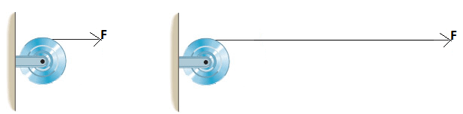

1. Calculate the torque exerted on the pulley.

2. Calculate the angular acceleration of the pulley.

3. If the pulley is at rest initially, how long the force needs to be applied to make the pulley spin at 26 rad/s?

VII. A 1500-N uniform horizontal beam of length 8.0 m is hinged to a vertical wall at one end and is supported by a cable at the other end as shown below. A fireman of mass 85-kg is standing on the beam at 5.0 m from the hinge.   
1. Draw a free-body diagram for the beam, showing all the forces acting on the beam, including the horizontal (Rx) and vertical (Ry) forces exerted by the hinge on the beam.

2. Break the tension in the cable into horizontal and vertical components.  
3. Write down two equations by balancing the forces in x and y directions.  
4. Write down the torque equation.  
5. Find the tension in the cable and the horizontal and vertical forces exerted by the hinge on the beam.

