PHYSICS 201  Equations Sheet | Translational Motion | Rotational Motion
 | LINEAR | ANGULAR
Time | t | T
Displacement | x; (x = rθ) | θ
Velocity | v = Δx/Δt; (v = rω) | ω = Δθ/Δt
Acceleration | a = Δv/Δt; (a = rα) | α = Δω/Δt
Kinematic Equations | v = v₀ + at | ω = ω₀ + αt
 | x = ½(v + v₀)t | θ = ½(ω + ω₀)t
 | x = v₀t + ½ at² | θ = ω₀t + ½ αt²
 | v² = v₀² + 2ax | ω² = ω₀² + 2αθ
Inertia | m = mass | I = Rotational inertia;
To create | force = F | torque = τ = LA· F
Newton's second law of motion | ΣF = ma | Στ = Iα
 | ΣF = Δp/Δt | Στ = ΔL/Δt
Work | F·x | τ·θ
Kinetic Energy | Translational Kinetic Energy = TKE = ½ mv² | Rotational Kinetic  Energy = RKE = ½ Iω²
Momentum | p = m·V | L = I·ω
Conservation of momentum | Σm_{i}v_{i} = Σm_{f}v_{f} | ΣI_{i}ω_{i} = ΣI_{f}ω_{f}

Acceleration due to gravity = g = 9.8 m/s². 1 Revolution = 2π rad.
Area of a circle of radius r, A_{circle} = π r² .Area of a rectangle of length l, and width w, A_{rec}=l x w; Area of a triangle, A_{triangle}= 0.5 x base x height.
Volume of a cylinder of radius r and height h; V= π r²h; Volume of a sphere = (4/3) π r³.
Frictional force = F_{fr}=μ_{k}F_{N} Buoyant force: $F_{b}=ρ_{f}v_{f}g$ GPE = mgh
Hooke’s law: $\vec{F}=-k\vec{x}$ Elastic PE = EPE = $\frac{1}{2}kx^{2}$ Period = 1/Frequency
Period of a simple pendulum: $T=2π\sqrt{\frac{L}{g}}$ Period of oscillating mass on spring: $T=2π\sqrt{\frac{m}{k}}$

The moment of inertia, I for a cylinder (or disk) of mass m and radius r is: $I=\frac{1}{2}mr^{2}$

PHYS 201 Fall 2018 Test #3 Name:___________________________
I. For the following multiple choice questions, write your answer in the line next to the question number.
____1. What is the angular speed in degree/second of the second hand of an analog watch?
a. 6 b. 12 c. 15 d. 30 e. 36

____2. What is the angular speed in rad/s of the second hand of an analog watch?
a. 1.75 x 10⁻³ b. 0.105 c. 8.33 x 10⁻³ d. 8.73 x 10⁻³ e. 1.45 x 10⁻⁴
____3. The radius of each wheel on a bicycle is 0.400 m. The bicycle travels a distance of 3.0 km. How many revolutions does each wheel make (wheels do not slip)?
a. 7.5 b. 1200 c. 2400 d. 6000 e. 7500
____4. A ball of radius 0.200 m is given an initial angular velocity of 15 rad/s. The ball rolls along a straight line for 5 seconds until it comes to rest. How far the ball travels during this time?
a. 7.5 m b. 37.5 m c. 3 m d. 75 m e. 15 m f. 1.0 m

____5. A figure skater is spinning with an angular velocity of 18 rad/s. She then comes to a stop over a brief period of time. During this time, her angular displacement is 5.1 rad. Determine her average angular acceleration, in SI units.
a. 3.5 rad/s² b. 32 rad/s² c. -3.5 rad/s² d. -32 rad/s²

6-7) The drawing illustrates an overhead view of a door and its axis of rotation. The axis is perpendicular to the page. There are four forces acting on the door, and they have the same magnitude.
6. Show the lever-arm for the force F₂ in the diagram.
____7. Which pair of forces provide non-zero torque,
about the axis of rotation shown?
a. F₁ and F₂ b. F₃ and F₄ c. F₁ and F₄
d. F₃ and F₂ e. F₁ and F₃
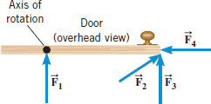

8-9) A uniform meter stick is supported at the 35 cm mark. Balance is obtained when a 65 gram mass is suspended at the 15 cm mark.
8. Draw a free-body diagram for the meter stick.
___9. What is the mass of the meter stick?
a. 29 g b. 46 g c. 75 g d. 87 g e. 93 g
8.
___10. Two 'point' masses, 1 has a mass of 2 kg and
2 has a mass of 4 kg, rotated as shown.
The length l = 0.2 m and 2l = 0.4 m. Calculate the moment
of inertia about the axis of rotation shown?
a. 0 b. 0.08 kg.m² c. 0.64 kg.m²
d. 0.72 kg.m² e. 2.72 kg.m²
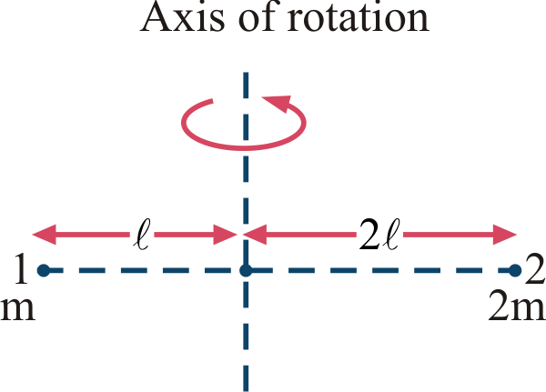

____11. The stretching force VS. stretch curve for a Hooke’s law experiment is shown below. What is the spring constant of the spring?
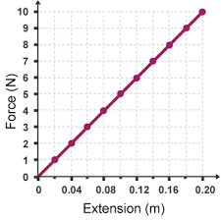
- 5 N/m
- 10 N/m
- 15 N/m
- 20 N/m
- 25 N/m
- 50 N/m

____12. What is the period, in millisecond, of the sound wave of frequency 440 Hz?
- 0.0023 b. 0.023 c. 2.3 d. 4.4 e. 44

____13. The period of a simple pendulum of length 0.993 m is found to be 1.95 s at a location. Calculate the acceleration due to gravity at this location to 3 significant figures.
a. 9.80 m/s² b. 9.83 m/s² c. 9.90 m/s² d. 10.3 m/s² e. 10.6 m/s²
____14. The spring loaded gun in a ballistic pendulum is compressed by 5.2 cm and released. The 54 gram steel ball leaves the gun with a velocity of 6.3 m/s. Calculate the spring constant of the spring.
a. 7.93 N/m b. 79.3 N/m c. 793 N/m d. 7930 N/m
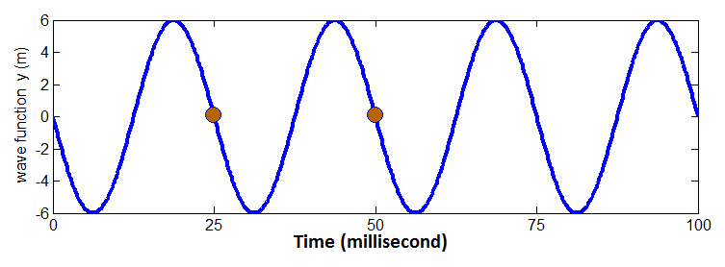
____15. What is the amplitude, in m, for the wave shown above?
____16. What is the frequency in Hz for the wave shown above?
Answers for 15 & 16: a. 6 b. 12 c. 25 d. 40 e. 80
II. Automobile Chevy volt, mass = 1750 kg (including its 4 wheels), moving with a velocity of 35 m/s.
a. Calculate the translational kinetic energy of the car in SI units.
b. If each of the rolling wheels, assumed to be a uniform disk, has a mass of 15 kg and radius 0.30 m, calculate the rotational kinetic energy for one wheel.
c. Calculate the total (rotational & translational) kinetic energy of the car.

III. A playground merry-go-round (a disk) has a mass of 120 kg and a radius of 2.0 m and it is rotating with an angular velocity of 3.5 rad/s. What is
its angular velocity after a 15 kg child gets onto it by grabbing its outer
edge? The child is initially at rest. Express your answer in SI units.

IV. Three forces are applied to a solid cylinder of mass 15 kg (see the drawing). The magnitudes of the forces are F₁ = 15 N, F₂ = 24 N, and F₃ = 16 N. The radial distances are R₂ = 0.26 m and R₃ = 0.12 m. The forces F₂ and F₃ are perpendicular to the radial lines labeled R₂ and R₃. Find the magnitude of the angular acceleration of the cylinder about the axis of rotation.
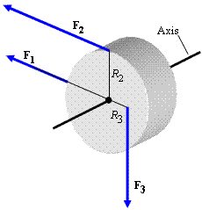

V. In an isometric exercise a person places a hand on a scale and pushes vertically downward, keeping the forearm horizontal. This is possible because the triceps muscle applies an upward force, M perpendicular to the arm, as the drawing indicates. The forearm weighs 19.5 N and has a center of gravity as indicated. The scale registers 108 N. Draw a free-body diagram for the forearm and determine the magnitude of M. Express your answer in SI units with 3 significant figures.
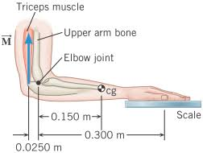

VI. A traffic light of mass 5.4 kg is supported by
a uniform pole (AB) of mass 11 kg, hinged at A, and
a horizontal cable, CD. Draw a free-body diagram
for the pole, identifying and showing all the
forces acting on it, and determine the tension in the
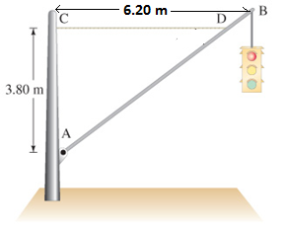
cable and the horizontal and vertical forces exerted
by the hinge on the pole.

