Tear this page and use it as your work sheet for MC questions.

Equations of Kinematics for constant acceleration are given below:

|  |  |  |  |
| --- | --- | --- | --- |
| 1. | 2. | 3. | 4. |
|  |  |  |  |

Newton’s seconds law: Σ**F** = m**a,** Force of friction:    
Acceleration due to gravity = g = 9.8 m/s2.

Newton’s law of gravitation is given by: 

Centripetal force is given by, 

Kinetic Energy is given by, 

Potential Energy is given by, 

Work done by a Force,    
  
Power = Work/Time.

Work-Energy Theorem: 

Linear momentum of an object of mass, *m* and velocity, ***v*** is given by: ***p*** = *m* x***v***.

Impulse is defined as the product of the force and time, ***J* = *F***x *t*.

Impulse-Momentum Theorem: 

Area of a triangle = 

PHYS 201   Test #2 Fall 2015            Name:_____________________________  
A. For the MC questions write your answers in the line next to the question number.

___1. Which one of the following is Newton’s first law motion?

___2. Which one of the following is Newton’s third law motion?

___3. Which one of the following is Newton’s law of universal gravitation?

Answers for 1-3

a. Every particle in the universe exerts a repulsive force on every other particle

b. Every particle in the universe exerts an attractive force on every other particle

c. An object will remain in a state of rest or of uniform motion in a straight line unless acted on by an outside net force.

d. The net force acting on an object is equals to the product of the mass of the object and the acceleration of the object.

e. When one object exerts a force on a second object, the second object exerts a force on the first that has an equal magnitude but opposite direction.

f. Frictional forces are in the opposite direction of motion.

___4. Which one of the following is also the unit newton, N?

___5. Which one of the following is also the unit joule, J?

___6. Which one of the following is also the unit watt, W?  
___7. Which one of the following is a unit for impulse?

Answers for 4-7  
a. kg.m2/s2 b. kg/(m.s2) c. kg.m/s2 d. kg.m2/s3 e. kg.m/s3 f. kg.m/s

___8. Which one of the following is a non-contact force?

a. pushing b. static frictional force c. Tension   
 d. kinetic frictional force e. normal force f. gravitational force

____9. Two identical cars have the same speed, one traveling east and one traveling west. Which one of the following is true?

a. Both have the same momentum and same kinetic energy.

b. Both have the same momentum, but different kinetic energy.

c. Both have different momentum and different kinetic energy.

d. Both have the different momentum, but same kinetic energy.

___10. Which one of the following is an example for a conservative force?

a. electric force b. frictional force c. pushing

d. pulling e. tension in a cord

___11. What is the centripetal force for a car moving around a flat-curve?  
___12. What is the centripetal force for a satellite in orbit around a planet?  
Answers for 11-12  
a. Normal force b. Kinetic frictional force  
c. Static frictional force d. Weight e. Gravitational force

___13. Which one of the following terms is used to indicate the natural tendency of an object to remain at rest or in motion at a constant speed along a straight line?  
a. Velocity b. Speed c. Inertia d. Force e. Acceleration

____14. Two objects with masses m1 and m2 are separated by a distance 2 d. Mass m2 is greater than mass m1. A third object has a mass m3. All three objects are located on the same straight line. The net gravitational force acting on the third object is zero. Which one of the drawings correctly represents the locations of the objects?

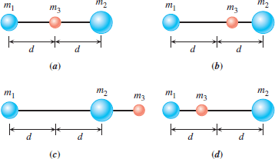

____15. An automobile approaches a barrier at a speed of 20 m/s along a level road. The driver locks the brakes at a distance of 50 m from the barrier. What minimum coefficient of kinetic friction is required to stop the automobile before it hits the barrier?

a. 0.4 b. 0.5 c. 0.6 d. 0.7 e. 0.8

16-17) A car is traveling at a constant speed along the road *ABCDE* shown in the drawing. Sections *AB* and *DE* are straight.   
___16. In which section of the road, the acceleration is the largest?

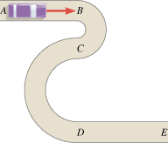

a. AB b. BC c. CD d. DE

___17. In which section of the road, the acceleration is zero?

a. AB & DE b. BC & CD   
c. CD & DE d. AB & BC

____18. In another solar system a planet has twice the earth's mass and half the earth's radius. Your weight on this planet is _______ times your earth-weight.   
____19. In another solar system a planet has earth's mass and half the earth's radius. Your weight on this planet is _______ times your earth-weight.   
Answers for 18 & 19   
a. 2 b. 3 c. 4 d. 6 e. 8 f. 10

_____20. An engineer is asked to design a playground slide such that the speed a child reaches at the bottom does not exceed 6.0 m/s. Determine the maximum height that the slide can be.  
a. 1.8 m b. 2.9 m c. 3.2 m d. 4.5 m e. 7.4 m

____21. The kinetic energy of a car is 8 × 106 J as it travels along a horizontal road. How much power is required to stop the car in 10 s?  
a. 8 × 107 W b. 8 × 106 W c. 8 × 105 W d. 8 × 104 W e. 8 × 103 W f. 8 × 102 W

22-23) The force component acting on an object along the displacement varies with the displacement *s* as shown in the graph.   
  
____22. Determine the work done on the object as it travels from   
*s*= 0.0 to 12 m.  
a. 81 J b. 66 J c. 72 J   
d. 57 J e. 48 J f. 96 J

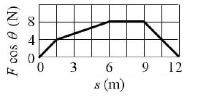

____23. If the mass of the object is 2.5 kg, what is the speed of the object at 12 m?  
a. 7.3 m/s b. 8.1 m/s c. 7.6 m/s d. 6.8 m/s e. 6.2 m/s f. 8.8 m/s

____24. A 45-kg person, running horizontally with a velocity of +3.0 m/s, jumps onto a 12-kg sled that is initially at rest. Ignoring the effects of friction during the collision, find the velocity of the sled and person as they move away.  
a. 11 m/s b. 3.0 m/s c. 2.4 m/s d. 1.5 m/s e. 0.63 m/s   
  
____25. The force applied to a tennis ball (mass = 0.06 kg) during   
a serve is shown as a function of time. What is the impulse applied   
to the ball?  
a. 5 N.s b. 10 N.s c. 15 N.s d. 30 N.s

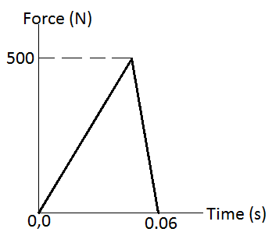

____26. Two objects are involved in a completely inelastic one-dimensional collision. The net external force acting on them is zero. The table lists four possible sets of the initial momenta and kinetic energies of the two objects, as well as their final momenta and kinetic energies. Identify the set that violates the collision laws?

|  |  |  |  |  |  |
| --- | --- | --- | --- | --- | --- |
|  |  | Initial (Before Collision) | | Final (After Collision) | |
|  |  | Momentum | Kinetic Energy | Momentum | Kinetic Energy |
| a. | Object 1: Object 2: | +6 kg·m/s   +2 kg·m/s | 15 J   0 J | +8 kg·m/s | 9 J |
| b. | Object 1: Object 2: | +8 kg·m/s  -2 kg·m/s | 5 J 7 J | +6 kg·m/s | 12 J |
| c. | Object 1: Object 2: | -3 kg·m/s +4 kg·m/s | 1 J 6 J | +1 kg·m/s | 4 J |
| d. | Object 1: Object 2: | 0 kg·m/s -8 kg·m/s | 3 J 8 J | -8 kg·m/s | 10 J |

B. Free Body Diagrams   
1. A skier is coasting down a 25° slope, at a constant velocity as shown below.   
Draw a free-body diagram for the skier, naming all the forces.

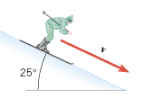

2. A car is turning along a banked-frictionless exit ramp. Draw a free-body diagram for the car, naming all the forces.

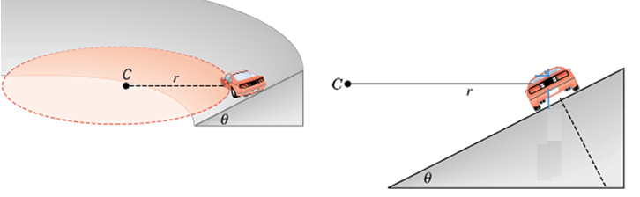

C. An expression for the magnitude of the centripetal force, *Fc* in terms of the mass (*m*) and speed (*v*) of the object and the radius (*r*) of the circular path is given below.   
1. Show that the following equation is correct unit wise.   


2. A car of mass 950-kg is traveling at a constant speed as shown below. First on a flat road, then along a dip of radius 45m, and then a hill of radius 35 m  
a. Draw free-body diagrams for each of the following three cases.  
b. If it loses contact with the road at the top of the hill, find its speed.

c. Calculate the normal force when the car is at the bottom of the dip.

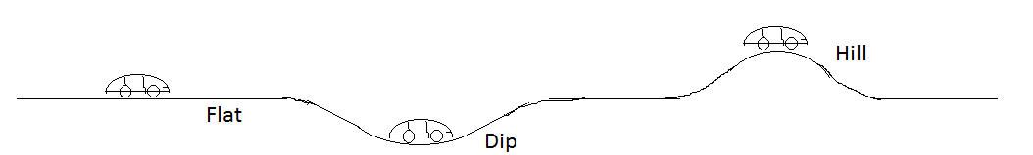

|  |
| --- |
| D. The drawing shows a skateboarder moving at 5.4 m/s along a horizontal section of a track that is slanted upward by *θ* = 35.0° above the horizontal at its end, which is 0.40 m above the ground. When she leaves the track, she follows the characteristic path of projectile motion. Ignore friction and air resistance. |

1. Using the conservation of mechanical energy, find her speed, V as she leaves the track.
2. Find the horizontal and vertical component of her speed as she leaves the track.
3. Find the maximum height *H* to which she rises above the end of the track.
4. Find the horizontal range, *R* she covers.

|  |  |
| --- | --- |
| |  | | --- | |  | |

E1. State the law of conservation of momentum.

2. A 54.0-kg skater is traveling due east at a speed of 3.70 m/s. A 77.0-kg skater is moving due north at a speed of 7.80 m/s. They collide and hold on to each other after the collision.  
a. Sketch a diagram of the above situation, showing the skaters before and after the collision.  
b. What type is this collision?______________________________  
c. Write down the conservation of momentum equations.

d. Solve the equations, and find the velocity (speed and direction) of the skaters after the collision, assuming that friction can be ignored.